Kongsberg Maritime to deliver a large electric winch package for a new fishing vessel
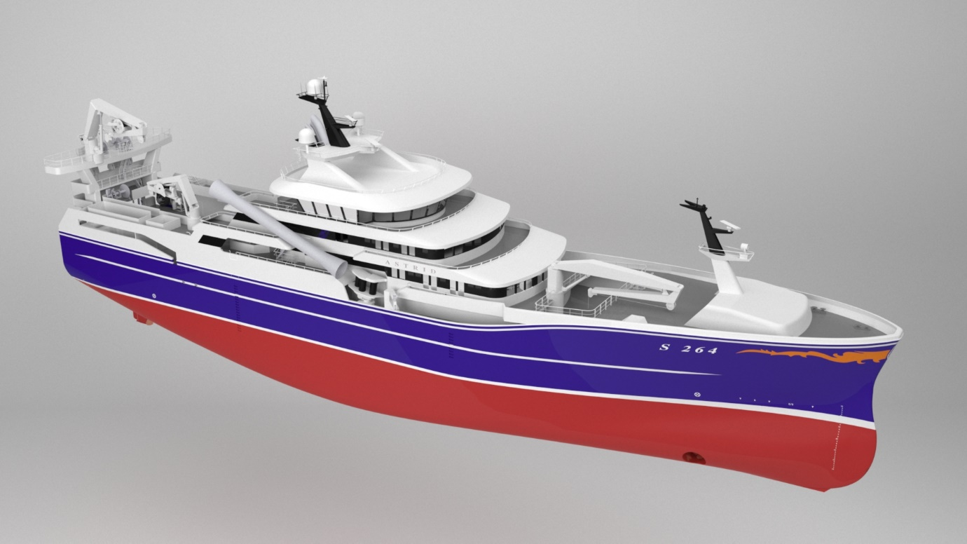 A large KONGSBERG electric winch package will be fitted to Astrid Fiskeri’s new pelagic trawler / purse seiner
Kongsberg, Norway, 16th December 2020 – Kongsberg Maritime is pleased to announce that it has been selected to supply a large electric winch package for a pelagic trawler / purse seiner, currently being built for the Danish company Astrid Fiskeri A/S at Karstensens Skibsvaerft A/S in Denmark.
The contract includes delivery and commissioning of a set of powerful fishery and auxiliary winches, together with a large Variable Speed Drive package and the latest version of KONGSBERG’s control and monitoring system.
The fishing winches will be fitted with new electric multidrive technology, developed by Kongsberg Maritime specifically for pelagic trawling and purse seining. This includes permanent magnet (PM) motors with gears mounted directly to the gearwheel and drum, allowing for direct transition and smoother, more dynamic operations.
“KONGSBERG was early in the market to deliver electric winches to the pelagic trawler fleet,” says Svein Hatlehol Henjesand, Sales Manager at Kongsberg Maritime. “This market has traditionally been mostly served by various high-pressure winches, while Kongsberg Maritime has also delivered dynamic low-pressure winches. We believe this has given us a head start in the current shift towards electric winches.”
The deliveries to Astrid Fiskeri include software solutions for remote access and self-assessment. A self-assessment tool is installed on an iPad and delivered to the vessel’s crew. This helps the crew to be proactive and it can assist in preventing component failure.
The self-assessment reports are also sent to Kongsberg Maritime’s onshore team of engineers. If required, a service engineer can then connect through remote access, and either resolve the issue online or make service plans for the next docking.
“These combined products and services demonstrate how digitalisation is essential to improved productivity for ship owners, even when the installed product is mechanical. Through a high level of cooperation with vessel crews, Kongsberg Maritime can help to remove or reduce unnecessary costs and avoid interruptions in fishing,” says Lisa Edvardsen Haugan, EVP Deck Machinery and Motion Control, Kongsberg Maritime.
The winch package is scheduled for delivery to the yard in Q4 2021, with commissioning during the first half of 2022.
Ends

For further information, please contact:
Gunvor Hatling Midtbø, VP Communication
Kongsberg Maritime
Tel: +47 9921 4209
gunvor.hatling.midtbo@km.kongsberg.com
David Pugh
Saltwater Stone
Tel: +44 (0)1202 669244
d.pugh@saltwater-stone.com

About Kongsberg Maritime
Kongsberg Maritime is a global marine technology company providing innovative and reliable ‘Full Picture’ technology solutions for all marine industry sectors including merchant, offshore, cruise, subsea and naval. Headquartered in Kongsberg, Norway, Kongsberg Maritime has manufacturing, sales and service facilities in 34 countries.
Kongsberg Maritime solutions cover all aspects of marine automation, safety, manoeuvring, navigation, and dynamic positioning as well as energy management, deck handling and propulsion systems, and ship design services. Subsea solutions include single and multibeam echo sounders, sonars, AUV and USV, underwater navigation and communication systems.
Training courses at locations globally, LNG solutions, information management, position reference systems and technology for seismic and drilling operations are also part of the company’s diverse technology portfolio. Additionally, Kongsberg Maritime provides services within EIT (Electro, Instrument & Telecom) engineering and system integration, on an EPC (Engineering, Procurement & Construction) basis.
Kongsberg Maritime is part of Kongsberg Gruppen (KONGSBERG), an international, knowledge-based group that celebrated 200 years in business during 2014. KONGSBERG supplies high-technology systems and solutions to customers in the oil and gas industry, the merchant marine, and the defence and aerospace industries.
Web: Kongsberg Gruppen | Kongsberg Maritime
Social media: LinkedIn | Twitter | Facebook

