KONGSBERG Remote Services
now available through Vessel Insight

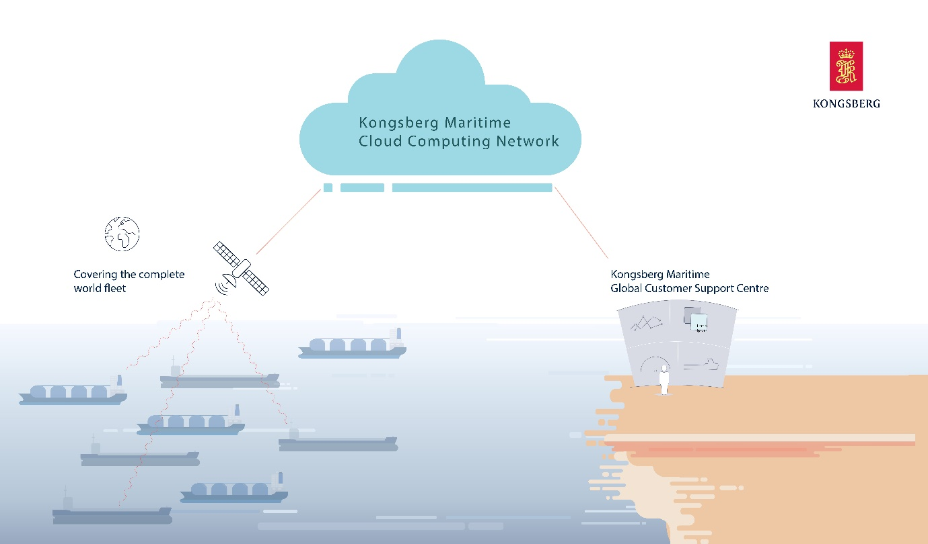
KONGSBERG Remote Services provide expert service engineers with a complete status overview of
the KONGSBERG systems on board, enabling operational guidance, configuration and diagnosis

Kongsberg, Norway, April 3rd, 2020 – In the past weeks, KONGSBERG has experienced an increase in the need for remote support and services to the maritime industry.
Now, the group has made their Remote Services solution available to customers using Vessel Insight.
KONGSBERG Remote Services is a tool for KONGSBERG-certified engineers worldwide to connect to an installation – such as a vessel – upon customer request and provide remote support. When service engineers cannot inspect vessels physically, a practical alternative for customers is to use remote service sessions. To ensure that more customers can access this alternative, KONGSBERG has enabled Remote Services on KONGSBERG automation, navigation and bridge solutions using Vessel Insight.
“Customers who are using Vessel Insight will from now on be automatically enabled for KONGSBERG’s Remote Services. That means expert assistance is available by agreement, and the experts will have a complete status overview of the situation on the KONGSBERG systems on board the vessel from secure KONGSBERG premises. That is of immediate value in the situation we are in, but also a major benefit for Vessel Insight users in the long term,” says Vigleik Takle, SVP Kongsberg Digital.
Remote Services enables operational guidance, configuration, diagnosis and troubleshooting. Although the need for remote assistance increases significantly when engineers cannot board ships physically, there are many benefits to having Remote Services enabled on Vessel Insight in the long term. Remote Services enables vessel operators to minimize the number of service trips and thereby reduce operational costs, reduces time for fault finding via specialist remote support, reduces downtime for locations where service engineer access is difficult, and provides operational support and guidance.
“Enabling Remote Services on Vessel Insight gives KONGSBERG the ability to provide more of our customers with assistance and support remotely. When our service engineers do not need to access the vessels physically, this brings major benefits to our customers – particularly at times when travelling is restricted. We are happy that by using Vessel Insight we can enable Remote Services for an extended number of customers,” says Martin Wien Fjell, EVP Global Customer Support, Kongsberg Maritime.

KONGSBERG Remote Services is built on a common technology platform for KONGSBERG products. The system is designed to address the challenges of establishing a secure and reliable remote session to the vessel control system via satellite communications. All communications are authenticated and encrypted by the KONGSBERG Global Secure Network.
More information can be found here.
Ends

Notes for Editors
Interviews with Vigleik Takle, SVP Maritime Digital Solutions at Kongsberg Digital, can be arranged on request.

For further information, please contact:

Mathilde Vik Magnussen
VP Communications & Marketing
Kongsberg Digital
Tel: +47 4567 8255
mathilde.magnussen@kdi.kongsberg.com

David Pugh
Saltwater Stone
Tel: +44 (0)1202 669244
d.pugh@saltwater-stone.com

About Kongsberg Digital
Kongsberg Digital is a provider of next-generation software and digital solutions to customers within maritime, oil and gas, and renewables and utilities. The company consists of more than 500 software experts with leading competence within the internet of things, smart data, artificial intelligence, maritime simulation, automation and autonomous operations.
Kongsberg Digital is subsidiary of KONGSBERG (OSE-ticker: KOG), an international, knowledge-based group delivering high-technology systems and solutions to clients within the oil and gas industry, subsea, merchant marine, defence and aerospace. KONGSBERG has 11.000 employees located in more than 40 countries.
Web: Kongsberg Gruppen | Kongsberg Digital
Social media: LinkedIn | Twitter | Facebook

