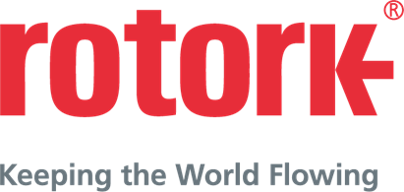
APPROVED PRESS RELEASE (2.116C) 25th January 2019
ROTORK ADDS PLUG AND SOCKET OPTION TO IQ RANGE
Rotork IQ intelligent electric valve actuators are recognised for being technically advanced, robust, reliable and user-friendly. These qualities have now been further enhanced with the option of a bespoke plug and socket electrical connection.
The new optional modular Rotork plug and socket interface provides a fast connect / disconnect option for IQ3 multi-turn and IQT3 part-turn actuators, encompassing 3-phase, 1-phase and DC (IQT3 only) electrical variants and including many actuators with explosionproof EXd enclosures conforming to ATEX, IECEx, CSA and CSAus international standards. The plug and socket terminal cover maintains the integrity of the actuator’s double-sealed enclosure and IP68 watertight environmental protection (submersible in 20 metres of water for 10 days).
A plug and socket interface is favoured in some industries for providing quick and easy field wiring and quick removal or interchange of actuators for maintenance and other operating requirements. The Rotork solution provides further flexibility to the advanced, user-friendly design of the IQ actuators. These include secure Bluetooth® non-intrusive setting and commissioning, an information-rich display, real-time status reporting and configurable datalogging to provide detailed analysis of the valve condition and asset management support.

END
Photo captions
Photo Ref 2.116C
Caption: The Rotork plug and socket option provides further flexibility to the advanced, user-friendly design of IQ3 and IQT3 actuators.

For further information please contact Rotork PLC
Sarah Kellett/Liam Jones Brassmill Lane
Bath
tel: +44 (0) 1225 733200 BA1 3JQ
email: Sarah.Kellett@rotork.com / Liam.Jones@rotork.com UK

About Rotork
Rotork is the market leading actuator manufacturer and flow control company that operates in any market where the flow of gases or liquids needs to be controlled. It has established manufacturing facilities, a global network of local offices and agents who can truly provide a worldwide service. You will be able to locally source Rotork’s products, supported by life-of-plant maintenance, repair and upgrade services.

