FOR IMMEDIATE RELEASE
Contact: Madeline Loucas
Phone: (410) 821-8220
E-mail: madelinel@imre.com

STANLEY® Introduces New Line of Safety Knives
16 unique SKUs offer customers a safe and secure cut

NEW BRITAIN, CT (October 31, 2018) – STANLEY announced today the introduction of its latest safety knives that complement the brand’s full range of utility knives. The latest offerings include STANLEY® and STANLEY® FATMAX® concealed, auto-retracting, and spring-loaded safety knives. The addition of 16 unique safety knives were designed to increase protection and security in fast-paced work environments where safety is a priority. Buyers can select from an array of different knife products that meet the unique user needs and solve for common safety challenges at reasonable costs.

The new STANLEY and STANLEY FATMAX safety knives offer three blade depth settings to protect contents within packaging materials. These capabilities also improve ease of use with its new trigger-squeeze to reduce user strain*. The newly introduced safety knives also include blade locks that help prevent accidental blade exposure to help keep those safe during use.

With the new STANLEY and STANLEY FATMAX safety knives, Environmental Health, Safety Officers, and Purchasing Managers will feel confident knowing their employees will be able to achieve the perfect cut while using a safety knife designed to reduce the risk of cuts, lacerations and punctures that can occur during various applications from cutting layered tape, changing blades, or opening and breaking down boxes efficiently.

STANLEY FATMAX PREMIUM AUTO-RETRACT SQUEEZE SAFETY KNIFE:  - Improved technology with a pressure-sensitive blade that automatically retracts once disengaged from cutting surface  - The trigger squeeze technology increases safety conditions by only exposing the blade while reducing user strain  - These knives offer the user durability and precise cuts with its slip-resistant bi-material grip | 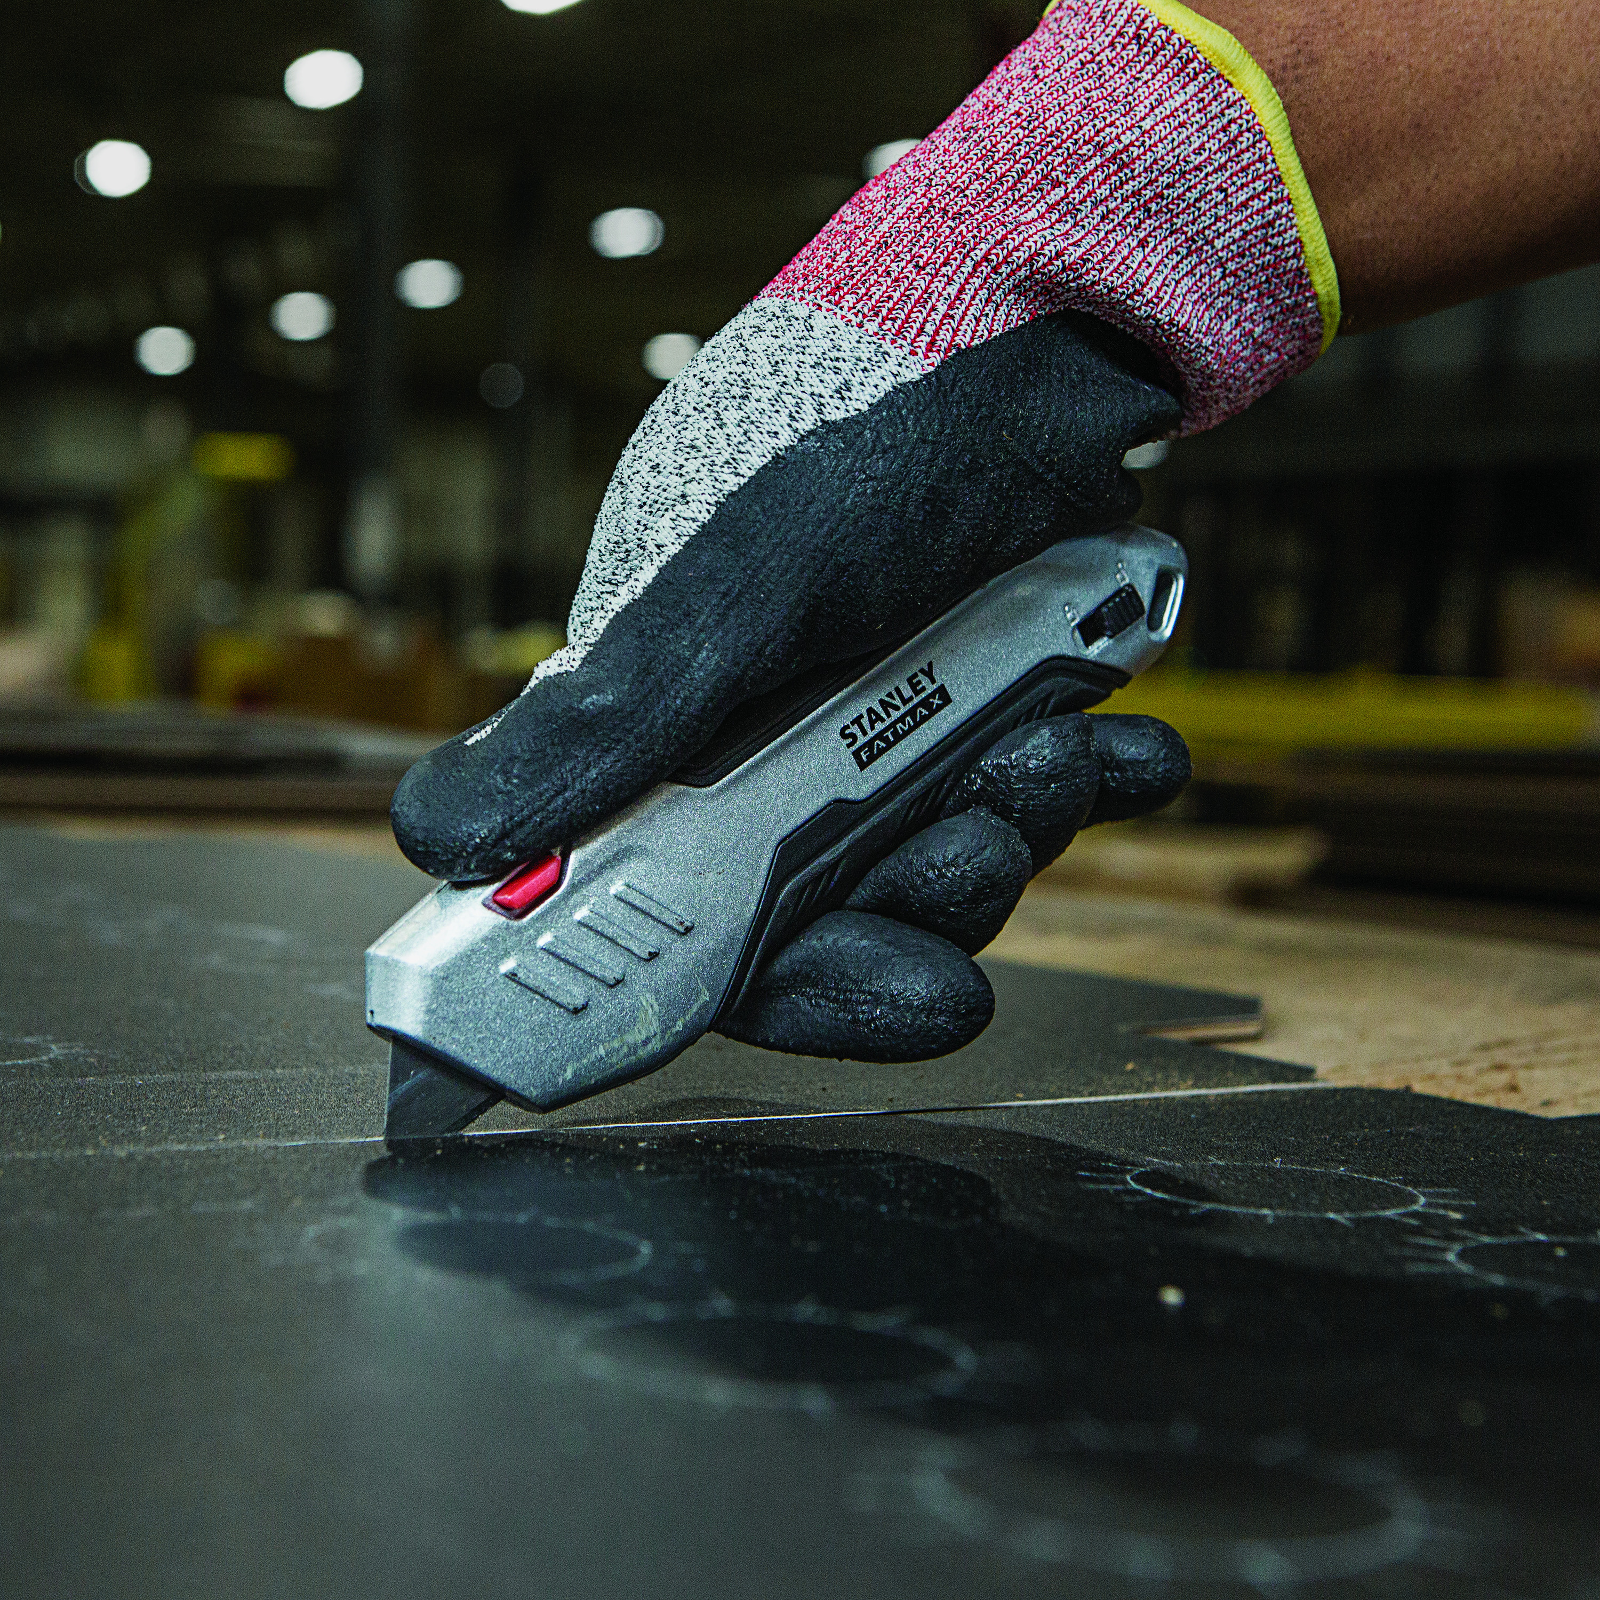  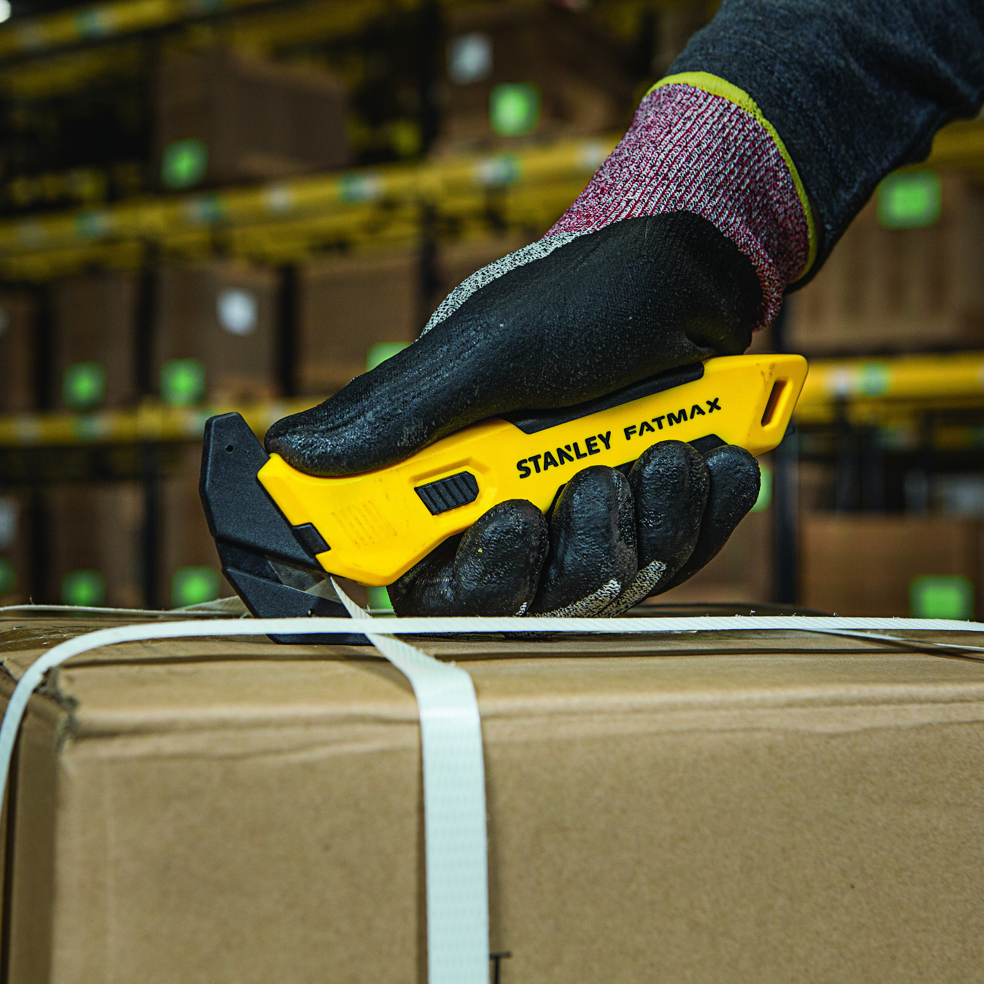  STANLEY FATMAX SINGLE-SIDED REPLACEABLE HEAD PULL CUTTER:  - Increase safety precautions with a completely concealed blade when not in use to help reduce risk of injury  - Single-sided, replaceable blade head for convenience, waste reduction, and cost efficiency  - Improved ergonomic design with slip-resistant, bi-material grip for comfort and control

“At STANLEY, we take pride in knowing our customers are using tools designed for safety and protection. Understanding they have the proper tools they need, while also being able to confidently complete jobs or projects is what we value most,” said Brian Rowan, Director of Product Management at STANLEY Tools. “Every customer runs into situations where they receive a package with multiple layers of tape that is difficult to open. Having the availability to quality safety knives that can withstand various cutting environments while reducing the risk of injury is important,” added Rowan.

A closer look into the new lineup of safety knives includes:

STANLEY® and STANLEY® FATMAX® Concealed Safety Knives each offer a completely recessed blade reducing the risk of injury. These safety knives are also available in a multi-pack option. The full lineup of units includes:
- STANLEY® FATMAX® Double-Sided Replaceable Head Pull Cutter - FMHT10361
- STANLEY® FATMAX® Single-Sided Replaceable Head Pull Cutter - FMHT10358
- STANLEY® Double-Sided Bi-Material Pull Cutter - STHT10360
- STANLEY® Double-Sided Bi-Material Pull Cutter – STHT10360A**
- STANLEY® Single-Sided Round Tip Bi-Material Pull Cutter - STHT10357
- STANLEY® Single-Sided Round Tip Bi-Material Pull Cutter – STHT10357A**
- STANLEY® Single-Sided Bi-Material Pull Cutter - STHT10356
- STANLEY® Single-Sided Bi-Material Pull Cutter – STHT10356A**
- STANLEY® Double-Sided Pull Cutter – STHT10359A**
- STANLEY® Double-Sided Pull Cutter – STHT10359B***
- STANLEY® Single-Sided Pull Cutter – STHT10355A**
- STANLEY® Single-Sided Pull Cutter – STHT10355B***

STANLEY® FATMAX® Auto-Retracting Safety Knives offer pressure sensitive blade capabilities. With advanced technology, these knives also have blades that automatically retract once disengaged from the cutting surface. The full lineup of units includes:
- STANLEY® FATMAX® Premium Auto-Retract Squeeze Safety Knife - FMHT10370
- STANLEY® FATMAX® Premium Auto-Retract Tri-Slide Safety Knife - FMHT10367
- STANLEY® FATMAX® Auto-Retract Squeeze Safety Knife - FMHT10369
- STANLEY® FATMAX® Auto-Retract Tri-Slide Safety Knife - FMHT10365

STANLEY® & STANLEY® FATMAX® Spring-Loaded Safety Knives feature a spring-loaded blade, that automatically retracts when pressure on the squeeze trigger or slide button is released for increased safety precautions. There are specialized safety knives for cutting box tops within this lineup of STANLEY and STANLEY FATMAX safety knives featuring an integrated tape splitter; these models are also available in left- and right-handed designs. The full like up of SKUS includes:
- STANLEY® FATMAX® Right-Handed Box Top Safety Knife - FMHT10363
- STANLEY® FATMAX® Left-Handed Box Top Safety Knife - FMHT10362
- STANLEY® Tri-Slide Safety Knife - STHT10364
- STANLEY® Squeeze Safety Knife - STHT10368
- STANLEY® Folding Pocket Safety Knife - STHT10243
- STANLEY® Self-Retracting Safety Knife – Orange - 10-189C
- STANLEY® Self-Retracting Safety Knife - Unpainted - 10-189P

These products will be available in Grainger, MSC, and Fastenal stores beginning in late fall 2018. STANLEY and STANLEY FATMAX safety knives MSRP ranges from $2.49 - $159.00 for single- and multi-quantity knife packs****. For more information about availability and pricing, please visit www.StanleySafetyKnives.com.

* When compared to thumb slide safety knife models.
** Available in 10-piece quantity multi-pack.
*** Available in 100-piece quantity multi-pack.
**** Price range includes both single- and multi-quantity packs.

###

About STANLEY:
STANLEY, a brand of Stanley Black & Decker, Inc. is a diversified manufacturer of innovative tools and engineered solutions for professional, industrial, woodworking, construction, automotive repair, organizational, and do-it-yourself use. Since 1843 STANLEY has consistently provided solutions that make life easier with reliable hand tools. Headquartered in New Britain, CT, STANLEY is committed to manufacturing tools in the USA with global materials. Annually, STANLEY produces a large variety of hand tools including tape rules, knives, blades, hand saws, screwdrivers, plastic storage, and accessories in multiple manufacturing locations in North America. STANLEY can be found internationally wherever tools are sold and has helped build America with a breadth of quality hand tools people can trust for over 175 years. For more information visit www.stanleytools.com or follow STANLEY on Facebook, Instagram, and Twitter.

