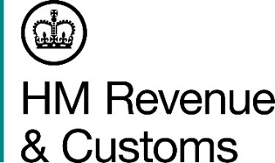
News Release

 | For the attention of News Desks |  | No. of pages: 2
 | Date: | 7 March 2019 | Ref: | SW 01 19

Music tuner’s VAT fraud falls flat
A Somerset company boss, who fraudulently reclaimed more than £230,000 of VAT, has been jailed for two years after a HM Revenue and Customs (HMRC) investigation.

Richard John Whittall, 76, of Minehead, was a supplier of precision tuners for stringed instruments and a director of Self Tune Systems Ltd and Clair Price Trading Ltd. When his business started to struggle he began conducting tax fraud. Between 2012 and 2015 he made dozens fraudulent VAT repayment claims totalling £233,142.

Richard Wilkinson, Assistant Director, Fraud Investigation Service, HMRC, said:

“When we pay tax, we expect it to go towards paying for vital public services, not to line the pockets of unscrupulous traders. Whittall knew he was breaking the law, but thought he could get away with ripping off honest taxpayers.

“HMRC are targeting those who are stealing public money and want to level the playing field for all businesses to operate fairly. Tax fraud is a serious crime and I ask anyone with information about those who may be involved to contact our hotline on 0800 788 887.”

Whittall previously pleaded guilty at Taunton Crown Court during an earlier hearing and was sentenced to two years in jail before the same court today (7 March 2019).

Confiscation proceedings are underway.

Notes for editors

- Richard John Whittall (DOB 27/11/1942) of Cleeve Park, Chapel Cleeve, Minehead, was sentenced at Taunton Crown Court on 7 March 2019 to two years in jail. He pleaded guilty at an earlier hearing on 23 October 2017 to being knowingly concerned in the fraudulent evasion of VAT, contrary to section 72 of the VAT Act 1994.

- Anyone with information about people or businesses involved in tax fraud can contact HMRC online or call our hotline on 0800 788 887.

- Follow HMRC’s press office on Twitter @HMRCpressoffice

Issued by HM Revenue & Customs Press Office

Press enquiries only please contact:

Will Lyon
Scotland press officer
Tel: 07469 023 331
Email: william.lyon@hmrc.gov.uk

Out of hours
Tel: 07860 359544
Website www.gov.uk/hmrc

