Epson launches world’s smallest 3LCD laser projector, a flexible and easy-to-use laser lifestyle projector for the home

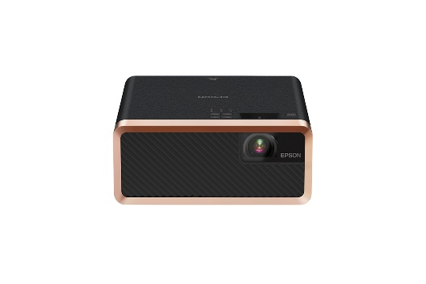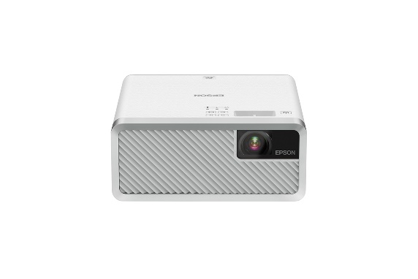
Epson’s EF-100B (left) and EB-100W (right) projectors

Kuala Lumpur (Wednesday, 28 August 2019) – Movie enthusiasts can now bring the cinema experience to the comfort of their homes with the launch of the world’s smallest 3LCD laser projector, Epson’s new sleek-looking Epson EF-100 laser projectors that can project brilliant images anywhere within the home. With a projection of up to 150 inches in size, the innovative new projectors combine large screen viewing with flexibility and usability and are set to be a game-changer in home projection.

With a slim and minimalist design, the portable projectors come in tailored black (EF-100B) and classy white (EF-100W) looks. Designed for style-conscious users, they blend seamlessly into the home environment aesthetics and complement the lifestyle of the user. The projectors are compact and lightweight, measuring at just 23cm along its longest edge and weighing at 2.7kg, making it easy for users to carry and position them easily anywhere within the home.

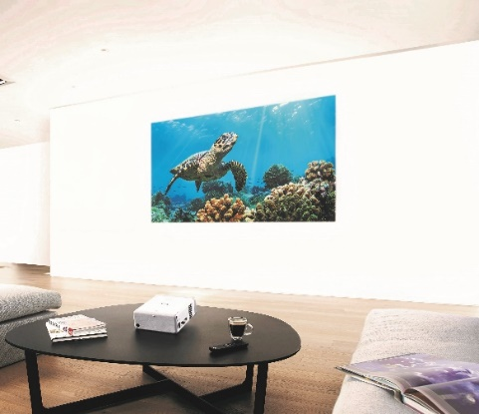

The projectors have the ability to project at any angle with a 360-degree flexibility, opening up many possibilities for projection, from watching movies on the living room wall to even projecting on the ceiling from the bed.

Accessing content from a phone, tablet, DVD player, games console or laptop is easy by inserting a cable into the HDMI port. Streaming content is simple too – Streaming devices can be plugged in the back.
Even in daylight, the projector’s laser light source delivers bright and vibrant images, and there is no need to turn lights off or close the windows. With the EF-100 laser projectors, movie buffs can enjoy their movies at 2,000 lumens of brightness and a high contrast ratio of over 2,500,000:1, delivering exceptionally rich and vivid images.

The projectors need minimal maintenance – with its long-lasting maintenance-free laser light source, there is no need for any projector lamp changes for the lifespan of the projector.

These home projectors have a user-friendly interface and are designed for beginners in projection. Set up is easy with minimal technical installation required – Users simply follow a quick start-up guide to get going. A key feature includes geometric keystone correction that enables easy adjustment of projections.

“With the EF-100 series, we aim to change the way people view content. With ease of use and portability as key features of the projector, users can carry the projector around and easily project in any room. Users who may have installation concerns when it comes to using home projectors need not worry as set up is a breeze with these projectors. With up to 150 inches in projection size, the home owner can now bring the cinematic large screen viewing experience right into their homes,” said Daisuke Hori, Managing Director of Epson Malaysia.

***
About Epson
Epson is a global technology leader dedicated to connecting people, things and information with its original efficient, compact and precision technologies. With a lineup that ranges from inkjet printers and digital printing systems to 3LCD projectors, watches and industrial robots, the company is focused on driving innovations and exceeding customer expectations in inkjet, visual communications, wearables and robotics.
Led by the Japan-based Seiko Epson Corporation, the Epson Group comprises more than 76,000 employees in 87 companies around the world and is proud of its contributions to the communities in which it operates and its ongoing efforts to reduce environmental impacts.
http://global.epson.com

About Epson Malaysia
Epson began operations in Malaysia in 1991 as Epson Trading (M) Sdn Bhd before being incorporated as Epson Malaysia Sdn Bhd. The company has the exclusive rights to market, distribute and support a complete range of leading-edge Epson consumer and business digital imaging products in Malaysia and Brunei. Today, Epson Malaysia has 84 employees and an extensive network of 61 authorised service outlets throughout the country. For more details, please visit www.epson.com.my or connect with us at www.facebook.com.my/EpsonMalaysia.

For media enquiries, please contact:
Chua Li Tinn,
Marketing Communications Manager
Epson Malaysia Sdn Bhd
Tel: (03) 5628 8288 Ext 274
Email: ltchua@emsb.epson.com.my

LEWIS
Natasha Aida / Leong Ee Sa
Tel: +603 2716 5818
Email: EpsonMY@teamlewis.com

Research is done by Futuresource Consulting Limited for 3LCD laser projectors with brightness of more than 500 lumens (as of 15 May 2019).
The projection is up to 150 inches in size with 3.41m projection distance.

