SCANDIC invests for the future and strengthens its market position

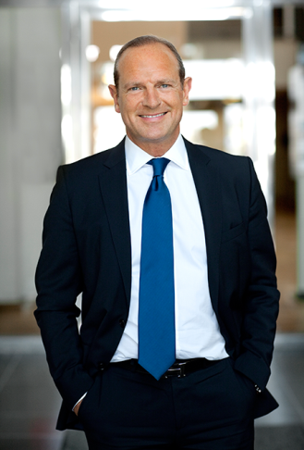
Summary by Frank Fiskers, President & CEO:
I am excited and proud to be back at Scandic. Major changes have been made in recent years to consolidate Scandic’s market position. The focus on meetings, food & beverage and the new hotel chain HTL has broadened and strengthened the Group’s customer offer. In January 2014, we announced that Scandic has secured exclusive rights in the Nordics to Jamie Oliver’s popular restaurant concept, Jamie’s Italian. The first restaurant will open at Scandic Anglais in Stockholm in late autumn 2014.
The most significant strategic move for Scandic is naturally the acquisition of Rica Hotels, which was announced on 11 February 2014. The addition of the 72 Rica Hotels will take Scandic to a whole new level on the Nordic hotel market, adding hotels in attractive new locations, making guests able to choose between almost 230 Scandic hotels across the Nordic region.
The investment in digital solutions such as mobile check-out, which was launched in June 2013, is key both to communicating with our guests in digital channels and also meeting demand from customers for simplicity and mobility. An evolution is under way in the digital distribution landscape, where our strong presence in all channels is a success factor.
In 2012, Scandic took a strategic decision to terminate certain distribution partnerships that were preventing us from being flexible in our pricing and differentiating our offer according to the distribution channel. These terminated distribution agreements did impact us in 2013 in the form of lower volumes, particularly in the leisure segment. This, combined with extensive refurbishing work and reduced room capacity, caused weaker Group results in 2013 than in the previous year.
Renegotiations of these distribution partnerships have occurred during the end of 2013 and have paved the way for better future collaborations. Already in the last quarter we saw increased volumes from new and renegotiated distribution partnerships.
I look forward to continuing and accelerating the journey that Scandic has begun, and my focus as new President & CEO is to ensure that the strategic initiatives generate good financial returns.
In recent months, we have seen clear signs of positive developments in all four of our home markets. Bookings for 2014 in the meetings, business and leisure segments are on a clear upward trend.

January–December 2013 Scandic Hotels Holding Group

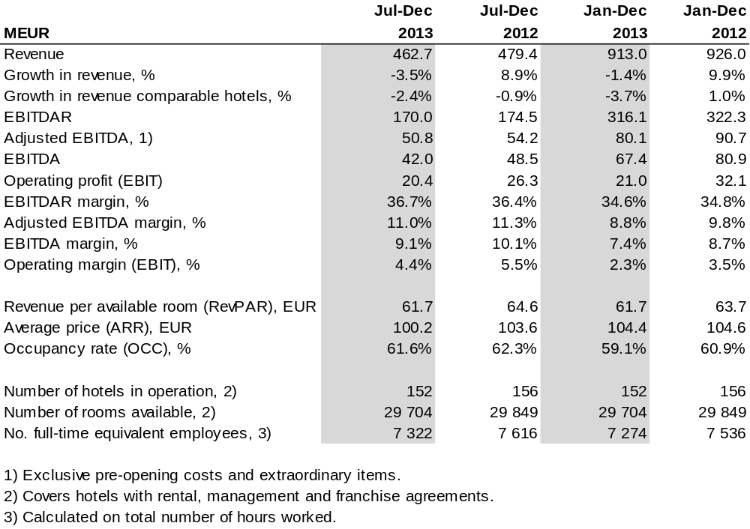

Market trends
During the first half of the year, the Nordic markets made slow progress, affected by continued economic instability, fewer major congresses compared with 2012 and new hotels bringing additional room capacity, all of which has led to lower occupancy rates. There are, however, considerable variations between countries. The weakest trend has been noted in Finland, where the general downturn in the economy has had a negative impact on demand for hotel nights, while in Denmark the market showed good growth in the second half of the year, partly driven by congresses in Copenhagen.

Results January–December 2013
Revenue per available room (RevPAR) was down 3.1%. For comparable hotels and at a fixed exchange rate, RevPAR fell by 3.2%. RevPAR has been affected negatively by the availability of fewer sellable rooms due to the extensive refurbishment programme, which means more rooms than usual being refitted during 2013–2014. In addition, occupancy has been affected negatively by reduced distribution capacity as a result of terminating partnerships with certain OTA’s (Online Travel Agencies) and distributors, which led to reduced volumes primarily in the leisure segment and particularly during the summer months. These distribution agreements were, however, renegotiated in Q4 2013 and production has since returned to normal.

Growth compared with the previous year
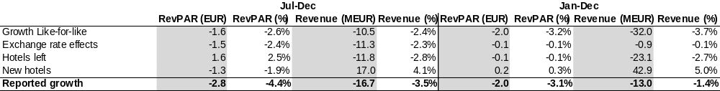

Revenue fell 1.4% to EUR 913.0 (926.0) million. The six new hotels that opened in 2012 and this year’s openings in Malmö, Kristiansand and Visby jointly brought revenue growth of 5.0%. For comparable hotels and at a fixed exchange rate, revenue fell by 3.7%. The fall is attributable to both lower accommodation income (reduced room capacity and lower occupancy) and lower earnings from restaurants and conferences, with the lower guest volume also impacting negatively on breakfast and restaurant revenue. Demand for meetings and conferences has remained stable over the year and conference revenue shows growth compared with the previous year, driven by the new conference hotels. Restaurant and conference revenue accounted for 32 (31)% of total revenue.
The adjusted EBITDA came in at EUR 80.1 (90.7) million, giving a margin of 8.8 (9.8)%. A continued focus on cost-efficiency, exploiting economies of scale in purchasing and operations, a high proportion of variable costs, plus variable rents have helped keep margins up despite a drop in revenue compared with the previous year.
Opening costs for new hotels amounted to EUR 2.1 (7.1) million. Items affecting comparability total EUR -10.6 (-2.7) million, including development costs for the new hotel chain HTL, decommissioning costs for hotels leaving the system and restructuring costs.

Key events
Scandic is continuing its expansion in the Nordic market with a focus on larger hotels with city centre locations and a stronger position in the conference segment. During the year, two meeting and conference hotels were added to the portfolio: in January Scandic took over operation of Triangeln in Malmö, Sweden, and June saw the opening of Scandic Bystranda in Kristiansand, Norway, a hotel that focuses on families and leisure travellers in the summer and conferences in the winter. A franchise agreement was also signed with Gotland’s largest hotel, which was rebranded to Scandic Visby in June. The refocusing of the Group as the largest hotel operator in the Nordic region involved non-strategic hotel operations in Estonia being divested to other owners and operators in April 2013. A total of 829 rooms were added to the portfolio over the year, while seven hotels with a total of 974 rooms left the chain.
In September 2013, Scandic launched a new hotel chain – HTL. Two hotels are scheduled to open in Stockholm, in 2014 and 2015 respectively. The concept for the new chain, city compact hotels, is to offer the best city centre locations at the best prices, with smart digital solutions and quality design features. HTL is aimed at a new generation of travellers and meets a growing demand within a new market segment. Similar initiatives have emerged internationally, and now Scandic is securing its position in the Nordic market by broadening its offer and introducing a new hotel concept. The aim is to establish 20 HTL’s in the largest Nordic cities within five years.
In 2012, Scandic launched a major refurbishment programme together with property company Pandox, which involves upgrading and improving 40 hotels in Sweden, Norway and Finland. Just over half of these are roadside hotels, while the others have city centre locations. During 2013, the refurbishment work led to reduced room capacity, which had a negative impact on revenue and profits. As of December 2013, around 60% of the total investment programme had been completed. The hotels that were newly refurbished during the year received a superb response from guests and have helped keep Scandic’s customer satisfaction index rising. The refurbished rooms are expected to contribute towards increased revenue per available room.

On 15 October 2013, Frank Fiskers became the new President & CEO.

Sustainability
Scandic’s environmental impact per guest per night continued to decrease during 2013. The focus on food waste is yielding clear results, as illustrated by the figures for unsorted waste. As a consequence of a rise in energy consumption early in the year, measures were put in place that resulted in reduced consumption by the end of the year. Scandic Denmark received the Bevica Foundation’s Accessibility Prize 2013 for the way Scandic makes hotels accessible to everyone, whatever their needs. During the year, the world’s first web-based training on sustainability was launched for both team members and the general public. Scandic in Norway was awarded Debio’s bronze label for its focus on organic breakfast. No other hotel chain has such a large proportion of Nordic Ecolabelled hotels, and Scandic has a total of 129 hotels with some form of ecolabelling.
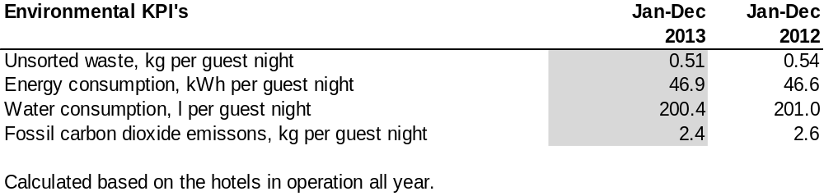

For further information, please contact:

Frank Fiskers

President & CEO

Tel: +46 8 517 350 11

Gunilla Rudebjer

CFO

Tel: +46 8 517 351 64

gunilla.rudebjer@scandichotels.com

Find out more at www.scandichotels.com

