FOR IMMEDIATE RELEASE

PACCAR Achieves Record Annual Revenues and Net Income
PACCAR Celebrates 80th Consecutive Year of Profits

January 29, 2019, Bellevue, Washington – “PACCAR reported record annual revenues and profitability in 2018 and has achieved an impressive 80 consecutive years of net income,” said Ron Armstrong, chief executive officer. “PACCAR’s financial results reflect the company’s premium-quality products and services, record heavy-duty truck market share in Europe, strong global truck markets, and record aftermarket parts results. I am very proud of our 28,000 employees who have delivered outstanding products and services to our customers.”

“The North American and European economies are projected to continue growing in 2019. Our customers are very profitable and benefiting from strong freight demand. Freight activity grew 6.6% percent in the U.S. in 2018, the highest growth in 20 years. Kenworth and Peterbilt’s 2019 build schedules are substantially full due to the robust orders. We expect 2019 to be another excellent year for PACCAR,” added Armstrong.

PACCAR achieved record quarterly revenues of $6.28 billion in the fourth quarter 2018, a 15% increase compared to the $5.45 billion reported in the same period in 2017. The company earned $578.1 million ($1.65 per diluted share) in the fourth quarter of 2018. PACCAR earned $589.2 million ($1.67 per diluted share) in the fourth quarter of 2017, including $173.4 million of net tax benefits resulting from changes to U.S. tax law. Excluding the one-time tax benefits, PACCAR reported adjusted net income (non-GAAP)¹ of $415.8 million ($1.18 per diluted share) in the fourth quarter of 2017.

PACCAR achieved record revenues of $23.50 billion in 2018, a 21% increase compared to revenues of $19.46 billion in 2017. The company earned a record $2.20 billion ($6.24 per diluted share) in 2018, 31% higher than the $1.68 billion ($4.75 per diluted share) earned in 2017. PACCAR’s 2018 net income of $2.20 billion increased 47% compared to 2017 adjusted net income (non-GAAP) of $1.50 billion ($4.26 per diluted share).

Increased Dividends and Share Repurchases
PACCAR declared cash dividends of $3.09 per share during 2018, a 41% increase compared to the $2.19 per share declared in 2017. Dividends declared in 2018 included a $2.00 per share extra cash dividend paid in January 2019. PACCAR has increased its regular quarterly dividend an average of 11% per year during the last 20 years. PACCAR’s Board of Directors approved in December 2018 an additional 14% increase in the regular quarterly dividend to $.32 per share beginning in the first quarter of 2019. “PACCAR has delivered annual dividends, including regular quarterly and extra cash dividends, totaling approximately 50% of net income for many years,” said Harrie Schippers, PACCAR president and chief financial officer. “PACCAR’s total dividend yield, including regular quarterly and extra cash dividends declared in 2018, was an excellent 5.4% as of December 31, 2018.”

PACCAR repurchased 5.85 million of its common shares for $354.4 million during 2018. PACCAR’s Board of Directors approved the repurchase of $300 million of its outstanding common stock in July 2018, and the repurchase of an additional $500 million of its common stock in December 2018. Stock repurchases of $539.9 million are remaining under these authorizations.

Business Highlights – 2018
- PACCAR delivered a record 189,100 vehicles worldwide.
- DAF achieved record above 16-tonne market share of 16.6% in Europe, compared to 15.3% in 2017.
- DAF earned the prestigious International Truck of the Year 2018 award, and was honored with national Truck of the Year awards in the U.K., Poland, Slovakia and Slovenia.
- PACCAR participated in the CES 2018 and 2019 shows in Las Vegas, Nevada, exhibiting Peterbilt autonomous Model 579, Peterbilt electric Model 579, Peterbilt electric Model 220 and Kenworth zero emission, hydrogen fuel cell electric T680 trucks.
- DAF introduced CF Electric, LF Electric and CF Hybrid vehicles at the IAA 2018 truck show in Hannover, Germany.
- DAF was honored with the Computable Award 2018 in The Netherlands for its 3D Truck Configurator web application.
- Peterbilt and Kenworth were recognized as top workplaces for women by Women in Trucking, an organization that promotes the employment and success of women in the trucking industry.
- DAF Brasil increased its market share in the above 40-tonne truck segment to 6.7%, and earned the Truck Brand of the Year honor for the third consecutive year by the Brasilian national dealer association, Fenabrave.
- Peterbilt in Denton, Texas, the PACCAR engine factory in Columbus, Mississippi and PACCAR Ste-Thérèse, Canada each earned a prestigious Manufacturing Leadership Award from Frost & Sullivan, a leading industry research firm.
- PACCAR achieved an elite “A” rating from CDP for its environmental practices.

Financial Highlights – Fourth Quarter 2018
Highlights of PACCAR’s financial results during the fourth quarter of 2018 include:
- Record quarterly net sales and revenues of $6.28 billion.
- Record quarterly worldwide deliveries of 50,400 trucks.
- Net income of $578.1 million, 9.2% after-tax return on revenues.
- Record PACCAR Parts revenue of $970.9 million.
- PACCAR Parts pretax income of $193.8 million, 20.0% pre-tax return on revenues.
- PACCAR Financial Services earned $87.2 million.
- Research and development expenses of $80.5 million.
- Capital investments of $135.1 million.

Financial Highlights – Full Year 2018
Highlights of PACCAR’s financial results during 2018 include:
- Record net sales and revenues of $23.50 billion.
- Record net income of $2.20 billion, 9.3% after-tax return on revenues.
- Record PACCAR Parts revenue of $3.84 billion.
- Record PACCAR Parts pretax income of $768.6 million.
- Record Financial Services new business volume of $5.23 billion.
- Financial Services pretax income of $305.9 million.
- Cash provided by operations of $2.99 billion.
- Dividends declared of $1.08 billion.
- Medium-term note issuances of $2.21 billion.
- PACCAR invested $743.2 million in capital projects and research and development.
- Record year-end stockholders’ equity of $8.59 billion.
- After-tax return on equity of 27.3%.

Global Truck Markets
“Strong GDP, industrial production and consumer spending growth in 2018 resulted in record freight tonnage, high fleet capacity utilization and record Kenworth and Peterbilt truck orders, deliveries and backlog,” said Preston Feight, PACCAR executive vice president. Class 8 truck industry retail sales in the U.S. and Canada were 285,000 units in 2018, 30% higher than the 218,000 vehicles sold in 2017. U.S. and Canada Class 8 truck industry retail sales are expected to increase to a range of 285,000-315,000 trucks in 2019.

European truck industry registrations above 16-tonnes were a robust 319,000 trucks in 2018. It is estimated that European truck industry registrations in the above 16-tonne market in 2019 will be another excellent year in the range of 290,000-320,000 trucks. “European transport activity and truck demand have been strong due to five consecutive years of steady European economic growth,” said Harry Wolters, DAF president. “DAF produced a record number of trucks and achieved record above 16-tonne market share of 16.6% in 2018. DAF trucks, including the DAF XF and CF ‘International Truck of the Year 2018,’ deliver premium quality, exceptional fuel efficiency and superior driver comfort for our customers.”

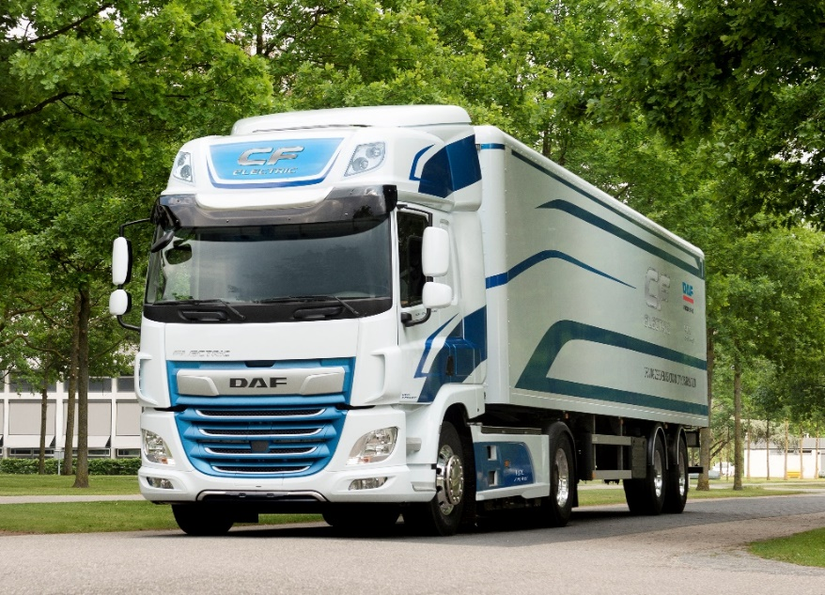
DAF CF Electric Truck

“PACCAR achieved excellent 2018 truck production and market share in Australia, Mexico, Taiwan and Brasil, delivering 17,300 trucks in these markets and surrounding regions,” said Gary Moore, PACCAR executive vice president. DAF Brasil was honored in 2018 by Fenabrave, Brasil’s industry dealer association, as Truck Brand of the Year for the third consecutive year.

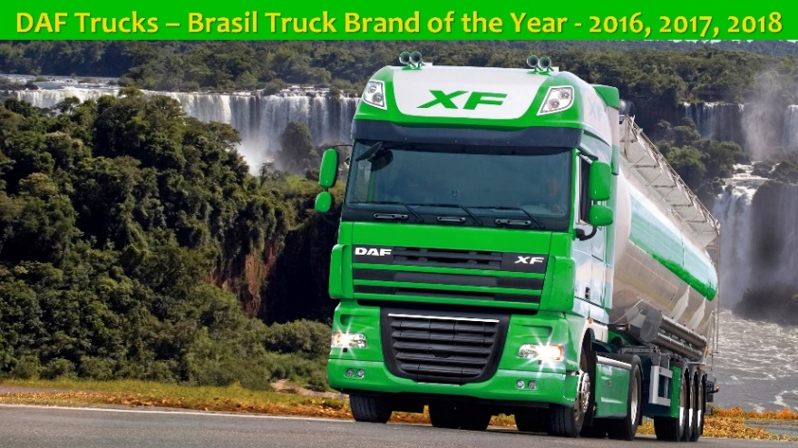

PACCAR Displays Innovative Electric and Hydrogen Fuel Cell Trucks at CES 2019
PACCAR participated in the CES 2019 show in Las Vegas, Nevada this month. CES is one of the world’s largest showcases for technological innovation. PACCAR exhibited three zero emission vehicles: a battery electric Peterbilt Model 579EV; a battery electric Peterbilt Model 220EV; and a hydrogen fuel cell electric Kenworth T680 developed in collaboration with Toyota. These trucks are designed for a range of customer applications, including over-the-road transportation, port operations and urban distribution. PACCAR was the only commercial vehicle manufacturer displaying trucks at CES.

Kenworth, Peterbilt and DAF are leaders in the development of alternative powertrain commercial vehicles. Kenworth, Peterbilt and DAF are field-testing battery electric, hydrogen fuel cell and hybrid powertrain vehicles with customers in North America and Europe. “PACCAR is excited about the opportunity to create the next generation of powertrains that will continue the company’s environmental leadership and enhance our customers’ operations,” said Landon Sproull, PACCAR vice president.

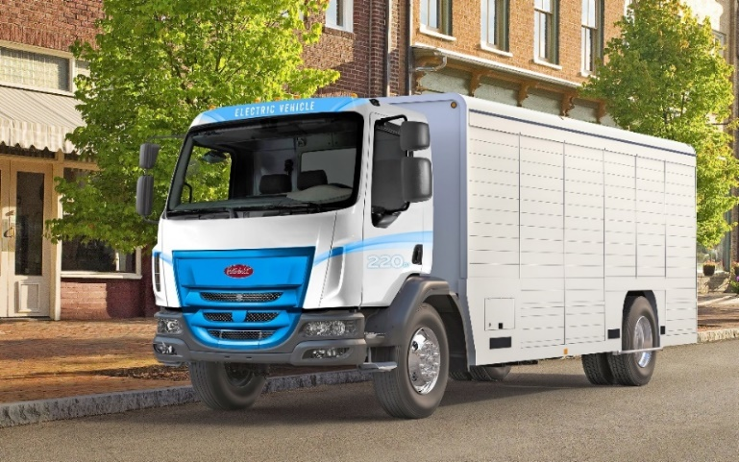
Peterbilt Model 220 Electric Truck

Kyle Quinn, PACCAR chief technology officer, noted, “PACCAR is investing in next generation technology across its portfolio of industry-leading products and services. The PACCAR Innovation Center in Silicon Valley, California enhances the company’s access to emerging technologies and talent from around the world. CES is an outstanding forum to showcase PACCAR’s advanced engineering leadership.”

PACCAR Parts Achieves Record Results
PACCAR’s aftermarket parts business achieved strong fourth quarter pre-tax income of $193.8 million, 24% higher than the $156.2 million earned in the fourth quarter of 2017. Fourth quarter 2018 revenues were a record $970.9 million, compared to $877.2 million reported in the fourth quarter of 2017. PACCAR Parts achieved record annual pre-tax income of $768.6 million, 26% higher than the $610.0 million earned in 2017. Annual revenues were a record $3.84 billion, 15% higher than the $3.33 billion in revenues in 2017. David Danforth, PACCAR vice president and PACCAR Parts general manager, noted, “PACCAR Parts’ revenue and profit growth has been driven by investments in distribution and technology, initiatives such as TRP all-makes parts, TRP stores and a growing population of Kenworth, Peterbilt and DAF trucks, powered by PACCAR engines. PACCAR Parts’ excellent long-term profit growth has enhanced the stability of PACCAR’s earnings throughout the business cycle.”

PACCAR Parts’ 18 Distribution Centers (PDCs) support over 2,200 DAF, Kenworth and Peterbilt dealer locations to deliver industry-leading customer service. PACCAR opened a new 160,000 square-foot distribution center in Toronto, Canada in 2018 to enhance parts availability for customers in eastern Canada.

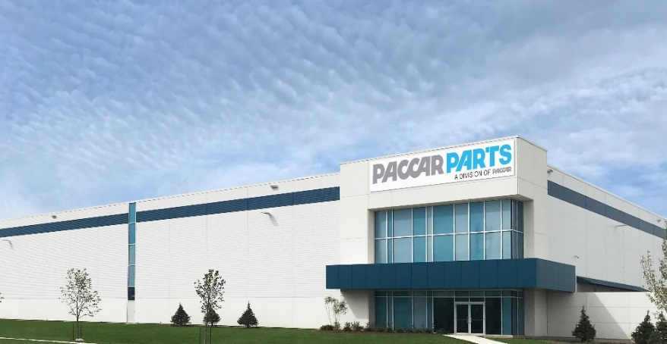
PACCAR Parts Distribution Center in Toronto, Canada

Increased Investments in Products, Technologies and Aftermarket Support
PACCAR’s consistent long-term profits, strong balance sheet, and intense focus on quality, technology and productivity have enabled the company to invest $6.1 billion in new and expanded facilities, innovative products and new technologies during the past decade. Capital investments of $437.1 million and research and development expenses of $306.1 million in 2018 were invested in new vehicles and technologies, enhanced manufacturing and parts distribution facilities and innovative aftermarket support programs. George West, PACCAR vice president, said, “We are increasing our capital and research and development investments in 2019. Capital expenditures are projected to be $525-$575 million and research and development expenses are estimated to be $320-$350 million. PACCAR is investing for long-term growth in new truck models, integrated powertrains including zero emission electrification and hydrogen fuel cell technologies, enhanced aerodynamic truck designs, advanced driver assistance systems and truck connectivity, and expanded manufacturing and parts distribution facilities.”

PACCAR Achieves Elite “A” Score from CDP for Environmental Management
PACCAR has been honored as a global leader in environmental practices by environmental reporting firm CDP, earning recognition on the 2018 CDP Climate Change A List. Every year, over 6,000 companies disclose data about their environmental impacts, risks and opportunities to CDP for independent assessment. Reporting companies receive scores of A to D- rating their effectiveness in tackling climate change and other environmental issues. “Environmental leadership is one of PACCAR’s core values. We are proud to earn a CDP score of ‘A,’ which places PACCAR in the top 2% of reporting companies,” said Darrin Siver, PACCAR senior vice president. PACCAR’s 2018 CDP report is available to the public at www.cdp.net.

Financial Services Companies Achieve Good Results
PACCAR Financial Services (PFS) has a portfolio of 198,000 trucks and trailers, with total assets of $14.40 billion. PacLease, a major full-service truck leasing company in North America and Europe with a fleet of over 39,000 vehicles, is included in this segment. PFS achieved fourth quarter 2018 pretax income of $87.2 million, a 21% increase compared to the $71.9 million earned in the fourth quarter of 2017. Fourth quarter 2018 revenues were $347.0 million compared to $332.2 million in the same quarter of 2017. PFS earned $305.9 million of pretax profit in 2018, 17% higher than the $261.7 million earned in 2017. PFS revenues were $1.36 billion in 2018, 7% higher than the $1.27 billion achieved in 2017.

“PFS’ excellent portfolio performance and increased earning assets contributed to very good results in 2018,” said Bob Bengston, PACCAR senior vice president. “Industry demand for used trucks in the U.S. is strong. Kenworth and Peterbilt truck resale values continue to command a 10-20% premium over competitors’ trucks.”

“PACCAR’s strong balance sheet, complemented by its A+/A1 credit ratings, enables PFS to offer competitive retail financing to Kenworth, Peterbilt and DAF dealers and customers in 24 countries on four continents,” said Todd Hubbard, PACCAR Financial Corp. president. “PACCAR Financial Services has excellent access to the debt markets, issuing $2.21 billion in two-, three-, four- and five-year term notes during 2018.”

PACCAR is a global technology leader in the design, manufacture and customer support of high-quality light-, medium- and heavy-duty trucks under the Kenworth, Peterbilt and DAF nameplates. PACCAR also designs and manufactures advanced diesel engines, provides financial services and information technology, and distributes truck parts related to its principal business.

PACCAR will hold a conference call with securities analysts to discuss fourth quarter earnings on January 29, 2019, at 9:00 a.m. Pacific time. Interested parties may listen to the call by selecting “Q4 Earnings Webcast” at PACCAR’s homepage. The webcast will be available on a recorded basis through February 8, 2019. PACCAR shares are traded on the Nasdaq Global Select Market, symbol PCAR. Its homepage is www.paccar.com.

This release contains “forward-looking statements” within the meaning of the Private Securities Litigation Reform Act. These statements are based on management’s current expectations and are subject to uncertainty and changes in circumstances. Actual results may differ materially from those included in these statements due to a variety of factors. More information about these factors is contained in PACCAR’s filings with the Securities and Exchange Commission.

See attached supplementary information for non-GAAP financial measures.

