PRESS RELEASE
Rototilt Group AB, Vindeln, 21 September 2016
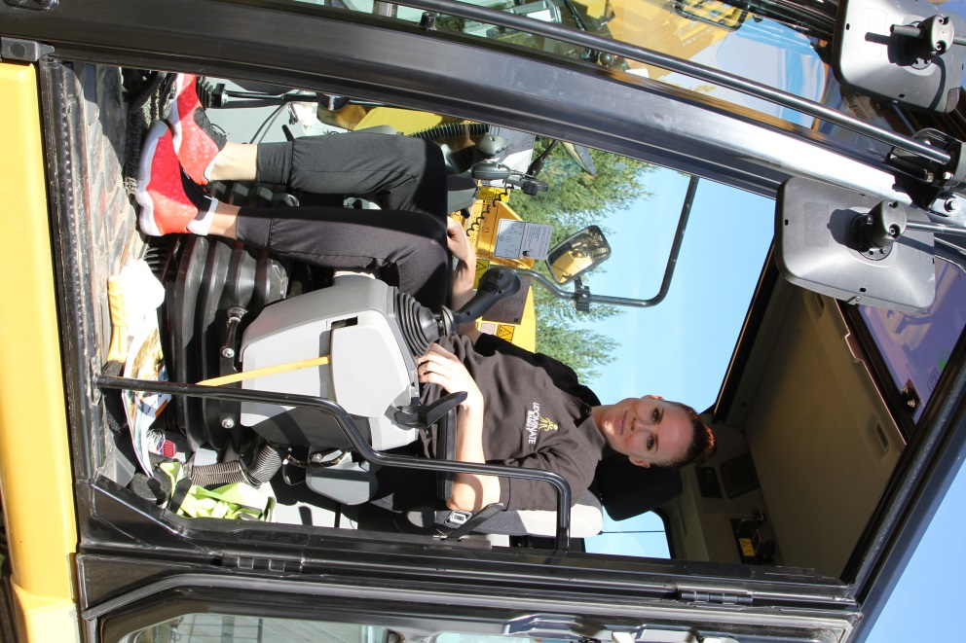
Rototilt Group and Udominate Basket continue to go for gold
Vindeln company, Rototilt Group, continues as the main sponsor of Udominate Basket during the 2016/2017 season of the Swedish Professional Women’s Basketball League. “This autumn, Udominate started an exciting journey with high ambitions, a journey that closely resembles our own in many ways,” says Per Väppling, Sales and Marketing Manager at Rototilt Group AB.
Becoming a sponsor for Udominate was a strategic decision taken in the spring of 2015, to coincide with a move to become wholly independent from Indexator, and a change of the company name to Rototilt Group AB. Udominate stands for equality, diversity and professionalism at all levels and as a progressive employer we immediately identified with these qualities.
“Udominate is in the middle of a journey to the very top, which is something we want to be part of,” says Per Väppling. “We share values and highly ambitious goals; Udominate is aiming for Swedish Championship gold and the European Cup, while Rototilt is determined to develop its world-leading position and establish itself internationally”.
“Diversity and equality are strengths that contribute to success. This applies both at the workplace and in sports”.
“We see a bright future and are fully focused on growth, which is why it is vital for us to retain our skilled employees, as well as entice more skilled and competent men and women to our company”, states Peter Strömberg, Personnel Manager at Rototilt Group AB. “Through our association with Udominate, Rototilt draws inspiration and direct benefit from their outstanding teamwork, ambassadors and role models. Additionally, over the past year, we have enjoyed a successful partnership with Udominate at both the Uniaden career fair in Umeå as well as at our Open House Days that celebrated our tiltrotator’s 30th anniversary,” adds Peter.
Prior to the start of the season, planning of joint activities for Rototilt and Udominate has been fully underway. A decision has already been reached for Udominate to play a league game, in Vindeln, on 9 October. An activity for all of the employees has also been planned at the company.
“We are incredibly happy that Rototilt is continuing to collaborate with Udominate and we are proud that they, in particular, want to follow along on our fantastic basketball journey,” says Lisa Åström, Sales and Marketing Manager for Udominate Basket. Rototilt is a powerful company that continues to conquer the world; a company focused on its goals, where diversity and equality are two of the most important cornerstones. These cornerstones are something that we, as an organisation, also strive for,” concludes Lisa Åström.

For more information, contact:
Per Väppling, Rototilt Group AB, +46 70 347 22 54, per.vappling@rototilt.com
Lisa Åström, Udominate Basket, +46 70 606 08 10, lisa@udominatebasket.com

Rototilt Group AB is a world-leading manufacturer of tiltrotators, accessories and systems. With Rototilt®, we are breaking new ground for construction equipment, by turning excavators into fully fledged tool carriers.

