Digital Yacht launch NavLink US
marine charting app for iPhone and iPad navigation afloat
Just $19.99 and now available in the app store
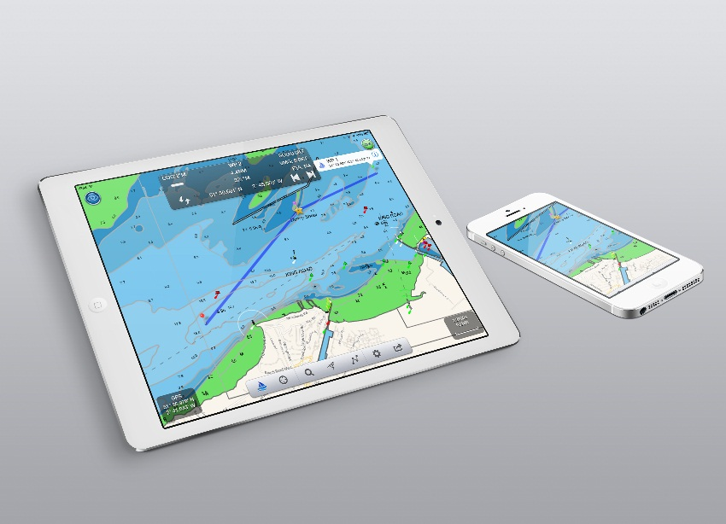
BOSTON, February, 2014

Digital Yacht have launched a new low cost marine charting app for the iPad and iPhone called NavLink US

With NavLink, you can explore, plan and navigate your boating trips in real time and in high resolution using the latest NOAA digital vector marine charts covering the whole of the US which are included with the $19.99 app.

Whilst using an iPad and NavLink is an attractive alternative to the cost of a dedicated touchscreen chart plotter, it does not compromise on features. Charts can be presented north up or course up and routes and waypoints are created and edited using a simple touch screen interface. Real time navigation shows your current position, track, course, speed, ETA, VMG, bearing and distance to next waypoint. There’s a simple A-B chart ruler too and you can tap on an object such as a buoy or nav-aid and get a pop up data window of its characteristics. Its sharp, high-definition display enables simple zooming on detailed vector format charts, as well as allowing chart data to be layered and therefore de-cluttered.

It’s also designed to work seamlessly with Digital Yacht’s NMEA to WiFi devices so will integrate with your boat’s GPS and AIS systems. If AIS data is available, you’ll see AIS targets overlaid with all their identity information and a heading line as well as alarms for CPA and TCPA.

Utilising your on board GPS with these wireless servers means you don’t need a GPS enabled iPad. Even if your device is GPS enabled, it significantly reduces battery drain when using an external source. It also means your iPad/Phone can be used below deck and generally, the boat’s GPS is superior for marine based navigation.

Other advanced features include tidal information, weather data from weather buoys showing current local conditions such as wind speed and direction and swell and full route planning capability with sharing – useful for keeping all the crew updated!

NavLink also helps with your watch keeping and lookouts. In its unique HorizonView mode, you can use the camera on the iPad to scan the horizon. You’ll get an overlay on the camera screen of nav-aids, AIS targets and waypoints which serves as a great visualisation tool.

NavLink is priced at just $19.99 including detailed US charts. Further details from Digital Yacht TEL 978 277 1234 or visit www.digitalyachtamerica.com or the Apple app store

-Ends-
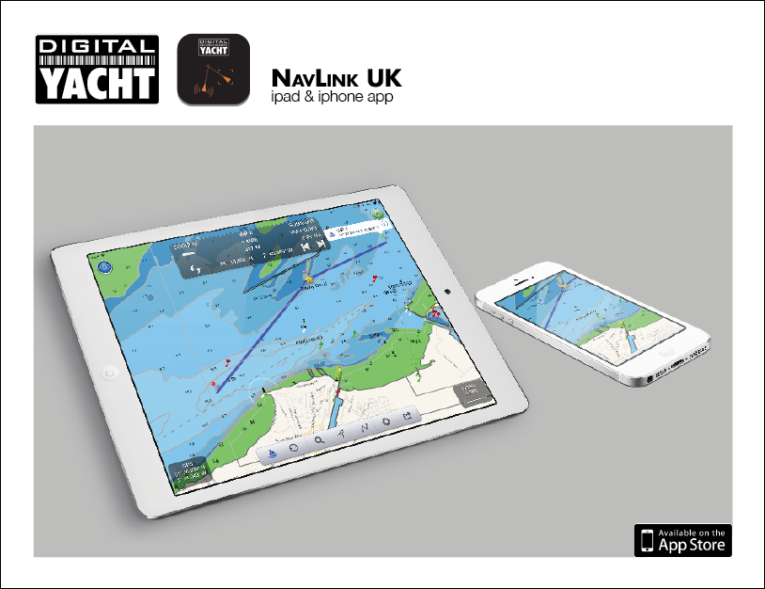
Digital Yacht – Note’s For Editors
Digital Yacht is a UK based manufacturer of specialist marine electronics. We produce a range of innovative products including AIS receivers and transponders, WiFi servers for on board NMEA data, long range WiFi internet devices and a range of sensors including GPS and electronic compasses. Digital Yacht won the prestigious METS DAME Electronic Product Award for iAIS as well as the NMEA Technology Award for BOATraNet in 2011. The GPS150 was nominated for a DAME award at this year’s 2013 exhibition in November
For further information, please contact:

Nick Heyes (Direct Line + 44 207 100 9116)

Digital Yacht Ltd.The Technology Centre, Green Lane, Failand, Bristol. BS8 3TR. UK.
Telephone: +44 (0)1179 554474
Email: sales@digitalyacht.co.uk www.digitalyacht.co.uk

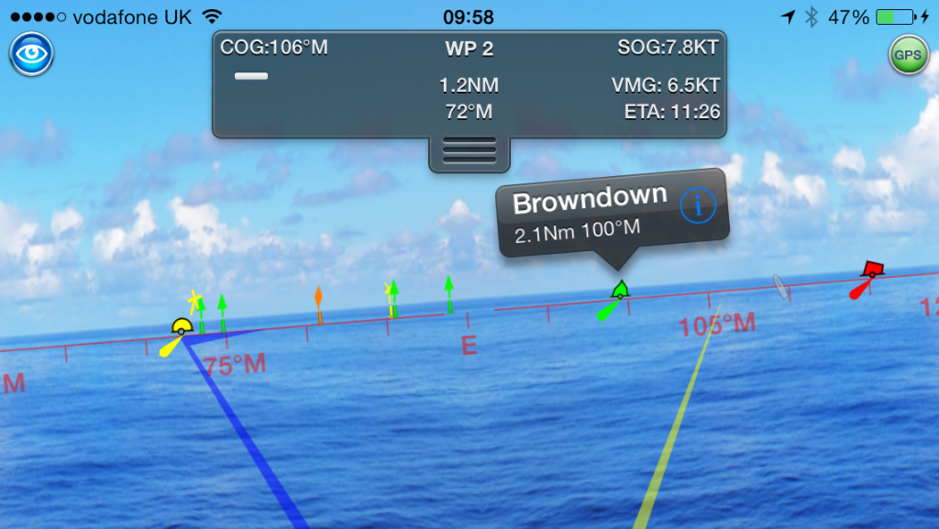
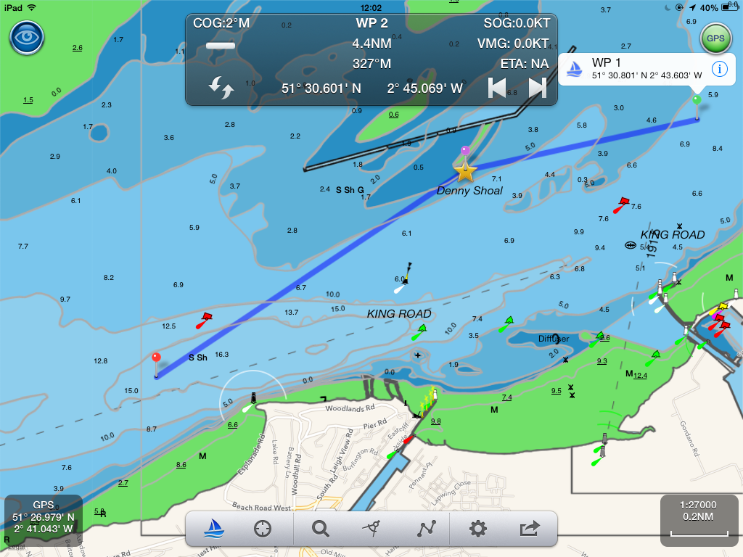
Additional Images – please visit our press room at www.digitalyachtamerica.com for a great selection
In HORIZONcVIEW you can utilise the iPad camera to scan the horizon. Active waypoints, AIS targets and navaids are overlaid onto the camera display creating an easy to understand visual landscape
In NAVIGATION view you can see your current route and active waypoint (indicated with a star). The data window shows waypoint bearing and distance, course, ETA and VMG and the arrow keys allow you to jump to the next or previous waypoint.

