Bureau Veritas issues Approval in Principle for Kongsberg Maritime’s DP Digital Survey application
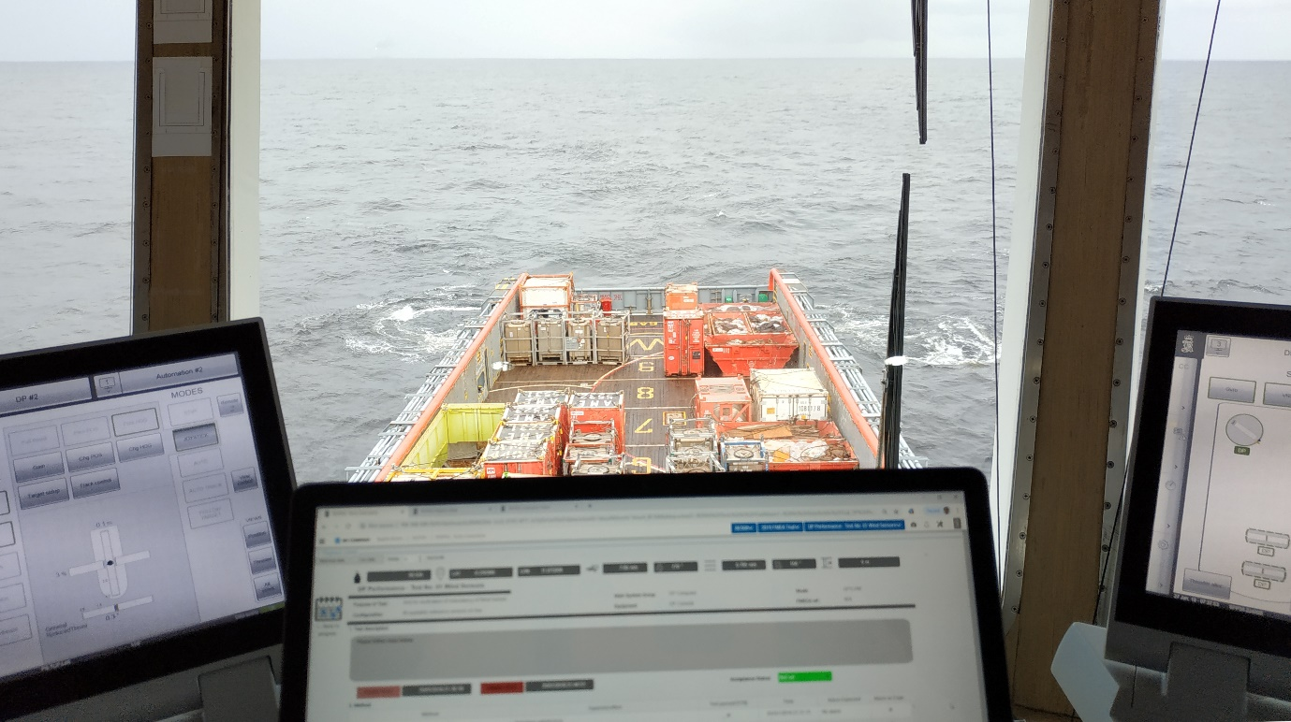
Kongsberg Maritime’s Dynamic Positioning Digital Survey application has been recognised by
leading classification society Bureau Veritas
Kongsberg, Norway, 26th August 2020 – Following two years of careful development and thorough trialling, Kongsberg Maritime’s Dynamic Positioning Digital Survey (DPDS) application has been endorsed by Bureau Veritas (BV) through their designation ‘Approval in Principle’.
In the wake of last year’s successful pilot trials, conducted with the assistance of offshore service provider BOURBON Offshore (https://bit.ly/3f8zGyU), BV and Kongsberg Maritime have been working in close collaboration to leverage the insights derived from the initial installation. BV is now allowing vessel owners and operators to conduct DP Annual trials using the DPDS application. Kongsberg Maritime has also used this time to prepare and equip for widespread delivery.
The DPDS application uniquely digitises all the data derived from the DP Annual tests, carried out in accordance with IMO MSC Circ 1580 guidelines and IMCA M 190, to verify the performance and redundancy of the vessel-specific DP system. This encompasses the complete installation necessary for dynamically positioning a vessel, comprising, but not limited to, the following sub-systems: power system, thruster system and DP control system.
Running on a validated, industrial data recording and management platform that provides incomparable data quality and consistency, the KM DPDS application provides access to data acquired directly from the DP system. The data is transferred to class surveyors via KONGSBERG’s secure cloud infrastructure upon completion of the trials. The surveyor can then play back the DP Annual trial program onshore, based on the high-quality DP data accumulated. Each test is unique and can be played back individually. Surveys can be carried out at any time from any location once the data is uploaded to the KM cloud.
This data-driven aspect of the application is of particular value for ship owners, who can use the digital survey tool to collate and present concrete evidence that the necessary test procedures have been carried out and completed.
Thanks to maintenance management system interfaces and tamper-proof image upload functionality, the test visualisation provided by the DPDS application is far superior to the paper-based evidence collection – complete with photo and video recordings – which has tended to act as the industry norm for many years.
“The benefits of the DPDS application to vessel owners are numerous,” says Egil Haugsdal, President, Kongsberg Maritime. “The digital survey tool enables substantial savings to be made because far less time needs to be spent off-hire, and it obviously removes the requirement to cover travel expenses for surveyors. It can also improve crew competence, simplifying DP Annual trials and making the approval process far more efficient and straightforward.
“Furthermore, as the application is essentially an add-on to our existing K-IMS application suite, it’s easy for vessels to integrate and deploy DPDS.”
Bureau Veritas’ own progress in the digitalisation of surveys has seen the development of an additional BV class notation, DDPS (Digital Dynamic Positioning Survey), an addition to the existing DYNAPOS notation. “It should be very apparent that BV approval is not issued lightly. The DPDS application has met our stringent criteria to demonstrate compliance in principle with the BV additional class notation DDPS (Digital Dynamic Positioning Survey),” adds Laurent Leblanc, Vice-President and Marine Operations Director, Bureau Veritas. “The quality, detail and security of the transferred data have to meet our exacting standards, and we’re satisfied to confirm that the KM DPDS application fulfils its function admirably.”
Ends

For further information, please contact:
Gunvor Hatling Midtbø, VP Communication
Kongsberg Maritime
Tel: +47 9921 4209
gunvor.hatling.midtbo@km.kongsberg.com
David Pugh
Saltwater Stone
Tel: +44 (0)1202 669244
d.pugh@saltwater-stone.com

About Kongsberg Maritime
Kongsberg Maritime is a global marine technology company providing innovative and reliable ‘Full Picture’ technology solutions for all marine industry sectors including merchant, offshore, cruise, subsea and naval. Headquartered in Kongsberg, Norway, Kongsberg Maritime has manufacturing, sales and service facilities in 34 countries.
Kongsberg Maritime solutions cover all aspects of marine automation, safety, manoeuvring, navigation, and dynamic positioning as well as energy management, deck handling and propulsion systems, and ship design services. Subsea solutions include single and multibeam echo sounders, sonars, AUV and USV, underwater navigation and communication systems.
Training courses at locations globally, LNG solutions, information management, position reference systems and technology for seismic and drilling operations are also part of the company’s diverse technology portfolio. Additionally, Kongsberg Maritime provides services within EIT (Electro, Instrument & Telecom) engineering and system integration, on an EPC (Engineering, Procurement & Construction) basis.
Kongsberg Maritime is part of Kongsberg Gruppen (KONGSBERG), an international, knowledge-based group that celebrated 200 years in business during 2014. KONGSBERG supplies high-technology systems and solutions to customers in the oil and gas industry, the merchant marine, and the defence and aerospace industries.
Web: Kongsberg Gruppen | Kongsberg Maritime
Social media: LinkedIn | Twitter | Facebook

