STEELSERIES ANNOUNCES NEW DUAL WIRELESS CONTROLLER OPTIMIZED FOR GAMING ON ANDROID AND PC – THE STRATUS DUO

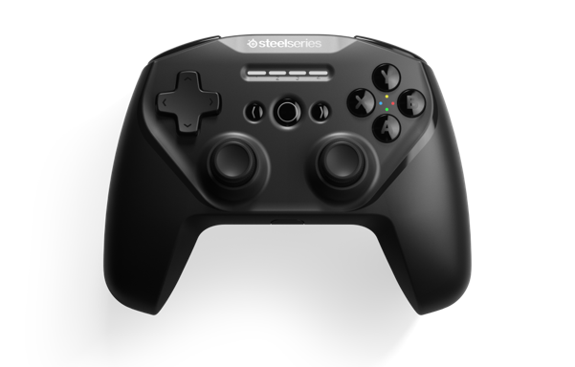
The Stratus Duo is easiest controller to quickly swap between playing on Android or PC.

CHICAGO – JANUARY 29, 2019 – SteelSeries, the global leader in gaming peripherals, today announced its newest full-size, multi-platform controller, the Stratus Duo. Gamers can swap between the low latency 2.4GHz wireless connection for gaming on Windows, and Bluetooth for mobile gaming on Android, Oculus Go and Samsung VR.

Gamers can utilize the Stratus Duo in multiple ways using the 2.4GHz wireless, Bluetooth and wired connections. With its Bluetooth connection, the Stratus Duo supports Android, Samsung Gear VR and Oculus Go. Gamers no longer need to struggle with awkward touchscreen controls while playing mobile games on their Android devices. The Stratus Duo allows gamers to enjoy playing on their Android device via Bluetooth or on their PC via the 2.4GHz wireless connection with no additional software needed for setup.

“The gaming ecosystem is continuing to evolve and grow beyond PC and consoles to include mobile devices and VR systems,” said Tino Solberg, SteelSeries CTO. “The Stratus Duo allows gamers to easily navigate across several platforms through wireless and Bluetooth technology to create a truly seamless experience.”

The 2.4GHz wireless receiver offers a solid, low latency plug-and-play connection for uninterrupted PC gaming. The controller is also Steam-enabled allowing users to play thousands of controller-enabled Steam games and enjoy full Steam Big Picture Mode and SteamLink support.

The Stratus Duo mirrors the familiar size and layout of console controllers, but sports an upgraded design from the Stratus XL with a new trigger design featuring Magnetic Hall Effect sensors that keeps triggers consistent and precise. The controller also includes high performance clickable analog joysticks that feature minimal dead zones and smooth operation. The controller is powered by a lithium ion battery for 20+ hours of play time and includes a Micro USB cable that is 1.8 meters/5.9 feet in length.

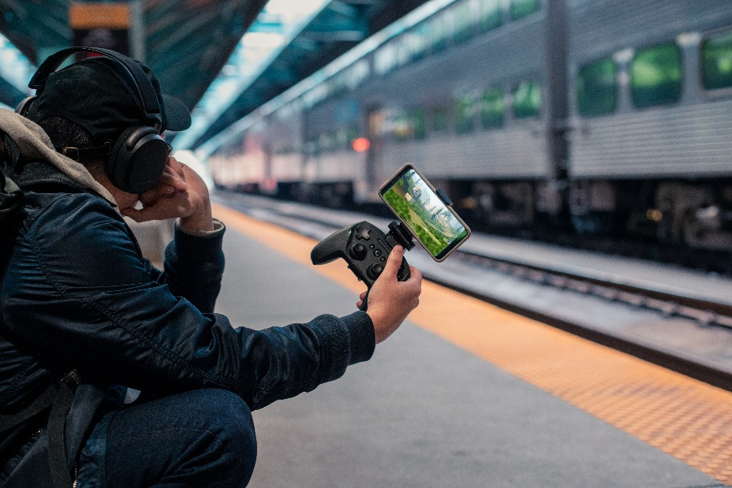

The Stratus Duo is also compatible with the new SteelSeries SmartGrip accessory. The SmartGrip is an adjustable phone mount that easily clips on to the Stratus Duo and holds gamers’ phones in place while gaming on the go. The SmartGrip will be available soon for $9.99.

With the addition of the Stratus Duo, SteelSeries has the most comprehensive lineup of mobile gaming controllers available. The line also includes the Stratus XL (Android) and the Nimbus (iOS/tvOS). The SteelSeries family of controllers will allow gamers to have the best possible gaming experience regardless of what platform they’re playing on.

The Status Duo is available now for $59.99/€69.99/$69.99 on www.steelseries.com.

For high-resolution images, click here.

# # #

About SteelSeries
SteelSeries is a leader in gaming peripherals focused on quality, innovation and functionality, and the fastest growing major PC gaming headset brand in the US. Founded in 2001, SteelSeries improves performance through first-to-market innovations and technologies that enable gamers to play harder, train longer, and rise to the challenge. SteelSeries is a pioneer supporter of competitive gaming tournaments and eSports and connects gamers to each other, fostering a sense of community and purpose. SteelSeries’ team of professional and gaming enthusiasts help design and craft every single accessory and are the driving force behind the company.

To learn more about SteelSeries’ products and esports partnerships, visit http://SteelSeries.com or follow us on social media for the latest updates at http://facebook.com/steelseries and be a part of the conversation on Twitter @SteelSeries.

Media Contacts:
Christian Cooper
SteelSeries
Christian.cooper@steelseries.com
(813) 447-0025

Patricia Nunez
Max Borges Agency
patricianunez@maxborgesagency.com
(305) 374-4404 x139

