Distribution: March 18
Embargo: Thursday, March 18 at 2:00pm CET / 9:00am ET/ 6:00am PT.

Prime Gaming is keeping the gaming deals going this March! Members can now claim new in-game content for Ubisoft’s Rainbow Six Siege and For Honor, along with loot Roblox and more! Additionally, this is the last chance to claim an epic lineup of 20+ SNK arcade games before they’re gone on March 31.

For a look at all the new content available with Prime Gaming, read on below!

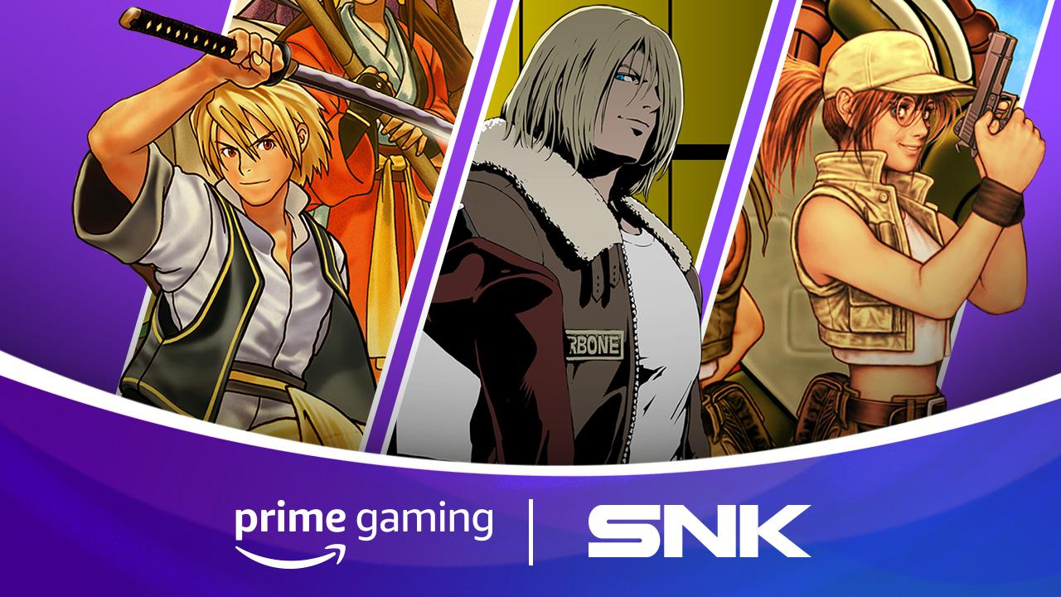

Last Chance to Claim 20+ SNK Games!
Prime Gaming members have until Wednesday, March 31 to claim 20+ games from the classic SNK arcade game library, with beloved titles such as Shock Troopers, Metal Slug 2, The King of Fighters 2000 and more available to keep forever! Whether you’re a longtime fan of SNK or a newcomer to these classics, be sure to claim these games before they’re gone.

Check-out the new last-chance sizzle video here and don’t forget to also check out the March Games with Prime lineup which includes Bomber Crew Deluxe, Blasphemous, SkyDrift, Boomerang Fu and Tengami.

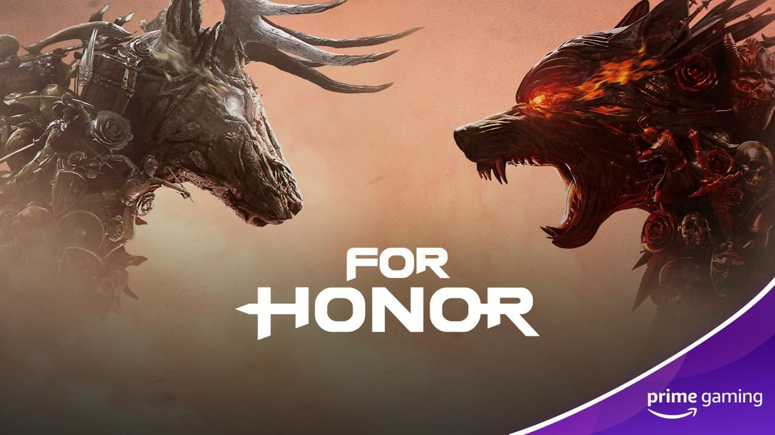 | 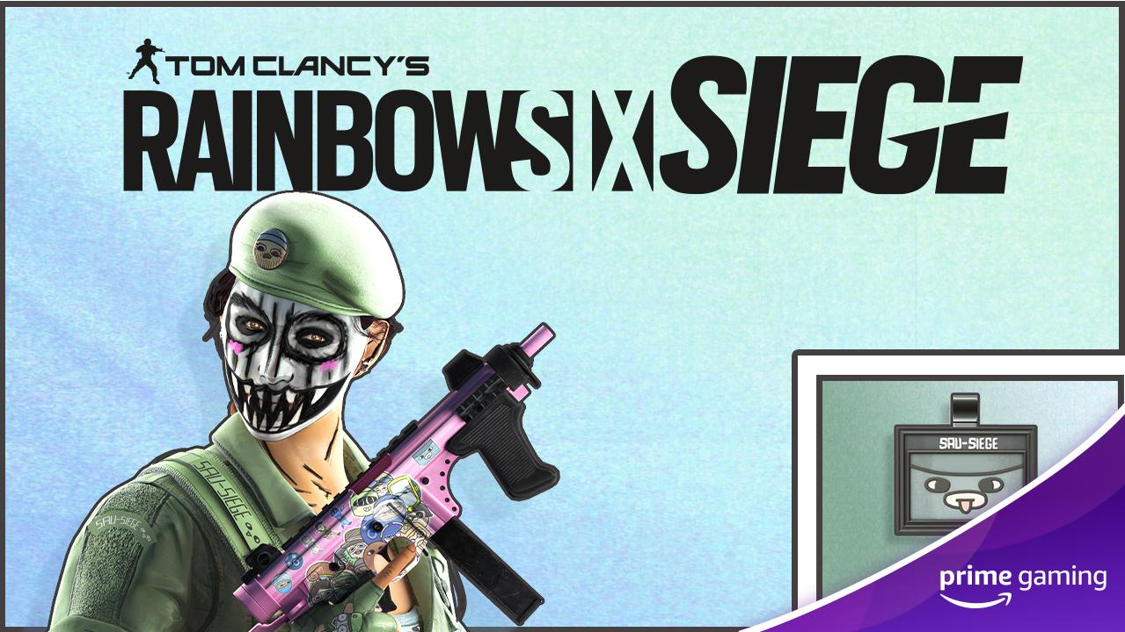
New Loot for Your Favorite Ubisoft Titles!
Check out the latest content available for Ubisoft’s popular games For Honor and Rainbow Six Siege!

For Honor (Drop 1) - Now Available - Unlock 7 Days of Champion Status (with XP boosts and more) plus receive two Scavenger Crates to take your heroes to the next level.

Rainbow Six Siege (Drop 4) - Available March 19 - Secure the exclusive Caveira Bundle designed by community artist SAU_SIEGE including new headgear, uniform, weapon skin and charm.

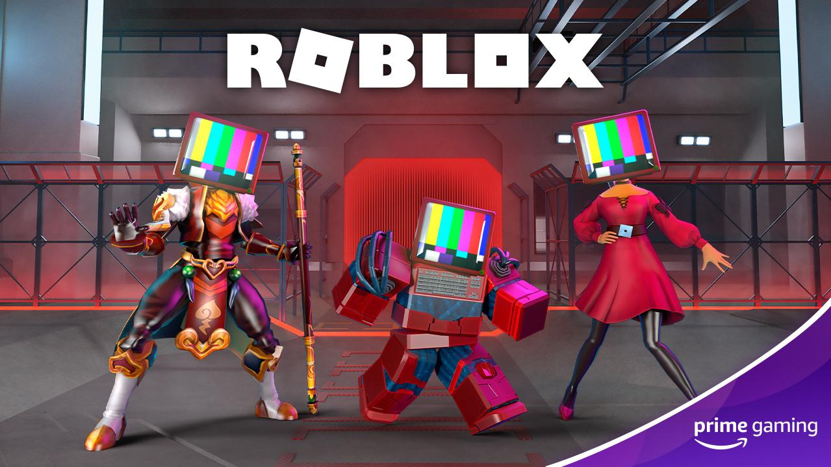
Gear Up with new Roblox exclusives!
Roblox (Drop 8) - Now Available - Prime members can gear up their Roblox avatar with a new Tech Head, along with an exclusive bonus skin in Arsenal. Be sure to act fast as this offer expires on April 16!

Lastly, Prime Gaming members can also claim new content for the following games:

- Apex Legends (Drop 3 of 12) - Now Available - Show everyone what Legends are made of with the Adrenaline Affliction skin for Octane!
- Rogue Company (Drop 6 of 12) - Now Available - Battle in style in the 4x4 team-based multiplayer shooter with the “The King” emote.
- UFC 4 (Drop 2 of 6) - Now Available - Shape your legend in EA SPORTS UFC 4 with exclusive vanity rewards - for Prime members. This March unlock the special Purple Tracksuit.
- Alliance vs Empire (Drop 2 of 12) - Now Available - Be sure to grab the following items: White Diamond x500; Emerald x50; Enhancement Guard Ticket x50; King's Blessing x2; and Benuv's Blessing x2.
- Trackmania (Drop 1 of 1) - Now Available - Be sure to redeem 3 months of Club Access for the ultimate track racing game Trackmania. This offer grants access to race on community created tracks, track creation and additional social features.
- V4 (Drop 1 of 12) - Available March 18 - Grab the Super Starter Pack and the Knight's Battle Horse (Rare Mount).
- Clash of Kings (Drop 1 of 13) - Coming Soon - Pick up a Building Enhancement Pack which includes 2-Hour Building Speedup x1000, 500,000 Food x500 and500,000 Wood x500.

All of these offers can be claimed by visiting gaming.amazon.com/home, while assets are available to download by visiting the link here.

