PRESS RELEASE
Vindeln, 16 October 2019
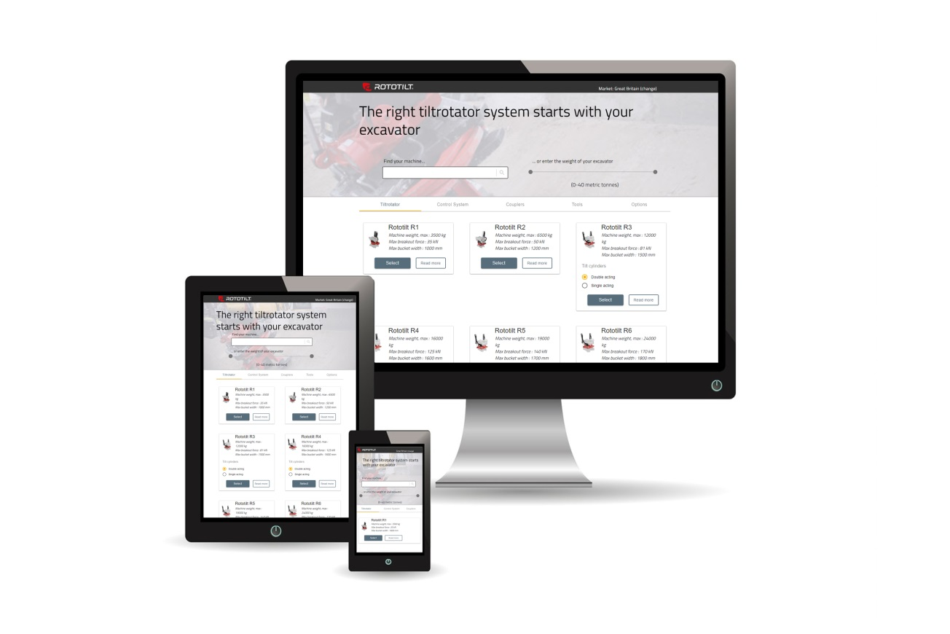

Rototilt digitalizes the purchasing process

Rototilt is releasing a digital product guide that will match the customer’s excavator with Rototilt’s tiltrotators and other products. “It’s a smart solution making it easier for customers to choose the right products and get in touch with the right dealer,” explains Per Väppling, Marketing and Sales Manager at Rototilt.

The Product Guide is a digital tool designed for both end users and Rototilt’s dealers, enabling them to easily see which of Rototilt’s products fits together with a specific excavator model.
- “Our numerous options and accessories have fuelled the need to gain an overview of what combinations can be fitted to the excavator. Using this Guide, our customers can easily find matching products. We believe that this is an excellent tool that makes things easier for both the machine purchaser and the dealer during the purchasing process,” says Väppling.
On Wednesday 16 October, Rototilt is going live on rototilt.com with the first version of the Product Guide.
- “There has been a great deal of work behind this, as a lot of data and various dependencies are hidden behind the results. We are looking forward to continue the development of this Guide, with the aim of making it even easier to buy our products,” concludes Väppling.
As before, all sales will continue to take place through Rototilt’s local dealers.
If you have any questions or for more information:
Per Väppling, Marketing and Sales Manager, Rototilt Group AB.
E-mail: per.vappling@rototilt.com, tel +46 70 347 22 54

