FOR IMMEDIATE RELEASE

Contact: Tiffany Vann
Phone: (860) 827-5980
E-mail: Tiffany.Vann@sbdinc.com

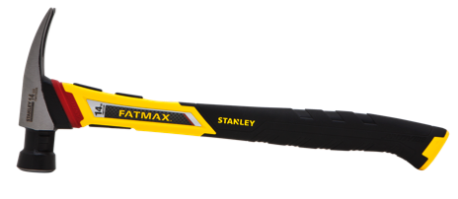
STANLEY® Product Roundup- “Everything for Everyone.”

New Britain, CT. (November 2015) — As the holiday season quickly approaches, don’t forget to deck the halls with STANLEY Tools. Whether you’re decorating your home to add a little holiday cheer, a DIYer, professional, or in construction, STANLEY has everything for everyone! From your most basic needs to smart technology, STANLEY has got you covered.
¼ in Heavy Duty Cable Tracker
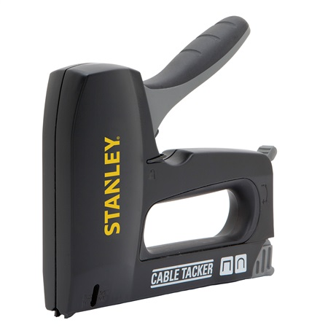

Make hanging holiday lights easier with the STANLEY ¼” Heavy Duty Cable Tracker. The tracker’s handle is 30% easier to squeeze and designed with a patented anti-jam mechanism. It’s not only great for hanging holiday lights, but also helpful in hanging other holiday decorations.
Smart Measure Pro
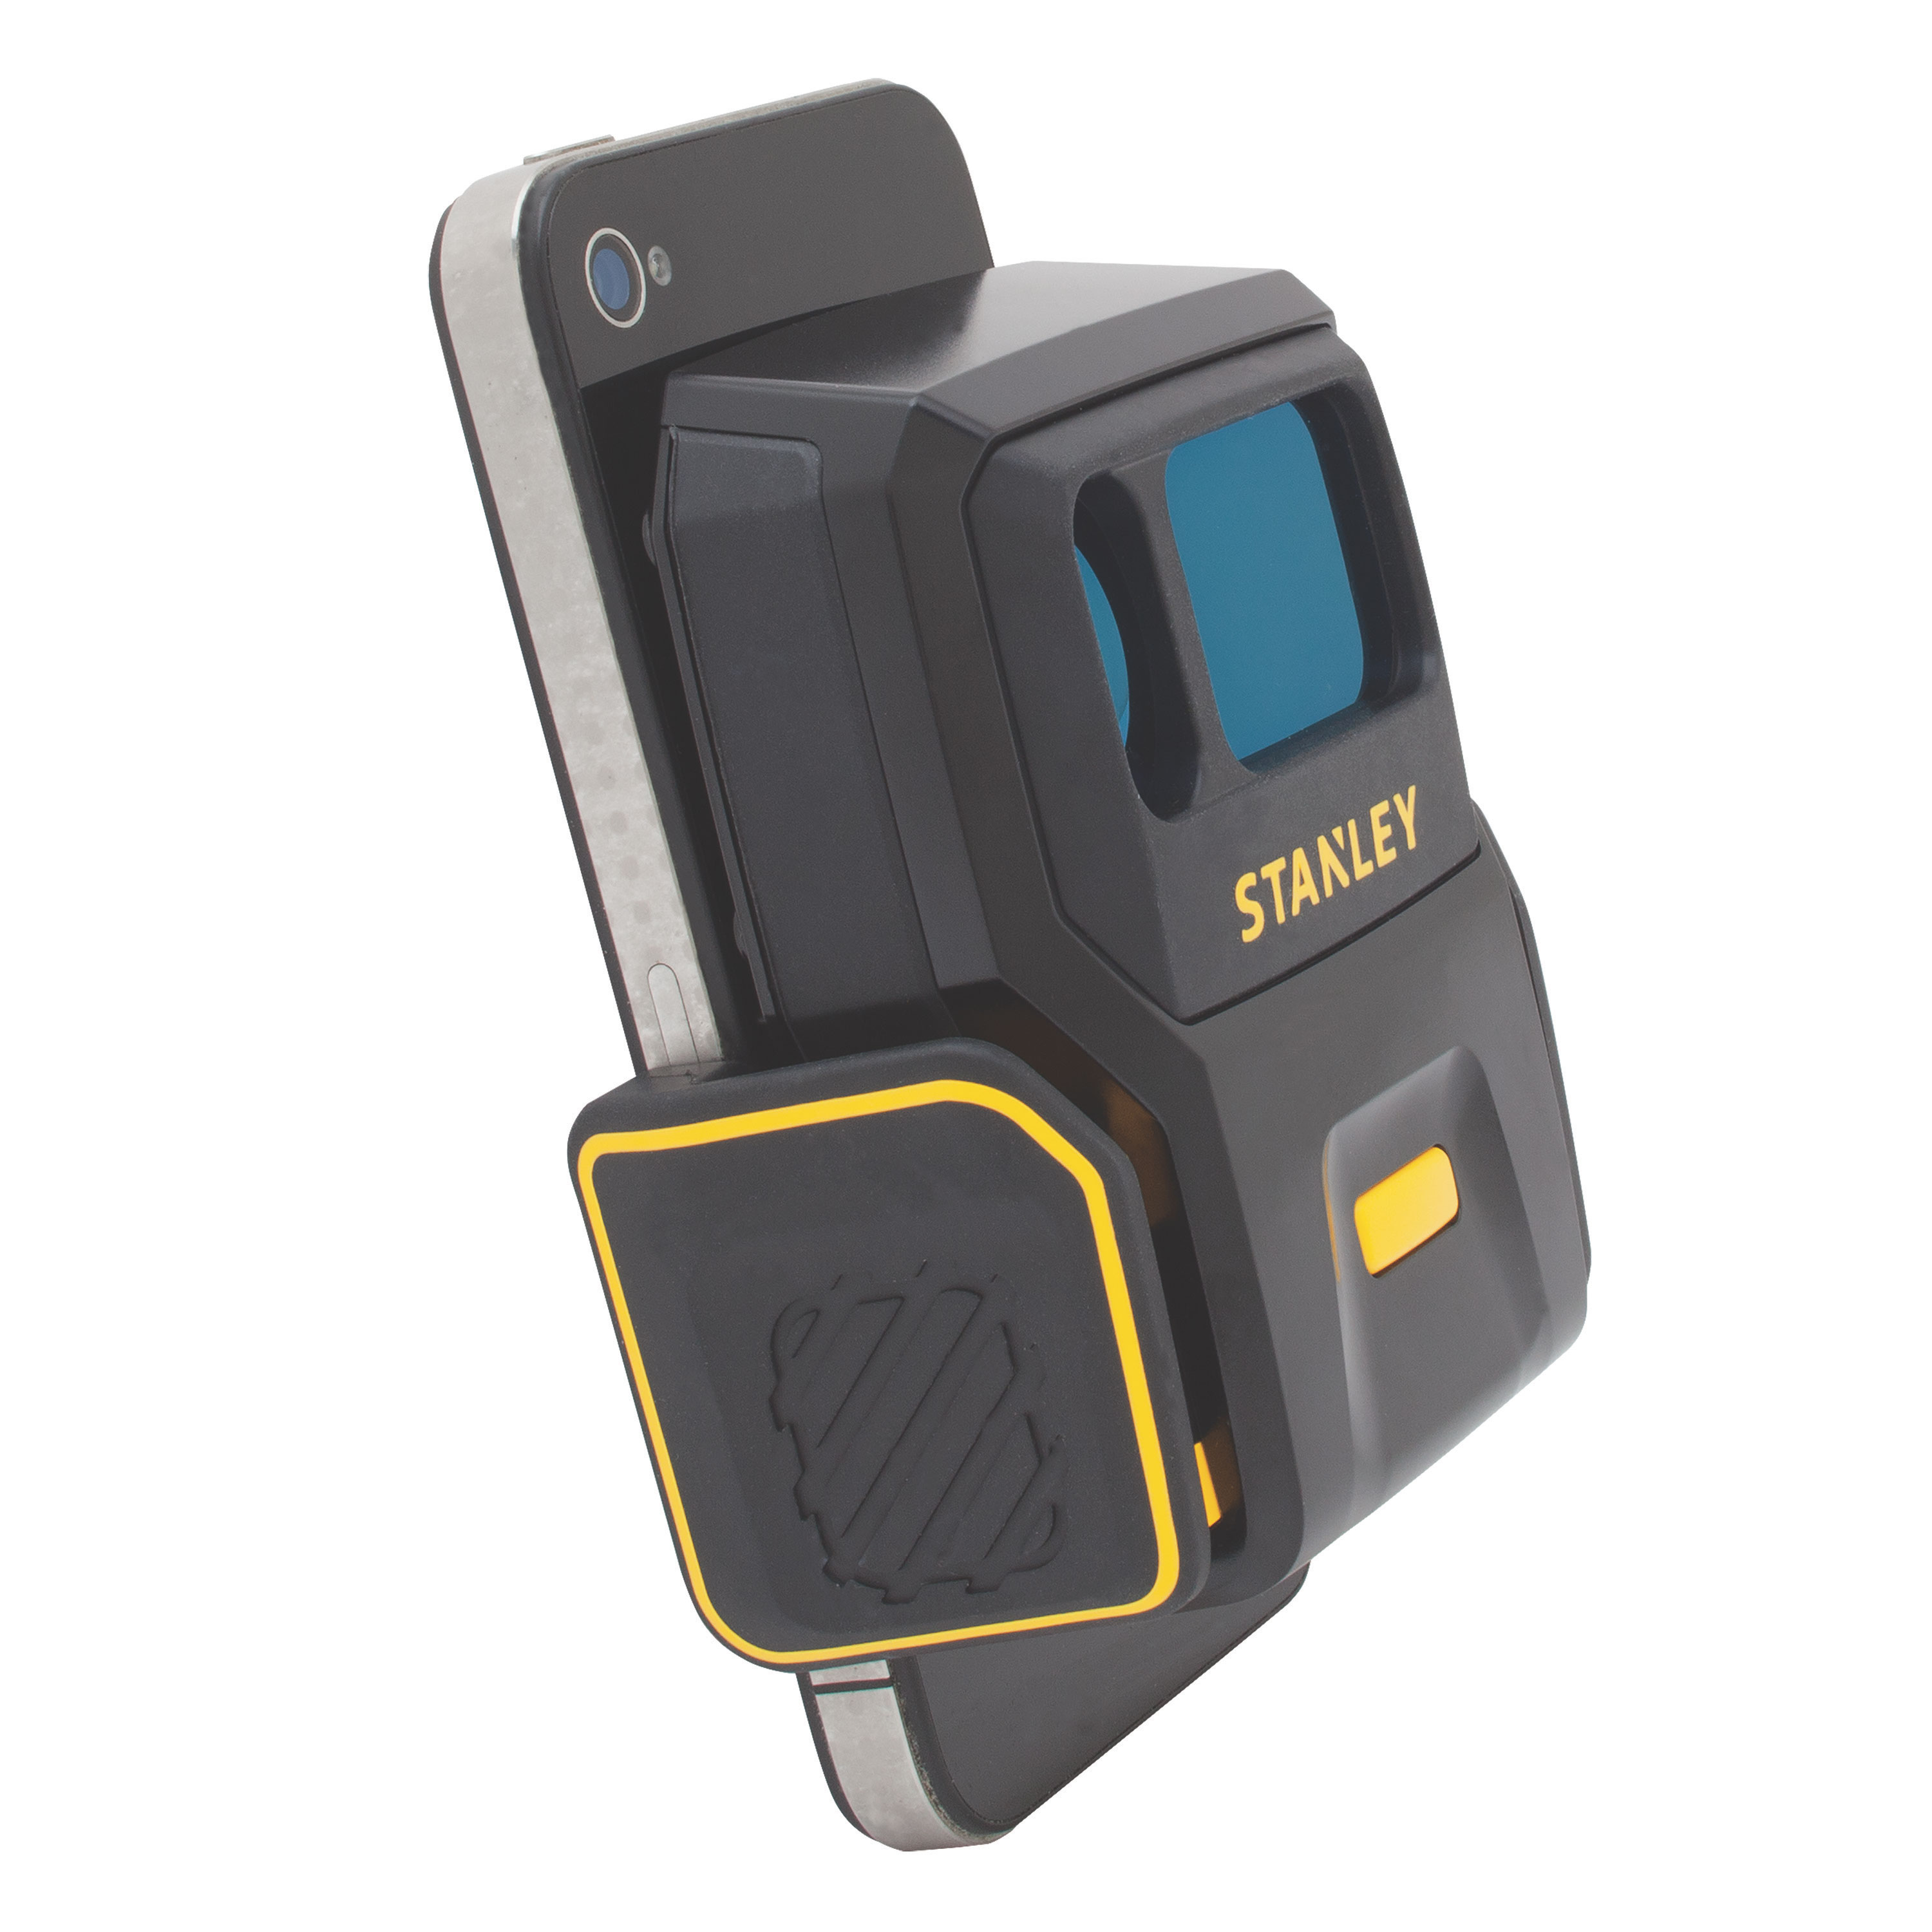

Have a project you’d like to complete that requires accurate measurements? The Smart Measure Pro is a cutting edge device with the ability to take a picture of almost anything and provide accurate measurements instantaneously. Simply connect your smart phone or mobile device to the Smart Measure Pro App, snap a picture, the Smart Measure Pro will automatically measure, then, review, store, or share the measurements. It’s also designed to provide rough estimates of specific material requirements preset within the application. This smart device is user-friendly so DIYer and professionals alike can easily find benefits in its features.
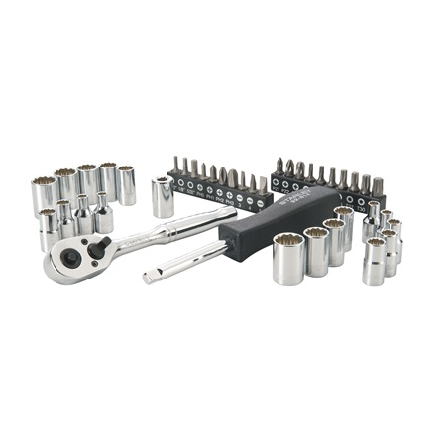
Mechanics Tool Sets

Choose from an array of durable STANLEY mechanics tools to get the job done right. Choose from a number of mechanics tool sets to assemble that new 15-speed bike for Christmas, major jobs in the garage, or simple repairs to your own vehicle. STANLEY mechanics tools come marked for an easy read and organization as well as a chrome finish for corrosion resistance. Whether its wrenches, ratchets, sockets, hex keys, bits, or extension bars, you can count on STANLEY mechanics tool sets to help finish the task so you can get back to doing what you love most.
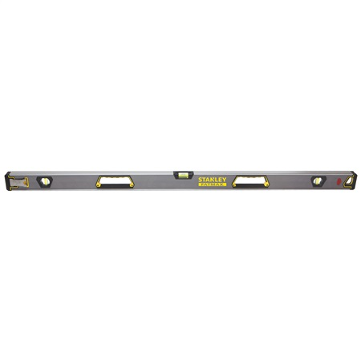
Levels

STANLEY levels are ideal for a number of jobs ranging from hanging family holiday portraits, mounting shelves, door and window installations, to site layout for a new foundation. STANLEY levels are simple to use and essential for correct measurements when accuracy matters most. Enjoy convenience, portability, durability, and increased productivity with any level from the STANLEY measuring and layout collection.
FatMax® Simulated Diamond Tip Screwdrivers
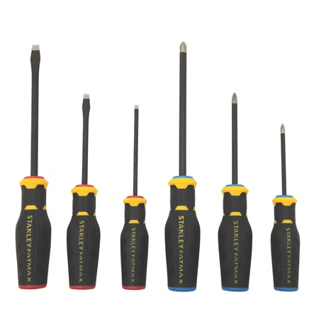

Show them how much you care with FatMax® Simulated Diamond Tip Screwdrivers which offer longer tip life over standard screwdrivers. Standard screwdriver tips take a beating over time and become less effective at staying seated in screws. FatMax® Simulated Diamond Tip Screwdrivers are encrusted with a simulated diamond sand composite to help bite into screws for easy screwdriving and screw removal. Color coded handles make it quick and easy to choose the right screwdriver size for the job at hand.
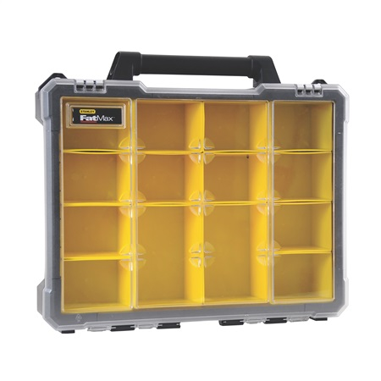
FatMax® Professional Organizer

The Stanley FatMax® Professional Organizer offers a unique design for storage and easy access to small items like clips, nails, screws, tape, ornaments, and so much more. The Professional organizer offers a transparent lid that keeps storage cups locked in place. It comes with heavy duty aluminum latches and durable handles so plan to keep this one for years to come.

About Stanley®:

STANLEY®, a brand of Stanley Black & Decker, Inc. is a diversified manufacturer of innovative tools and engineered solutions for professional, industrial, woodworking, construction, automotive repair, organizational, and do-it-yourself- use. Since 1843 Stanley has consistently provided solutions that make life easier with reliable hand tools. Headquartered in New Britain, CT, STANLEY® is committed to manufacturing tools in the USA with global materials. Annually, Stanley® produces a large variety of hand tools including tape rules, knives, blades, hand saws, screwdrivers, plastic storage, and accessories in multiple manufacturing locations in North America. STANLEY® can be found internationally wherever tools are sold and has helped build America with a breadth of quality hand tools people can trust for over 170 years. For more information visit www.stanleytools.com or follow STANLEY® on Facebook and Twitter.

###

