KONGSBERG’s integrated Wind Turbine Installation Vessel technology chosen by COSCO
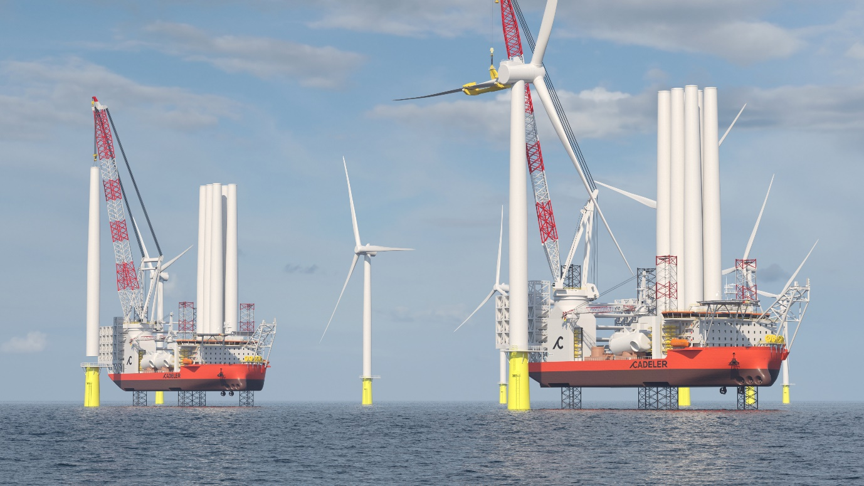
Cadeler’s new Wind Turbine Installation Vessels will be built by COSCO Shipping (Qidong) Offshore and fitted with Kongsberg Maritime’s field-proven integrated solution for WTIV operation
Kongsberg, Norway, 7th July 2021 – Kongsberg Maritime has won another important customer for its industry-leading Wind Turbine Installation Vessel (WTIV) technology, following the signing of contracts totalling EUR 49m with the Chinese shipbuilder COSCO Shipping (Qidong) Offshore. The agreement will see Kongsberg Maritime (KM) supply comprehensive technology packages for two new NG-20000X WTIVs, which COSCO is constructing for the Denmark-based service provider Cadeler.
KM’s Integrated Solution for Wind Turbine Installation Vessels will be crucial to the delivery and operation of the new vessels, which are destined to be among the largest of their type and capable of transporting and installing multiple sets of next- and future-generation wind turbines, and their foundations. This well-proven suite of solutions combines KM’s optimised thruster package and dynamic positioning functionalities to maintain operability in all conditions.
Monitoring and control of the KM components will be handled by a K-Chief marine automation system. Tailored energy control functionalities will optimise energy efficiency and reduce the WTIVs’ environmental footprints, and the battery hybrid electrical system includes such novel solutions as ThrustAllocator™ and PowerBoost™ to increase the vessels’ operational capability while reducing the number of engines and fuel consumption required for both crane operations and DP manoeuvring.
The state-of-the art vessels will also include technology for the regeneration of power from the jacking system and cranes. To further reduce the environmental footprint and minimise downtime, KM has also included its new onboard advisory system, EcoAdvisor™, and a condition-based monitoring system to extend maintenance intervals and detect any anomalies in the rotating equipment.
“Cadeler is committed to providing safe, high quality and reliable offshore services, with a strong focus on safety and the environment,” says Mikkel Gleerup, CEO at Cadeler. “KONGSBERG’s innovative WTIV solution will help us to pursue new levels of efficiency and enable the world's transition to a future built on offshore renewable energies.”
“We take a genuine pride in bringing the benefits of our technological expertise to all maritime sectors,” adds Egil Haugsdal, President, Kongsberg Maritime, “and the bespoke solution we have devised for wind turbine installation vessels indicates how much thought and effort we devote to facilitating and encouraging sustainable marine operations.”
The first of the new WTIVs, which will service the European renewable energy market, is expected to be delivered before the end of Q3 2024. The second is expected by Q1 2025.
Ends

For further information, please contact:
Gunvor Hatling Midtbø, VP Communication
Kongsberg Maritime
Tel: +47 9921 4209
gunvor.hatling.midtbo@km.kongsberg.com
David Pugh
Saltwater Stone
Tel: +44 (0)1202 669244
d.pugh@saltwater-stone.com

About Kongsberg Maritime
Kongsberg Maritime is a global marine technology company providing innovative and reliable ‘Full Picture’ technology solutions for all marine industry sectors including merchant, offshore, cruise, subsea and naval. Headquartered in Kongsberg, Norway, Kongsberg Maritime has manufacturing, sales and service facilities in 34 countries.
Kongsberg Maritime solutions cover all aspects of marine automation, safety, manoeuvring, navigation, and dynamic positioning as well as energy management, deck handling and propulsion systems, and ship design services. Subsea solutions include single and multibeam echo sounders, sonars, AUV and USV, underwater navigation and communication systems.
Training courses at locations globally, LNG solutions, information management, position reference systems and technology for seismic and drilling operations are also part of the company’s diverse technology portfolio. Additionally, Kongsberg Maritime provides services within EIT (Electro, Instrument & Telecom) engineering and system integration, on an EPC (Engineering, Procurement & Construction) basis.
Kongsberg Maritime is part of Kongsberg Gruppen (KONGSBERG), an international, knowledge-based group that celebrated 200 years in business during 2014. KONGSBERG supplies high-technology systems and solutions to customers in the oil and gas industry, the merchant marine, and the defence and aerospace industries.
Web: Kongsberg Gruppen | Kongsberg Maritime
Social media: LinkedIn | Twitter | Facebook

