Epson High-Capacity Ink Tank Inkjet Printers Reach Cumulative Global Sales of 40 Million Units
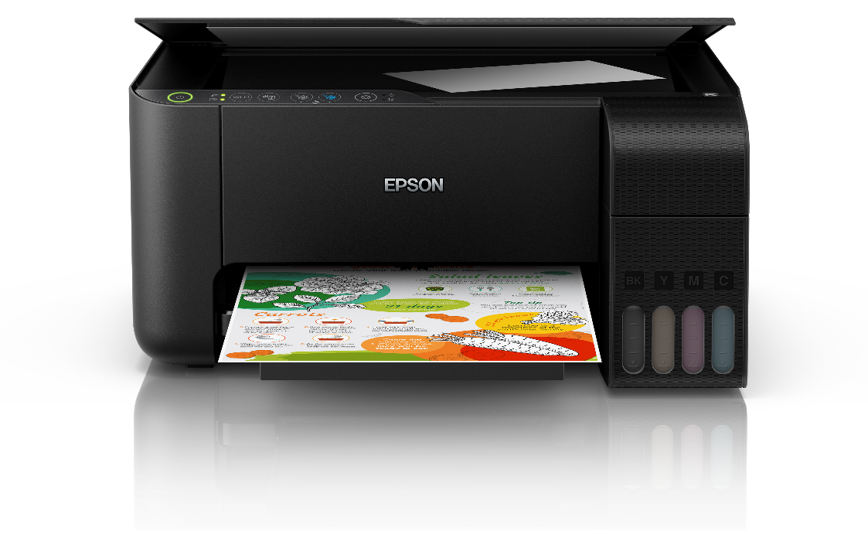

Epson high-capacity ink tank inkjet printer

[Malaysia, 10 September 2019] – Seiko Epson Corporation (TSE: 6724, "Epson") announces that cumulative global sales of Epson’s high-capacity ink tank inkjet printers have reached 40 million units.

Epson first launched high-capacity ink tank inkjet printers in October 2010, in Indonesia, and by 2018 had expanded into some 150 countries and regions. By first establishing a presence in emerging markets and then making inroads into developed economies, Epson has seen its high-capacity ink tank models account for a growing percentage of the total inkjet market each year. As a result, Epson, which boasts strong brand recognition and an extensive product lineup, has continued to maintain the top share* in the high-capacity ink tank printer market for nine consecutive years.

In 2019, Epson will accelerate the transition from ink cartridge printers to high-capacity ink tank printers by continuing to highlight the latter’s formidable advantage in terms of cost per print and environmental performance. The company will also speed up the replacement of laser printers by strengthening its lineup of blazingly fast and durable office inkjets that allow users in all segments to print freely without worrying about costs.

Through these efforts, Epson plans to sell 10.2 million high-capacity ink tank printers in FY2019 – an increase of 13% compared to the previous fiscal year. This is expected to account for about 64% of total inkjet printer sales in Epson.

*Top share in terms of the number of global high-capacity ink tank products sold from 2010 to 2018, per research by IDC (Source: IDC's Quarterly Hardcopy Peripherals Tracker 2019Q1)

***
About Epson
Epson is a global technology leader dedicated to connecting people, things and information with its original efficient, compact and precision technologies. With a lineup that ranges from inkjet printers and digital printing systems to 3LCD projectors, watches and industrial robots, the company is focused on driving innovations and exceeding customer expectations in inkjet, visual communications, wearables and robotics.
Led by the Japan-based Seiko Epson Corporation, the Epson Group comprises more than 76,000 employees in 87 companies around the world, and is proud of its contributions to the communities in which it operates and its ongoing efforts to reduce environmental impacts.
http://global.epson.com

About Epson Malaysia
Epson began operations in Malaysia in 1991 as Epson Trading (M) Sdn Bhd before being incorporated as Epson Malaysia Sdn Bhd. The company has the exclusive rights to market, distribute and support a complete range of leading-edge Epson consumer and business digital imaging products in Malaysia and Brunei. Today, Epson Malaysia has 84 employees and an extensive network of 61 authorised service outlets throughout the country. For more details, please visit www.epson.com.my or connect with us at www.facebook.com.my/EpsonMalaysia .

For media enquiries, please contact:
Chua Li Tinn,
Marketing Communications Manager
Epson Malaysia Sdn Bhd
Tel: (03) 5628 8288 Ext 274
Email: ltchua@emsb.epson.com.my

LEWIS
Natasha Aida / Leong Ee Sa
Tel: +603 2716 5818
Email: EpsonMY@teamlewis.com

