APPROVED PRESS RELEASE 4th April 2019
Intelligent Rotork actuators improve wireless functionality at UK crude storage hub
Rotork intelligent electric actuators have been chosen to increase the number of wirelessly controlled actuators at a liquid storage provider in the UK.
Rotork IQ3 multi-turn actuators have been commissioned for two Navigator Terminals road fuel and crude storage tanks at its North Tees hub in Middlesbrough.
The site, which is split into Inland and Marine terminals, supplies the North East of the UK and has connecting pipelines to a neighbouring Navigator Terminals storage facility, Seal Sands, on the north bank of the River Tees. It is connected to the Ekofisk North Sea crude oil terminal and pipeline, also at Seal Sands.
The IQ3 actuators have been fitted to 24 “ gate valves which control the flow of crude oil in and out of one of the storage tanks at the company’s Marine Terminal.
The actuators communicate using HART protocol via a Pepperl+Fuchs Bullet WirelessHART Adapter, which has enabled seamless integration with the site’s existing Rosemount wireless network. It will also allow the operator to add more wireless compatible actuators and control instruments to the site in future.
All IQ3 commissioning, configuration and control can also be carried out remotely using an intrinsically-safe Rotork Bluetooth® Setting Tool. Torque levels, position limits and indication functions can be adjusted while two-way data communication allows for multiple actuator configurations. The setting tool can also be used to extract information including operational starts profiles, starts per hour and temperature or vibration logs from an advanced datalogger. This data can be securely transferred via the cloud to a PC running Rotork Insight 2 software for diagnostics and asset management.
IQ3 actuators are ATEX certified as explosionproof, suitable for use in Safety Integrity Level 2 / 3 applications and watertight to IP66/68 standard – submersible at 20 metres for 10 days.
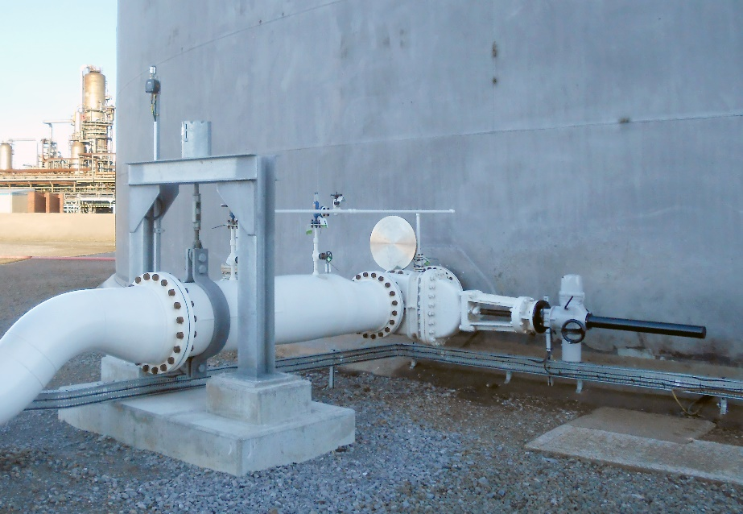

END
Photo captions
Rotork’s IQ3 electric multi-turn actuators are being used in a Navigator Terminals wireless network at its North Tees site.

For further information please contact Rotork PLC
Sarah Kellett Brassmill Lane
Group Marketing Communications Manager Bath
Telephone: +44 (0) 1225 733492 BA1 3JQ
Email: Sarah.Kellett@rotork.com UK

About Rotork
Rotork is the market leading actuator manufacturer and flow control company that operates in any market where the flow of gases or liquids needs to be controlled. It has established manufacturing facilities, a global network of local offices and agents who can truly provide a worldwide service. You will be able to locally source Rotork’s products, supported by life-of-plant maintenance, repair and upgrade services.

