Red Bull Ring next up for Jessica Bäckman
May 20-22nd, ADAC TCR Germany and its participants enter the well-known Red Bull Ring track in Austria. The Sweden National team driver Jessica Bäckman is ready for another race weekend.
﻿﻿ - Red Bull Ring is the absolute coolest track on the calendar, it has never been my favorite track to drive on, but I hope to be able to change that this weekend, Jessica Bäckman says.
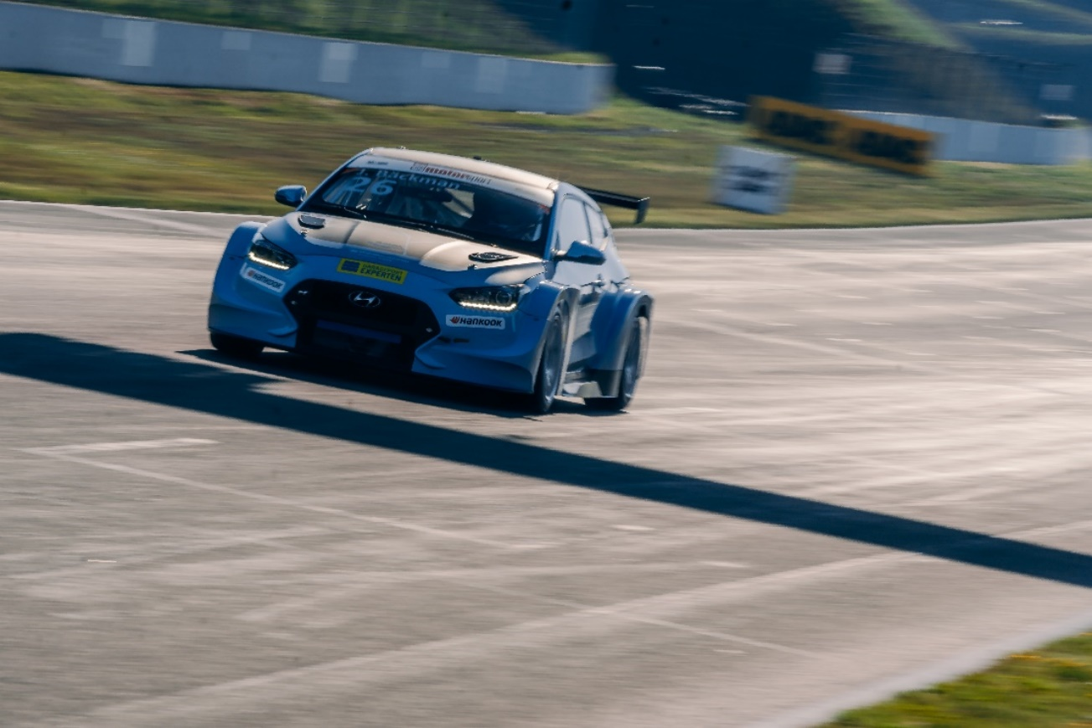
Österreichring, A1-Ring - and now Red Bull Ring. The racing track in Spielberg, Austria, has borne several names over the years but the challenging and fun driving conditions remains. The well-established designer Hermann Tilke has provided the 4,318 km with lots of hills, as well as quick and slow corners. Formula 1 was recently held on this track and next weekend it's time for second round of ADAC TCR Germany. Jessica is looking forward to competing again after the successful season premiere at the Oschersleben track in Germany.
- I had a very good start in the season premiere with my first win, now I of course aim to try to resume the same result again, Jessica Bäckman says.
﻿
﻿
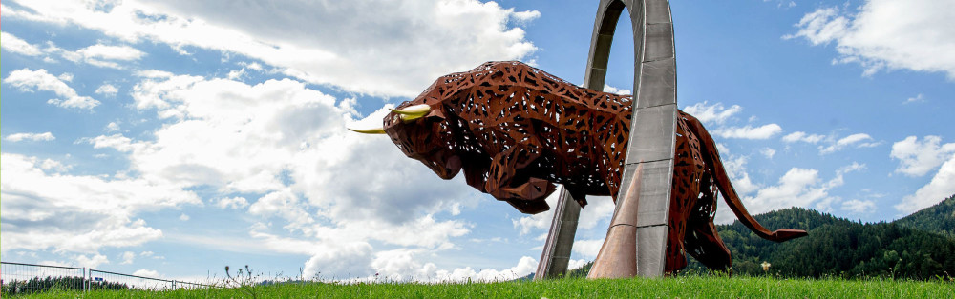
﻿
Large differences in height are waiting
Since 2011, the racing track has been named after the sponsor and energy drink manufacturer Red Bull, and its driving and atmosphere offers a unique experience.
- Red Bull Ring is the absolute coolest track on the calendar, however, it has never been my favorite track to drive on, but I hope to be able to change that this weekend. There are large differences in height on the track (maximum uphill slope of 12%, maximum downhill slope of 9.3%), which means that the braking points must be adjusted. I believe that the qualifying will be close, Jessica Bäckman says.
Timeschedule for this race weekend:
(all times in CET)
Friday May 20th:
14:10 Free practice 1
18:20 Free practice 2
﻿
Saturday May 21st:
11:45 Qualifying 1 (Q1)
18:15 Race 1 ﻿TV link for Race 1
﻿﻿
Sunday May 22nd:
09:15 Qualifying 2 (Q2)
15:35 Race 2 ﻿TV link for Race 2﻿
Live-streaming
Both races will be live streamed on motorsport.tv
Race 1: Click to watch Race 1
Race 2: Click to watch Race 2
Both race can be watched through re-live streaming at www.youtube.com/adacmotorsports and Motorsport.tv
Live-timing
All practices, qualifying and races can be followed through live-timing https://www.adac-motorsport.de/adac-gt-masters/live-timing
About the track:
﻿
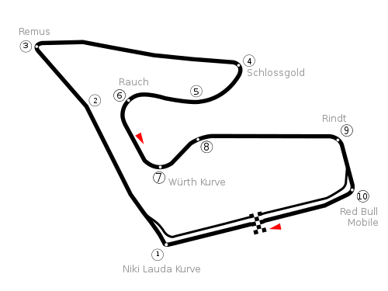
Place: Red Bull Ring, Austria
Lenght: 4,318 km
Corners: 10
Race length: 30 minutes + 1 lap
ADAC TCR Germany Calendar 2022:
22–24 April - Oschersleben, Germany
20-22 May - Red Bull Ring, Austria
17-19 June - Salzburgring, Austria
5-7 August - Nürburgring, Germany
19-21 August - Lausitzring, Germany
23-25 September - Sachsenring, Germany
21-23 October - Hockenheim, Germany
Free rights to use images.

