KONGSBERG brings in digital twin expertise to strengthen digital offering in the maritime space

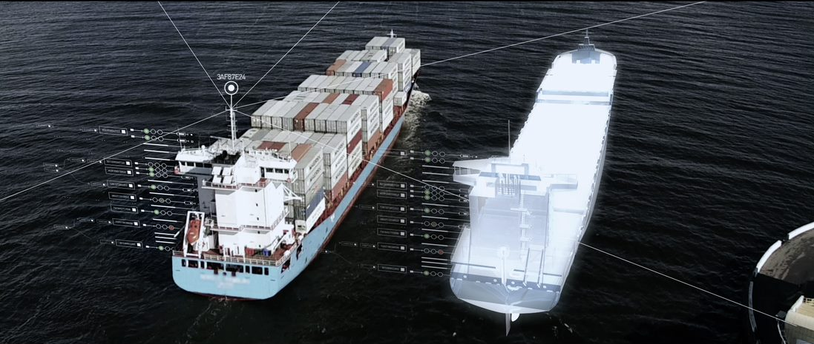
Digital Twins are key to remote operation and monitoring solutions and essential to autonomous shipping
Oslo, August 26th, 2020 – KONGSBERG announced today its plans to increase investment in maritime digital solutions, focus on building strong partnerships and combine Kongsberg Digital’s two maritime divisions into one brand: Digital Ocean. Digital Ocean will be headed up by former SVP Energy and digital twin expert Andreas Jagtøyen.
The benefits and necessity of digitalization are becoming increasingly apparent for the world’s industrial markets. KONGSBERG is spearheading the development of maritime digitalization solutions through our cost-efficient data infrastructure solution for vessel owners and operators, Vessel Insight, adjacent digital solutions such as Vessel Performance and Remote Services, and partnerships with other large maritime vendors such as DNV GL and recently ABB. All parties focus on digital deliveries based on their unique core expertise, to enable end-to-end digitalization that brings real value to customers. The next step for KONGSBERG in this undertaking is to combine Kongsberg Digital’s Maritime Digital Solutions unit with its Maritime Simulation hub, enabling the synergies required to address a need in the market for maritime digital twins. Heading up the new maritime stronghold, Digital Ocean, is former SVP Energy, Andreas Jagtøyen.
“Digitalizing the maritime industry is not a one-company job and therefore KONGSBERG is partnering up with experts externally and combining expertise internally to generate synergies. Kongsberg Digital has delivered highly realistic maritime simulation technology for decades and our experience from the energy sector has shown us how valuable simulation technology is in bringing about functional dynamic digital twins. Andreas spearheaded this work on the energy side, and now he will break new ground on the development of digital twins on the maritime side,” says Hege Skryseth, President of Kongsberg Digital and EVP KONGSBERG.
KONGSBERG’s digital value offering to the maritime sector builds on the company’s unique domain knowledge and history in delivering high technology solutions to the maritime market, combined with expertise in bringing about industrial digitalization solutions.
“Digitalization and the use of big data plays an important role in making shipping greener, and reaching the environmental targets set by IMO. In KONGSBERG we aim for a continued focus on digital opportunities in the Ocean space, together with our customers across the world,” says Egil Haugsdal, President of Kongsberg Maritime and EVP KONGSBERG.
Andreas Jagtøyen has a maritime background and has recently led Kongsberg Digital’s investments in and development of Kognitwin® Energy, the company’s digital twin solution for the energy sector. He sees an increasing interest in the market for digital twin solutions on the maritime side.
“From a digital twin perspective, there are obvious synergies between what we have developed over decades on the simulation side and, more recently, on the data infrastructure side with Vessel Insight. More and more customers reach out to learn how the development of maritime digital twins is progressing, both related to autonomous shipping and to solutions supporting more efficient and safe operation of advanced equipment and machinery on board the vessels. So, we believe this is a market to be reckoned with in the future. Together with the people in KONGSBERG, with their massive maritime technology and software expertise, and our partners, we will give the market answers to their questions,” says Andreas Jagtøyen, new EVP of Digital Ocean in Kongsberg Digital from September 1st 2020.
Read more about the recent digitalization partnership agreement with ABB here.
Ends
For further information, please contact:

Mathilde Vik Magnussen
VP Communications & Marketing
Kongsberg Digital
Tel: +47 4567 8255
mathilde.magnussen@kdi.kongsberg.com

Mei Lee
Senior Global Marketing Communications Manager
ABB Turbocharging
Tel: +41 585 85 1874
mei-jiuan.lee@ch.abb.com
David Pugh
Saltwater Stone
Tel: +44 (0)1202 669244
d.pugh@saltwater-stone.com

About Kongsberg Digital
Kongsberg Digital is a provider of next-generation software and digital solutions to customers within maritime, oil and gas, and renewables and utilities. The company consists of more than 500 software experts with leading competence within the internet of things, smart data, artificial intelligence, maritime simulation, automation and autonomous operations.
Kongsberg Digital is subsidiary of KONGSBERG (OSE-ticker: KOG), an international, knowledge-based group delivering high-technology systems and solutions to clients within the oil and gas industry, subsea, merchant marine, defence and aerospace. KONGSBERG has 11,000 employees located in more than 40 countries.
Web: Kongsberg Gruppen | Kongsberg Digital
Social media: LinkedIn | Twitter | Facebook

