Chr. Hansen and FMC Corporation extend collaboration on natural crop protection

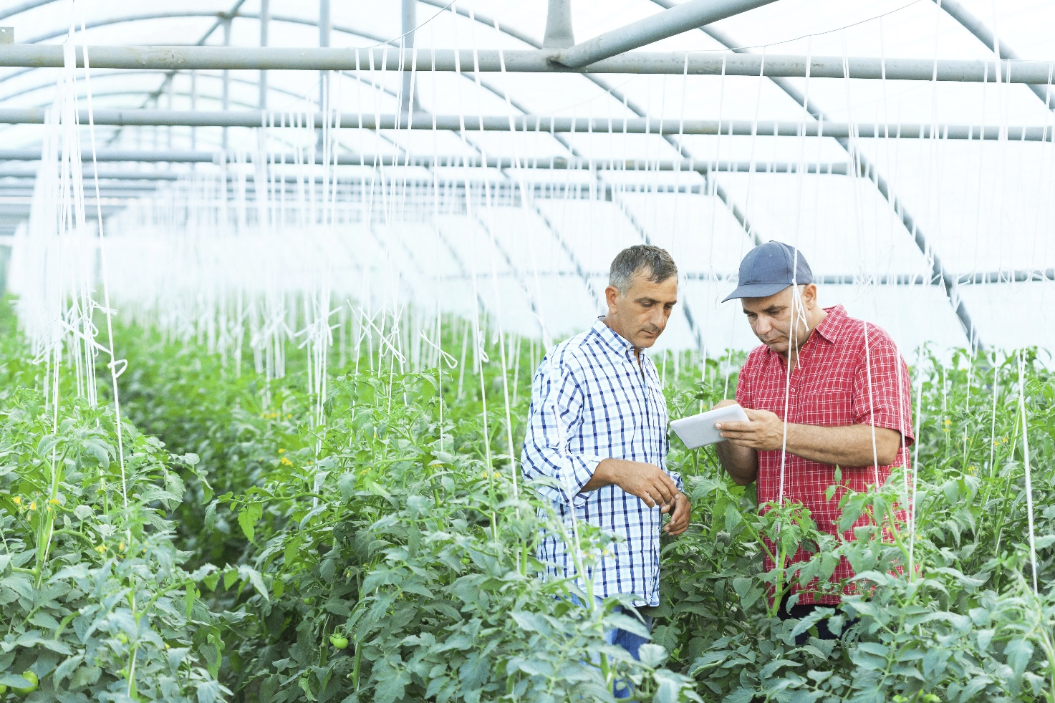
Chr. Hansen and FMC Corporation have announced a five-year extension of their collaboration to develop and commercialize natural solutions for the agricultural industry

The collaboration, which has launched several successful natural solutions over the last five years, has enabled both Chr. Hansen and FMC to join resources and expertise to accelerate entry into the rapidly growing biological crop protection market. The newly extended agreement continues to leverage the resources and expertise of both companies, while allowing for more flexibility.
During the last five years, Chr. Hansen and FMC have had an exclusive relationship regarding crop protection. While the mutual development pipeline will continue to be exclusive, both companies will be able to pursue development and commercial relationships with other partners, if desired.

“Chr. Hansen and FMC have enjoyed a successful relationship, including the launch of new products that provide natural alternatives for farmers to significantly boost crop yield,” said Christian Barker, Chr. Hansen executive vice president, Health & Nutrition. “Now, with our continued collaboration confirmed, we look forward to launching our strong pipeline of new products together in the years ahead. Beyond that pipeline, the new agreement provides full flexibility for both parties which will enable Chr. Hansen to further leverage our distinctive microbial capabilities by also collaborating with additional partners.”
Marc Hullebroeck, president, FMC Europe, Middle East and Africa, added:
“We are pleased to extend our relationship for at least another five years as we continue to collaborate on commercializing technologies that have been jointly developed. In addition, FMC will continue its own efforts on discovery, development and commercialization of new innovative technologies at our state-of-the-art laboratory facilities at FMC’s European Innovation Center near Copenhagen, Denmark. Our priority is to focus on differentiated solutions for growers throughout the world.”

About Chr. Hansen
Chr. Hansen is a leading, global bioscience company that develops natural ingredient solutions for the food, nutritional, pharmaceutical and agricultural industries. We develop and produce cultures, enzymes, probiotics and natural colors for a rich variety of foods, confectionery, beverages, dietary supplements and even animal feed and plant protection. Our product innovation is based on more than 30,000 microbial strains – we like to refer to them as ‘good bacteria’. Our solutions enable food manufacturers to produce more with less – while also reducing the use of chemicals and other synthetic additives – which make our products highly relevant in today’s world. We have been delivering value to our partners – and, ultimately, end consumers worldwide – for over 140 years. We are proud that more than one billion people consume products containing our natural ingredients every day. Revenue in the 2016/17 financial year was EUR 1,063 million. Chr. Hansen was founded in 1874 and is listed on Nasdaq Copenhagen.

About FMC
For more than a century, FMC Corporation has served the global agricultural, industrial and
consumer markets with innovative solutions, applications and quality products. On
November 1, 2017, FMC acquired a significant portion of DuPont's Crop Protection business.
FMC employs approximately 7,000 people throughout the world and operates its businesses
in two segments: FMC Agricultural Solutions and FMC Lithium. For more information, visit
www.FMC.com.

