PRESS RELEASE, Vindeln October 7 2016
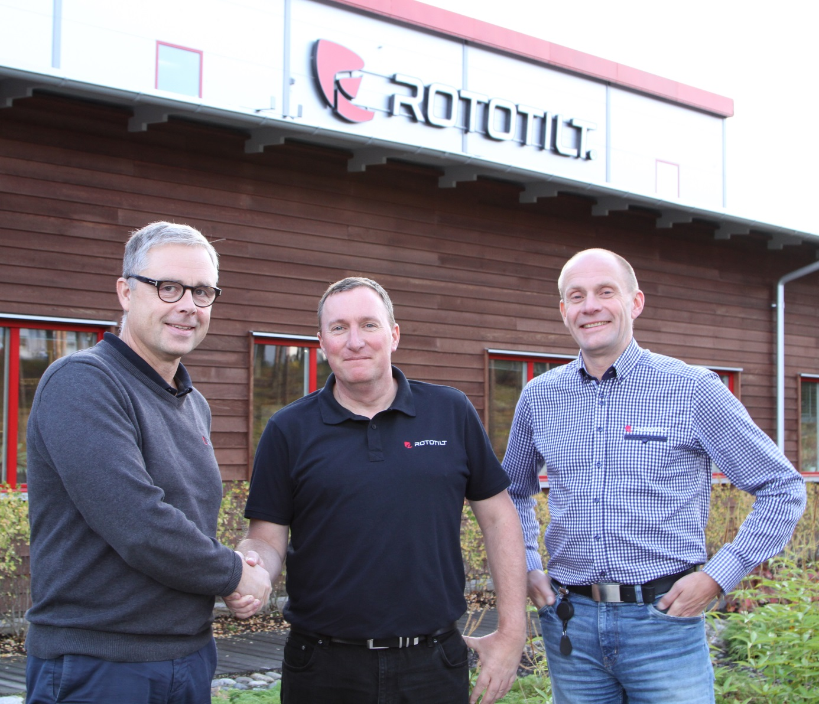
Per Väppling, Malcolm Long and Hans Röring.

Rototilt establishes Daughter Company in the United Kingdom

World leading tiltrotator manufacturer Rototilt is to open a direct company division in the UK.
Per Väppling, Sales and Marketing Manager at Rototilt Group AB explains “Rototilt has been very well received in the UK and we are now ready to set up our own organisation.” “As part of our international expansion, Rototilt Ltd will be operational from October 1st 2016 led by Sales Manager Malcolm Long.”

With customer service and supply firmly in the forefront of the strategy, this is a clear statement of the parent companies regard and commitment to current customers and the UK market potential.

“We started our journey in the UK two years ago with our appointed distributor Tiltrotators-UK and thanks to Tim Wood and his team we have a solid foundation to build from.” “Now is the time to continue that journey and take the next step for our organisation,” continues Per Väppling, ”the UK tiltrotator market is currently developing rapidly and Rototilt intends to be a major player.”
Organisation
Rototilt Ltd will be the focus for all sales, service, parts and support for the extensive Rototilt product range in the UK. Controlled and administered by Rototilt Ltd employees and by utilising strategic local partners, this ensures our current and future customers will experience the quality service you would expect from a direct, factory backed organisation. Making up the team Malcolm Long is joined by Josh Wood and Steve Ormesher, who were both previously with Tiltrotators-UK, to add their previous experience and knowledge of the products and industry. Josh will initially have a dual sales and customer/product support role while Steve will focus on the installation and service functions.
We are also very pleased to confirm that Cullion Plant Services based near Dungannon N.I. are the appointed dealer of Rototilt Ltd for NI & Ireland. Aiden O’Neill of Cullion will also have a service support role into the UK to reinforce our service capabilities.
- “a dedicated UK location to support and supply products and parts will also be in place shortly,” states Per Väppling, “and we will continue to build our organisation as sales develop”.

Exciting business development
- “I see great potential for Rototilt tiltrotators and attachments in the UK,” says Malcolm Long, “the establishment of the daughter company is a clear statement that Rototilt is here to stay”.
“The advantages the tiltrotator has made to the time, safety and efficiency of those operators shrewd enough to have one is staggering – so much so they would never now consider returning to the ‘traditional’ coupler and bucket setup.”
“I’m excited to be leading the next phase of Rototilt’s expansion in the UK,” added Malcolm, “– the new Rototilt R3 model for 7-12 tonne machines will prove a big hit and is complemented across the range with the likes of the Innovative Control System (ICS), SecureLock™ coupler safety system and the key distinguishing Rototilt quality of the oil-filled rotor housing – minimal service routine, less wear & tear and longer lifespan.”
“It’s the 30 years of precision engineering at the heart of Rototilt AB in Sweden that sets us apart from others in the market and I look forward to helping our customers profit from the tiltrotator revolution!”

For further information please contact:
Malcolm Long, Sales Manager Rototilt Ltd, E-mail: malcolm.long@rototilt.com,
Tel: +44 (0)7852299410
Per Väppling, Sales- and Marketing Manager Rototilt Group AB. E-mail: per.vappling@rototilt.com, Tel: + 46 70-347 22 54

Rototilt Group is a world-leading manufacturer of tiltrotators, accessories and systems. With Rototilt®, we are breaking new ground for construction equipment by turning excavators into tool carriers. We are able to provide a unique combination of technical expertise, quality, capacity and an understanding of our customers’ business through our global service network. We have a global customer base, and our aim is for our customers to experience precision, reliability and commitment in all their dealings with us.

