Pip Hare completes Transat Jacques Vabre
with a nail-biting finish
Pip Hare and Ysbrand Endt complete the 4,300-mile
Vendée Globe qualifier in 18 days
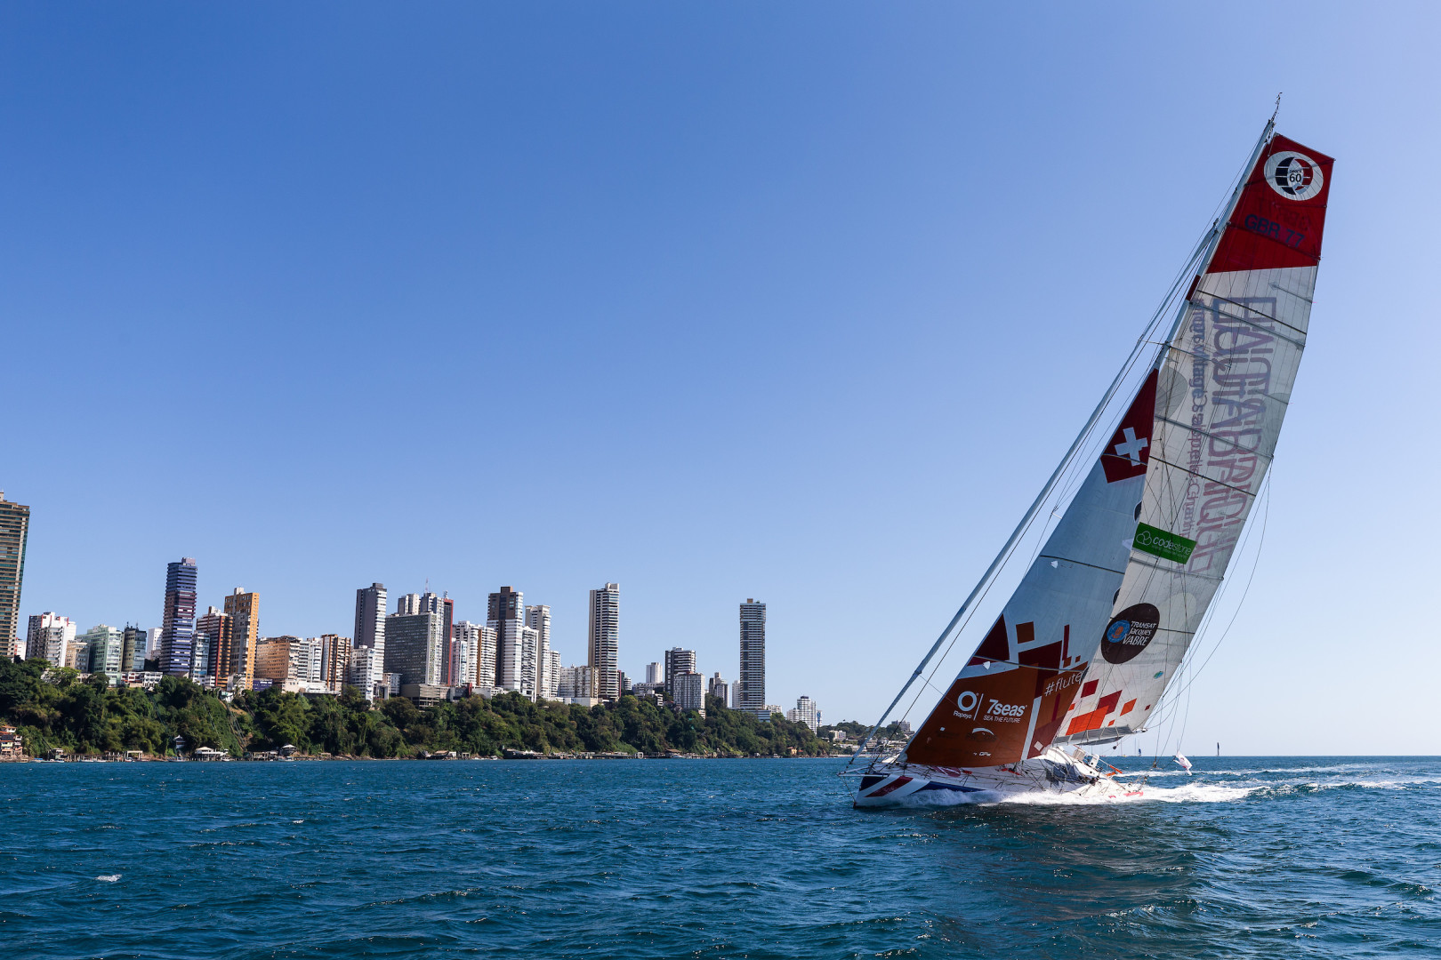
Superbigou approaches Salvador de Bahia
Pip Hare and her team-mate Ysbrand Endt have completed the Transat Jacques Vabre (TJV), finishing just minutes ahead of their closest rival. Pip’s boat Superbigou crossed the finish line at 17:26 UTC on 14th November, 10 minutes ahead of Alexia Barrier’s 4MyPlanet, with whom they had been jostling for position throughout the race.
Sailing races frequently devolve into races within races, and this was no exception. For nearly a week the two competitors traded places in the dash south from the Cape Verde islands, culminating in a nail-biting finish. “All day today, we’ve been within sight of each other,” said Pip in her final video as they approached Salvador de Bahia. “There’s been times where we’ve been within 100m of each other. Today, the most we got out was about two miles from each other.” The distance between the two boats had narrowed to 0.3NM when 4MyPlanet crossed Superbigou’s stern just 20 miles from the finish, but from there the gap gradually widened as Pip and Ysbrand sailed in to gain 24th place in the IMOCA class. They finished with a time of 18 days, 5 hours, 11 minutes and 43 seconds, 20.5 hours ahead of the final, 27th finisher.
Early in the race – following the beat north from Le Havre – Pip recorded a Facebook video in which she expressed disappointment at their position in the fleet, but Pip, Ysbrand and Superbigou soon proved a formidable team, keeping position with the non-foiling IMOCA 60s and demonstrating that the TJV was far more than a qualifying sail, but something to which they planned to give their all. Despite several wipe-outs, a leak in the pipework to one of the buoyancy tanks and problems with the water maker, they kept up the pressure on the boat and themselves throughout the race. With 4MyPlanet in their sights, Pip and Ysbrand took turns hand-steering when the autopilot struggled, switching to hourly watches as the heat made being in direct sunlight too much to bear for more extended periods.
Pip’s completion of the TJV puts her one step closer to her ultimate goal: the 2020-2021 Vendée Globe. The TJV is one of five acceptable qualifiers for the Vendée, the others being the Route du Rhum, the Transat, the New York-Vendée, and the previous edition of the Vendée Globe. One race is rarely enough to qualify, however – most competitors will need to sail a minimum of one additional single-handed race of at least 2,000 miles or more to meet the criteria, and newcomers will usually sail all the qualifiers in order to build miles. Places are guaranteed to those who participated in the 2016-2017 Vendée or are sailing a new boat, with the remaining positions allocated by accumulated miles. Pip is on the list to take one of the 34 remaining places, and finishing this race ensures she retains it.
About the Vendée Globe race
The Vendée is the premier event of the ocean racing calendar. The competitors will start from Les Sables d’Olonne on Sunday 8th November 2020, sailing south to Cape Horn and circling the notoriously treacherous Southern Ocean from west to east before returning to the starting point in 2021. With no outside assistance allowed, the skippers are truly alone in their endeavours, a point illustrated by the fact that in the eight events so far, fewer than 100 people have completed the race. As a comparison, more than 5,000 have reached the top of Everest.
For more information, visit piphareoceanracing.com.
For more images and videos, visit Pip’s Facebook page @PipHareOceanRacing
INFORMATION
Contact
David Pugh
Saltwater Stone
––
d.pugh@saltwater-stone.com
+44 1202 669 244
––
piphareoceanracing.com
saltwater-stone.com
––

