APPROVED PRESS RELEASE 12th July 2019
Malaysian petroleum storage and distribution project to use Rotork control network and electric actuators
Rotork’s Pakscan™ control system will be used to control hundreds of additional intelligent Rotork IQ actuators at a new petroleum terminal in Malaysia.
Neway Valve (Suzhou) Co Ltd has ordered more than 570 IQ3 multi-turn actuators to be installed on gate and ball valves ranging from 8 to 42 inches at the Pengerang Deepwater Petroleum Terminal. The site is operated by Pengerang Terminals (Two) Sdn Bhd.
Phase two of the project involved the construction of storage and distribution facilities needed to transport crude oil, petroleum, chemical and petrochemical products to the Refinery & Petrochemicals Integrated Development (RAPID) tank farm, also in southern Johor. The second phase also included the construction of Liquefied Natural Gas (LNG) facilities, comprised of a regasification unit and two 200,000 m3 LNG storage tanks, as well as the building of berths for the loading and unloading of LNG vessels.
The project’s third phase got underway in May and will see the construction of petroleum and petrochemical storage tanks for medium to long term customers.
Rotork’s IQ3 actuators will be used to control the flow of the products on to carriers which use a deepwater jetty with depths up to 24 metres to carry products to the two sites, and will also ensure the complete isolation of the hydrocarbon products to prevent contamination. The Pakscan network bus system will be connected to seven hot standby Rotork Master Stations.
Suitable for use in all industries, the Rotork Master Station is capable of operating up to 240 actuators across three separate field networks allowing the optimum network to be used in different plant areas. It supports Modbus® RTU protocol with third party device integration and Pakscan Classic, Rotork’s standard two-wire closed loop system, which has more than 170,000 existing devices installed in networks around the world. The Rotork Master Station can be supplied with built-in redundancy support via a hot standby configuration, allowing a replica unit to assume network control in the event of an error in the primary unit.
The end user is already successfully operating IQ3 actuators at six other sites in the Pengerang Integrated Petroleum Complex, a 6,239 acre downstream development in Malaysia.
The local support offered through Rotork Site Services (RSS) was also key in securing the order. RSS is carrying out extensive on site commissioning of both the IQ3 actuators and Rotork Master Stations. RSS provides field support for repairs, commissioning, upgrades and maintenance through a global network of fully trained and experienced service engineers. With support for both Rotork and non-Rotork products available, RSS can also assist with planned shutdown support through project management and supervision, on-site overhaul and testing, and a large stock of OEM spares.
END

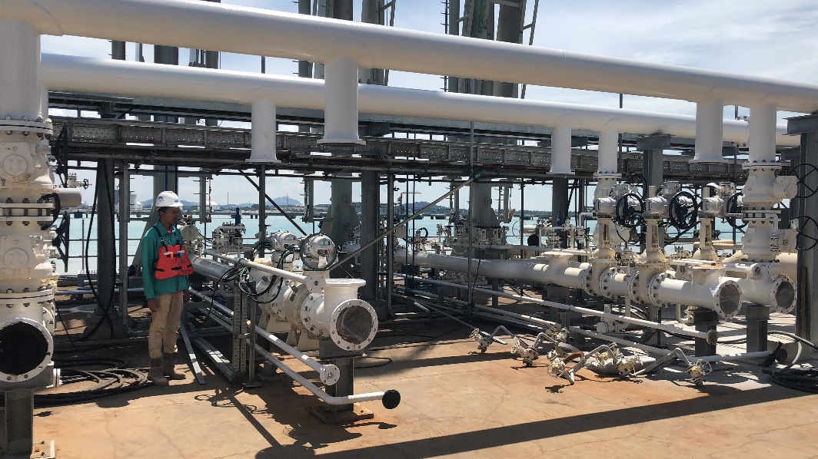
Photo captions
Caption 1: Some of the IQ3 actuators at the terminal during installation.

For further information please contact Rotork PLC
Sarah Kellett/Liam Jones Brassmill Lane
Group Marketing Communications Manager Bath
Telephone: +44 (0) 1225 733492 BA1 3JQ
Email: Sarah.Kellett@rotork.com / Liam.Jones@rotork.com UK

About Rotork
Rotork is the market leading actuator manufacturer and flow control company that operates in any market where the flow of gases or liquids needs to be controlled. It has established manufacturing facilities, a global network of local offices and agents who can truly provide a worldwide service. You will be able to locally source Rotork’s products, supported by life-of-plant maintenance, repair and upgrade services.

