Press release
The Non-Violence Project Foundation (NVPF) May 12th 2020, Geneva

The Non-Violence Project Foundation (NVPF) trained over 23,000 people in 2019 to prevent and reduce violence

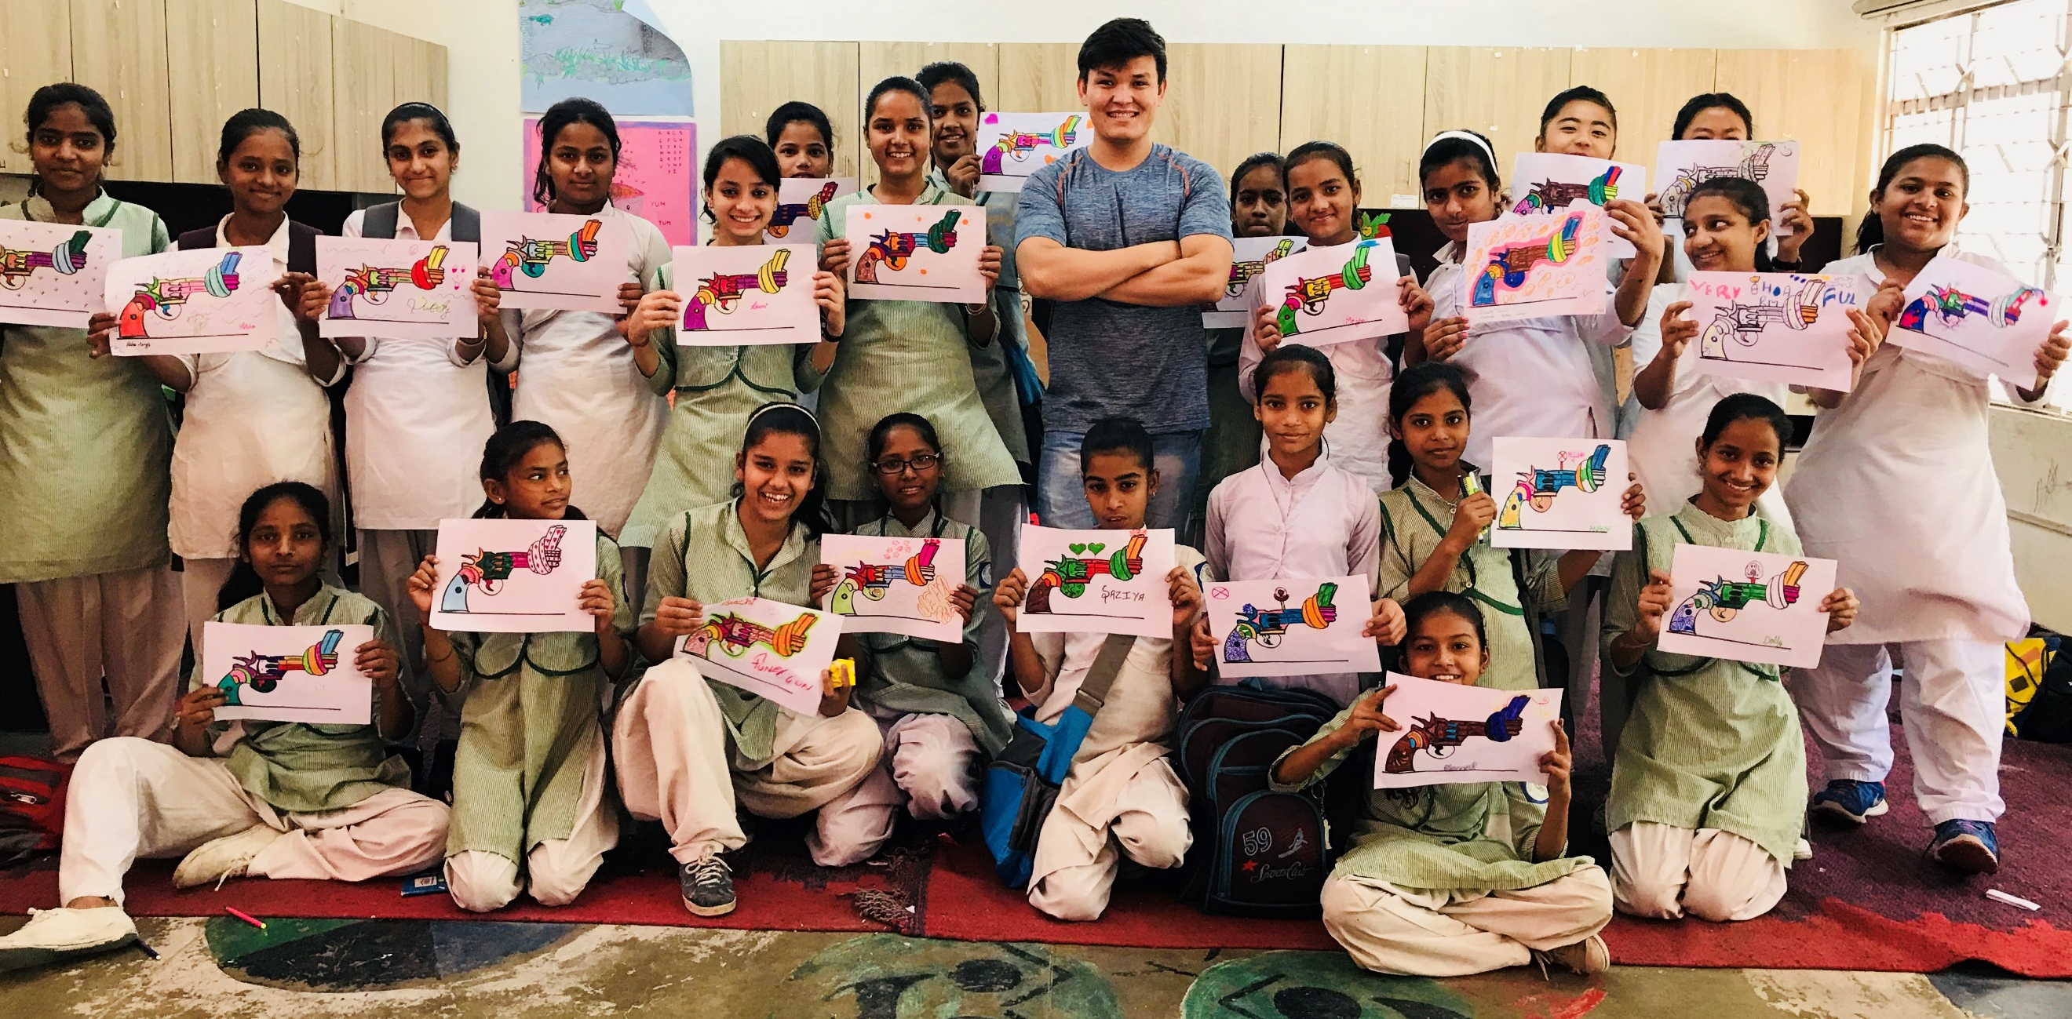

The Non-Violence Project Foundation (NVPF), whose mission is to prevent and reduce violence around the world, has today released its 2019 Evaluation Report outlining the foundation’s contribution to the global effort to stem violence across the globe. In 2019, NVPF trained 23,778 students, 1,587 teachers/trainers and 7,500 volunteers, on four continents.

The report also shows the impact of NVPF educational programs on youth, adults and communities. The results are measured through the systematic use of assessment tools applied to all countries where NVPF is active.

“World leaders, departments of education, schools, but also businesses and administrations must act to stem the violence and we know that the solution lies in education, as this report demonstrates once again. Our goal is to reduce violence by at least 30% in the areas where the Foundation is active and increase the number of beneficiaries of our programs.
Our work, which mainly depends on donations, sponsors and the help of volunteers, is today all the more needed with the dramatic rise of domestic and children abuse generated by the Covid 19 pandemic’s lockdown” says Blaise Oberson, CEO of NVPF.

NVPF has a 27 years expertise in fighting violence through education and has trained more than 8 million people since 1993. The Foundation has received numerous awards such as the Daily light award by Bill Clinton and the Presidents call to service award by Barack Obama.

“Based on the results gathered, we are pleased to confirm that our education efforts are indeed serving for making a much-needed change in the world. The positive improvement that participants experience through the development of their social, emotional and cognitive (SEL) skills are key indicators that prove that there is a real impact on reducing violent behaviour," adds Ivana Busljeta, Global Director of Education, NVPF.

Key figures and most significant results achieved 2019*

In 2019, NVPF trained 23,778 students, 1587 teachers/trainers, 7500 volunteers in 49 schools (without including number of schools in Mexico) over four continents.

- A greater aptitude to manage conflictual situations in any environment (academic, sportive, work…).
  - in India, 84% of the students who followed a non-violence training felt they were able to handle these situations in a different and more positive approach.

- An increased capacity to recognize harassment (moral, school, sexual) and act upon it.
  - in Switzerland, 85% of the students trained on sexual harassment stated they felt more prepared to face and deal with this issue both during their professional studies or their future career.

- A reduction in school violence
  - both in Uganda (-36%) and Sweden (-50%), the violent episodes decreased dramatically where a NVPF program was implemented.

- A stronger skillset of the teachers, coaches or community leaders who will deploy and implement NVPF programs to students of all ages
  - 87% of the teachers trained in Japan, are convinced of the efficiency of the program and feel ready to distribute them in the various schools

*Figures are based on answers provided by NVP Program participants in the countries mentioned. The full report is available here

For more information about NVPF
Blaise Oberson, CEO, NVPF - Email: blaise@nonviolence.com
For information about our educational programs
Ivana Busljeta, Director of Global Education, NVPF - Email: ivana@nonviolence.com

