FOR IMMEDIATE RELEASE

NIKE VISION ANNOUNCES NEW
WOMEN’S TRAINING SUNGLASSES COLLECTION
Collection Features Five Styles, Merging Fashion and Sport for Active Women

Today, premium sports eyewear brand Nike Vision announces the release of its Women’s Training Collection, designed for the needs of female athletes. The new sunglasses collection merges fashion and sport, and features five new styles: the Nike Flex Motion, Nike Flex Momentum, Nike Flex Finesse, and releasing in March of 2017, the Nike Helix Elite. The collection also includes color updates to the Nike Vital.

Developed using insights from top Nike female athletes, the Women’s Training line includes the innovative benefits of Nike’s performance eyewear in fashion-forward frames. The collection’s on-trend styles are complimented by sophisticated colorways, as well as premium metal accents. The frames are composed of lightweight nylon, and utilize bendable rubber temple arms and comfortable nose pads for a secure fit during activity. They also feature Max Optics with lens tints engineered to provide protection from the elements and precise clarity from every angle.

“We’re excited to offer our athletes a versatile collection that meets the growing demand for highly-functional performance products that don’t sacrifice style,” said Jackie Bronfeld, Retail Channel Marketing Manager at Marchon, Nike’s global eyewear licensee. “With contemporary frames and sleek metal details, the Women’s Training line allows actve women to seamlessly transition from workout to everyday wear.”

Women’s Training Styles for Fall 2016- Spring 2017 include:

NIKE FLEX MOTION
Rounded angles and mixed materials reveal an unexpected profile, both elegant and sporty. Metal accents give these sunglasses an edge, and excellent optics and durability make them tough enough for any activity. Available in four colorways.

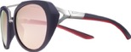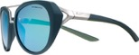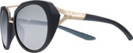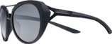

NIKE FLEX MOMENTUM
Sleek curves add sophistication to an updated aviator style. Ventilation and a lightweight frame provide comfort before, during, and after your workout. Available in five colorways.

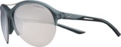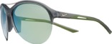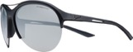

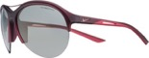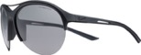

NIKE FLEX FINESSE
Lightweight and durable with a shape that gives a nod to the cat-eye frame, these are ideal sunglasses for transitioning from your workout to the rest of your day. Available in five colorways.

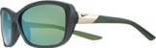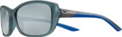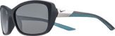

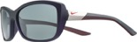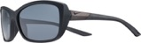

NIKE HELIX ELITE (Releasing in March ’17)
Nike +ZEISS Optics provide extraordinary clarity on the innovative one-piece lens on the Nike Helix Elite. The super-lightweight, aerodynamic combined lens-frame features rubber channels and ventilated temple arms for fog prevention and increased airflow. Available in four colors.

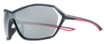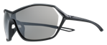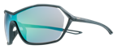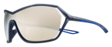

NIKE VITAL
With two new colorways added to the pre-existing style, the Nike Vital is designed and built for active women. The Nike Vital features a square, female-specific six-base frame with a rubber nose bridge and temples, delivering stay-put comfort—even during dynamic movement. Available in four colors.

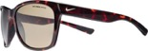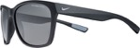

The 2016 Women’s Training Collection is now available for purchase at Nike.com. For more information, visit nikevision.com, and follow along on social media at @NikeVision.

ABOUT NIKE, INC.
NIKE, Inc., based near Beaverton, Oregon, is the world's leading designer, marketer and distributor of authentic athletic footwear, apparel, equipment and accessories for a wide variety of sports and fitness activities. Wholly owned NIKE subsidiaries include Converse Inc., which designs, markets and distributes athletic footwear, apparel and accessories and Hurley International LLC, which designs, markets and distributes action sports and youth lifestyle footwear, apparel and accessories. For more information, visit www.nikeinc.com and follow @Nike.

ABOUT MARCHON EYEWEAR, INC.
Marchon Eyewear, Inc. is one of the world's largest manufacturers and distributors of quality eyewear and sunwear. The company markets its products under prestigious brand names including: Airlock, Calvin Klein Collection, Calvin Klein platinum, Calvin Klein Jeans, Chloé, Columbia Sportswear, Diane von Furstenberg, Dragon, Etro, Flexon®, G-Star RAW, Karl Lagerfeld, Lacoste, Liu Jo, Marchon NYC, Marni, MCM, Nautica, Nike, Nine West, Salvatore Ferragamo, Sean John and Skaga. Marchon distributes its products through numerous local sales offices serving over 80,000 accounts in more than 100 countries.

