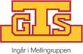

Göteborgs Truckservice GTS AB has been appointed to general agent for SANY GERMANY’s machinery
- including reach stackers, empty container handlers, heavy duty forklifts and other harbour and terminal equipment

Last Friday the agreement concerning general agency for SANY’s products on the Swedish market was signed by Göteborgs Truckservice GTS AB and SANY Germany GmbH. The agreement includes marketing, sales, service and maintenance of SANY’s complete product range for harbour and terminal machinery.
SANY Germany GmbH is a German company wholly owned by the Chinese SANY Group. Being a general agent enables GTS to sell and rent out SANY:s reach stackers, empty container handlers, heavy duty forklifts and other harbour and terminal equipment on the Swedish market.
SANY Germany has in just a few years time successfully developed their business in Europe, and the agreement with GTS is another step in their European venture. It will also be a take off for GTS future ambitions.

”- It feels very exciting to be a part of the SANY launch in Sweden. The product range holds a very high quality level and the products are, even in the basic models, very well equipped. Major focus has been assigned to driver and performance safety. SANY has a number of innovative solutions that are unique on the market. The products are developed by European specialists and built at the SANY plant in Bedburg, Germany. The SANY machinery are definitely competitive and we see a large potential on the Swedish market”, says Antti Laakso, Managing Director, Göteborg Truckservice GTS AB.

GTS has already started the sales of SANY’s machinery in Sweden and negotiations about the first deliveries are on-going.

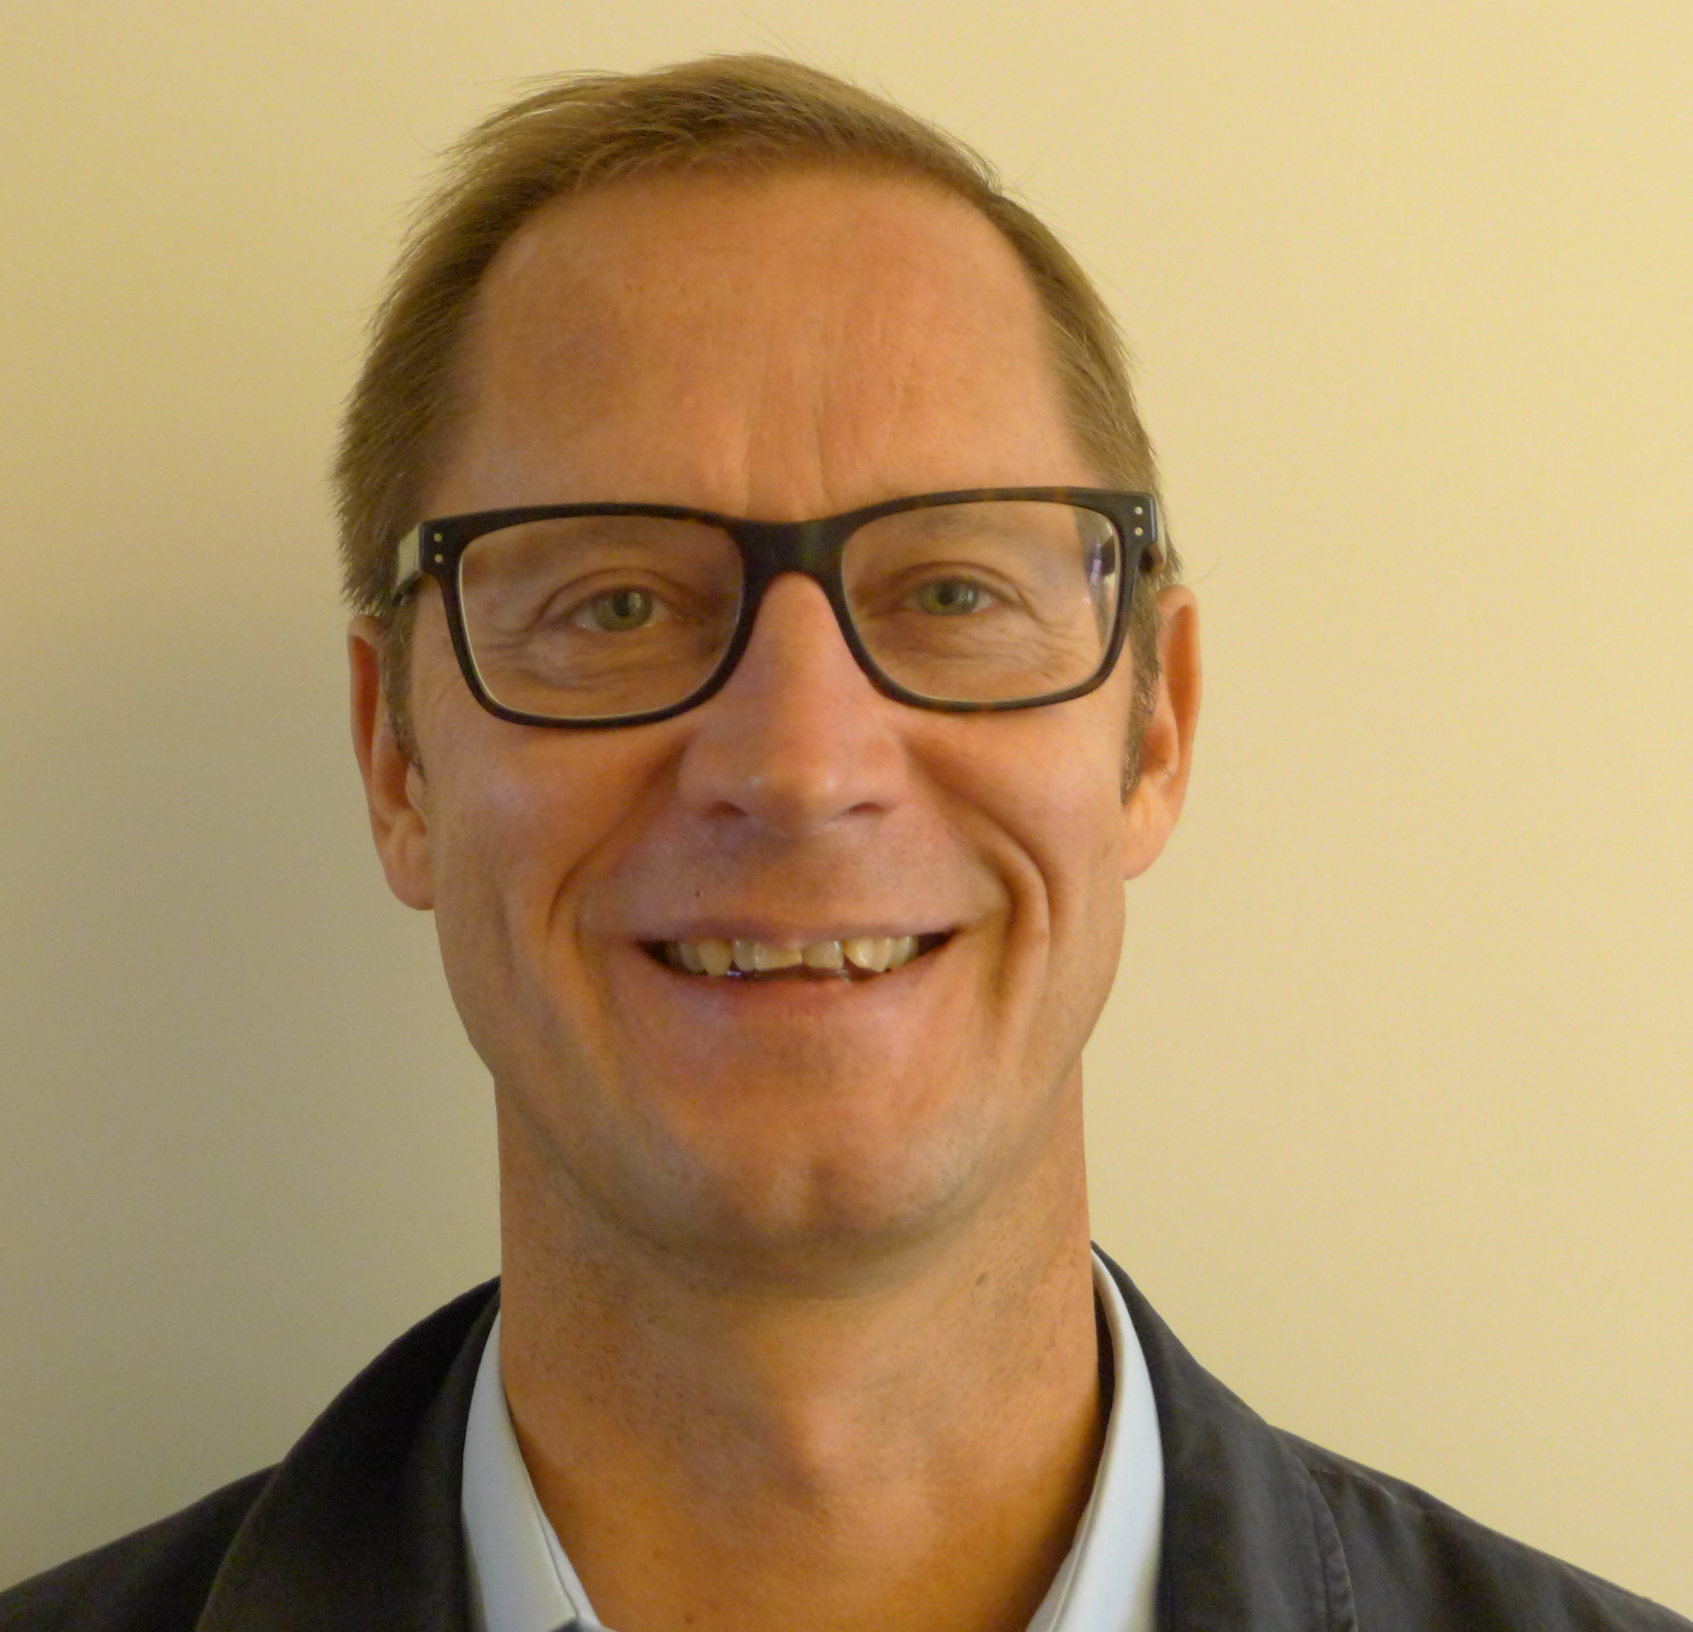 | For more information please contact:  Antti Laakso, Managing Director, Göteborgs Truckservice GTS AB  Tel. +46 31 7272 45 44, mobile phone +46 707 500 581  E-mail: antti.laakso@gts-truck.se

Facts
Göteborg Truckservice GTS AB, founded in the 1960-ies, is working with analysing and optimising their customers machinery and range of machinery. This is made by selling new and used heavy trucks and machinery and by rental of machinery to harbours and terminals as well as industries and storage facilities. Service and maintenance are also offered. https://www.gts-trucks.se
SANY Group was founded in 1989 and has during the last 20 years developed to be one of the worlds largest companies within construction equipment industry. SANY Germany, a part of SANY Group, was founded 2008. They manufacture heavy machinery within mining, concrete equipment, earth moving and ports. In 2012 SANY had a turnover of over 10 billion Euros and had over 40 000 employees world wide.
http://www.sanygroup.com/group/de-de/

