APPROVED PRESS RELEASE (3.1157) 19th August 2020
Low powered solenoid provides energy efficient solution at United Arab Emirates wellheads
Thousands of Bifold FP low powered hydraulic solenoids from Rotork have been installed on 170 new wellhead panels in the United Arab Emirates as part of an oilfield expansion project.

The customer required a low power, high pressure and high flow solenoid so Bifold FP02 hydraulic solenoids were installed with low powered coils as part of the construction of new wellheads in this project and play a critical role in this application. Wellhead applications require a solution which can operate on minimal power due to the difficulty involved in providing a power supply to remote locations.

Wellhead control panels are essential to the safety of the wellhead and are designed for monitoring, controlling and shutdown of valves on the wellhead. The solenoid ensures that the valves can always be opened and closed from a control panel, providing Emergency Shutdown (ESD) functionality. They were used in conjunction with Bifold quick exhaust valves to operate the wellhead actuators in the specified open/close times.

The SIL3 certified solenoids are powered by solar panels installed on the wellhead and while most solenoids draw power continuously in order to operate, the FP02 solenoid uses an integrated circuit board so that when it is energised it is able to remain in place on only a negligible amount of power, 1 W is used, rather than 3.5 W continuous, while maintaining their operation at 450 bar. Within our solenoid range options are also available for 5.7 W coils, taking them down to 2.8 W continuous (dependent on application). This allows higher flows/pressures to be controlled with reduced power solenoid valves.

The power required to energise a solenoid valve is generally two to three times higher than the power used to hold it in place. The integrated circuit board contains electronics to control the power delivered to the solenoid. Once the solenoid is energised, the circuit board limits the power to the coil in order to hold it in its energised position. When movement is required, it can reach heights of 8 W meaning that even though the overall power consumption of the solenoids remains low, they have the capacity for high pressure applications.

Often solenoids can experience a rise in temperature by up to 45 °C when they operate at 5.7 watts, which can pose a real threat to safety in desert applications where the ambient temperatures are already high. This can be avoided with the low powered solenoids as the current flowing through it remains at a low level for most of the time and it therefore does not increase in temperature. Additionally, all low-powered solenoids are ATEX certified.

END
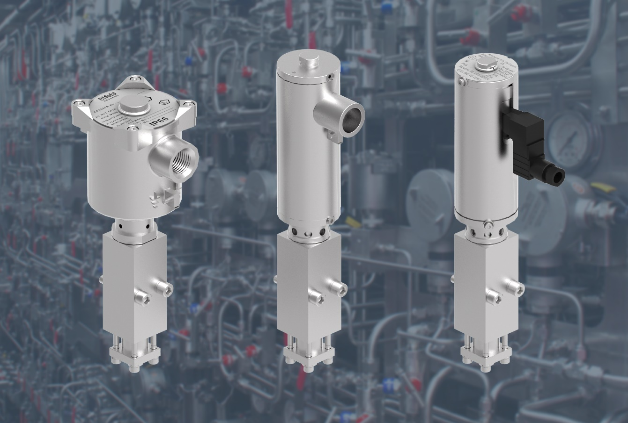
Photo caption
Bifold FP low powered hydraulic solenoids use an integrated circuit board so that when they are energised they are able to remain in place on only a negligible amount of power.

For further information please contact Rotork PLC
Sarah Kellett Brassmill Lane
Group Marketing Communications Manager Bath
Telephone: +44 (0) 1225 733492 BA1 3JQ
Email: Sarah.Kellett@rotork.com UK

About Rotork
Rotork is a market-leading global provider of mission-critical flow control and instrumentation solutions for oil and gas, water and wastewater, power, chemical process and industrial applications. We help customers around the world to improve efficiency, reduce emissions, minimise their environmental impact and assure safety.

