

**PRESS RELEASE STOCKHOLM, 17-12-2021**

DAILY SPORTS – FUNCTIONAL   
FEMININE CLOTHING

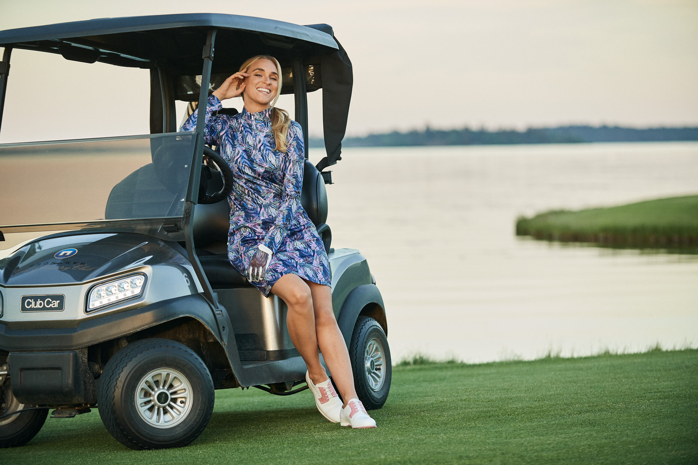

Pacific long-sleeved top in jersey fabric for protection against the sun, with matching skort.

Through the ages, women have often had to choose between being fashionable or being comfortable. A totally unnecessary dilemma, as far as Daily Sports is concerned. It’s entirely possible to create pants that are the perfect fit without a waistband that pinches, skirts you can wear without having to adjust how you move, and functional jackets with a feminine shape. Moreover, their garments are functional and so comfy that you’ll want to wear them for more than just golf.

Perhaps that aspect of their success is not so surprising. After all, at Daily Sports they only have female employees, and a female CEO and owner, who all know how liberating it is to wear something that’s both stylish and comfortable.

This is evident in their collection to be launched for Pre Spring 21-22. The collection is divided into three parts. One in shades of pink, white and butter yellow with graphic, asymmetric patterns. The second offers sporty elegance in turquoise and black, accentuated by white and beige. And lastly, pink once again, combined with white and two shades of blue. It feels as if much of the inspiration is drawn from the coastline and the dynamism of the ocean that provides both energy and a sense of calm.

* “Let’s turn up the colour and fun and dance into spring and summer! We need something to lift our spirits,” says Ulrika Skoghag, CEO of Daily Sports.

See the new collection at [www.dailysports.com](http://www.dailysports.com/)

**FOR MORE INFORMATION, PLEASE CONTACT:**

Tina Lindkvist

Project Manager, Marketing

Tel: +46 722-51 62 30

E-mail: [tina.lindkvist@dailysports.se](mailto:tina.lindkvist@dailysports.se)

Daily Sports is today one of Sweden’s biggest suppliers of golf clothes for women. We sell our golf and active wear in 26   
countries. Daily Sports clothing is famed for its feminine fit, focus on function and attractive details.   
Featuring designed patterns and matching combinations, the clothing is for both leisure and at work.

The company was founded in Sweden in 1995 with the aspiration to make women want to be active. Our current turnover   
is about SEK 80 million, of which the Swedish market accounts for about SEK 25 million.

Tulegatan 47 T +46 (0)8 120 105 00

113 53 Stockholm, Sverige

info@dailysports.se www.dailysports.com