2017

Specsavers County Championship

Bulletin – Week 16

Fixtures

Division One
Essex v Yorkshire
Lancashire v Surrey
Somerset v Middlesex
Warwickshire v Hampshire

Division Two
Gloucestershire v Derbyshire
Kent v Glamorgan
Leicestershire v Northamptonshire
Sussex v Nottinghamshire
Worcestershire v Durham

For more information
Email: Andrew.Walpole@ecb.co.uk

Opta Facts – Division One
Essex v Yorkshire

- Essex have beaten Yorkshire just twice in their last 15 meetings, one of those wins came at Scarborough earlier this season however.
- In Essex, Yorkshire are unbeaten in seven visits (W4, D3), although the last of these meetings was in 2012.
- Yorkshire’s win in the last round ended a winless run of six matches, their worst run since drawing eight on the trot in 2012.
- Jamie Porter (70) and Simon Harmer (67) remain the leading wicket takers in Division One this year, no other Essex player has more than 27 (Neil Wagner).

Lancashire v Surrey

- Six of the last eight meetings between these sides have ended in a draw, with both teams picking up one win apiece in the process.
- Surrey have won just once on their last nine trips to play Lancashire away from home (D4, L4).
- Kumar Sangakkara is the leading run scorer this season with 1442 to his name for Surrey, since he joined the club in 2015 he has scored 3,351 runs, only three players in the County Championship have notched up more in that time (Sam Northeast, Mark Cosgrove, Mark Stoneman).
- Lancashire have lost two games on the spin, they haven’t lost three in succession since 2001.

Somerset v Middlesex

- Somerset have picked up just two wins in their last 30 meetings with Middlesex (D20, L8) and are winless in their last seven clashes (D5, L2).
- Middlesex are unbeaten on their last four trips to play Somerset away from home (W3, D1).
- Somerset are in danger of bringing to an end their 10-year stay in the top division.
- Middlesex are looking for back to back victories for the first time since July last year, the second of those victories last year was against Somerset.

Warwickshire v Hampshire

- Hampshire are unbeaten in seven against Warwickshire (W3, D4), with their last defeat coming in 2010.
- The last two games between these sides in Warwickshire have ended in draws, the last time there was a longer such run however was a five game streak in the 1950s.
- Gareth Berg has scored 67 runs from sweep shots this season, more than any other player in either division.
- Warwickshire have lost four games in succession, the last time they lost five in a row was across the 1955 and 1956 seasons.

Opta Facts – Division Two
Gloucestershire v Derbyshire
- Gloucestershire are winless in six games against Derbyshire (D4, L2), their last such victory coming in 2012.
- These sides last met each other in the month of September back in 2008, their last 14 clashes falling outside of this month late in the season.
- Hardus Viljoen’s 15/170 against Sussex remain the best match bowling figures this season.
- Wayne Madsen is one of three players to hit 5+ scores of 50+ but not score a century this season.

Kent v Glamorgan
- Kent are unbeaten in their last five against Glamorgan (W2, D3) and have not lost at home against the side from Wales since 2011 (W1, D4).
- Kent are unbeaten in 12 games at Canterbury (W4, D8), their last defeat at their main venue coming in August 2015 against Northamptonshire.
- Sam Northeast has scored 3,516 runs since 2015, more than any other player in the County Championship.
- Marchant de Lange has scored 52 runs from slog shots this season, more than any other player in either division.

Leicestershire v Northamptonshire
- Northamptonshire are unbeaten in 11 against Leicestershire (W3, D8), their last such defeat coming in 2010.
- Leicestershire are still searching for their first home win of the season (D3, L3), overall they’ve won just once in their last 16 on their own patch (D8, L7).
- Rob Newton has a division high 11 scores of 50+ this season, but that includes just one century.
- Rory Kleinveldt has the best batting SR of anyone to play more than one match this season (98.98); meanwhile his figures of 9/65 v Nottinghamshire last round are the best innings figures this season.

Sussex v Nottinghamshire
- Nottinghamshire have won their last three against Sussex, the last time either side went on a longer winning streak in the history of this fixture was when Sussex won eight in a row in the 1960s.
- Only one of Sussex’s last nine home games have ended in a draw (W4, L4).
- Chris Read has a league high 50 dismissals this season, all of them catches.
- Nottinghamshire have lost two games in a row, the last time they lost three in succession in Division Two was in 2001.

Worcestershire v Durham
- Durham are unbeaten in 13 against the Pears (W9, D4), last losing against them in 2003.
- The last six clashes between these teams at New Road have alternated between draws and away wins, if this run were to continue we would be due a draw.
- Three wins in a row have put Worcestershire in the driving seat to win promotion to Division One, if they finish the season how they started it (four wins in a row) they will return to the top flight in 2018.
- Daryl Mitchell has scored 222 of his 1,138 runs from cut shots this season, no other player has scored more than 166 (Alastair Cook) via this method in either division.

2017 Tables

Division One
Team | P | W | L | D | Bat | Bowl | Deduct | Points
Essex | 13 | 9 | 0 | 4 | 27 | 37 | 0 | 228
Surrey | 13 | 2 | 1 | 10 | 46 | 31 | 0 | 159
Lancashire | 13 | 4 | 3 | 6 | 27 | 35 | 0 | 156
Yorkshire | 13 | 4 | 4 | 5 | 24 | 32 | 0 | 145
Middlesex | 13 | 3 | 3 | 7 | 28 | 34 | 2 | 143
Hampshire | 13 | 3 | 3 | 7 | 24 | 33 | 0 | 140
Somerset | 13 | 3 | 6 | 4 | 23 | 36 | 0 | 127
Warwickshire | 13 | 1 | 9 | 3 | 19 | 28 | 0 | 78
Middlesex deducted two points for a slow-over rate.
Division Two
Team | P | W | L | D | Bat | Bowl | Deduct | Points
Worcestershire | 13 | 8 | 3 | 2 | 42 | 36 | 0 | 216
Nottinghamshire | 13 | 7 | 2 | 4 | 39 | 39 | 0 | 210
Northamptonshire | 13 | 8 | 3 | 2 | 28 | 36 | 5 | 197
Sussex | 13 | 7 | 5 | 1 | 30 | 36 | 0 | 183
Kent | 13 | 4 | 1 | 8 | 32 | 33 | 0 | 169
Gloucestershire | 13 | 3 | 3 | 7 | 28 | 33 | 0 | 144
Glamorgan | 13 | 2 | 7 | 4 | 24 | 37 | 0 | 113
Derbyshire | 13 | 2 | 7 | 4 | 24 | 30 | 0 | 106
Durham | 13 | 3 | 5 | 5 | 35 | 34 | 48 | 94
Leicestershire | 13 | 0 | 8 | 5 | 32 | 31 | 16 | 72
Durham deducted 48 points ahead of the 2017 campaign.
Leicestershire deducted 16 points for a breach in player conduct.
Northamptonshire deducted five points for a slow-over rate.

Head-to-head records – County Championship
 | Essex | Yorkshire
Games | 161 | 161
Won | 26 | 84
Lost | 84 | 26
Drawn / Tied | 51 | 51
Win % | 16% | 52%
 | Lancashire | Surrey
Games | 185 | 185
Won | 42 | 55
Lost | 55 | 42
Drawn / Tied | 88 | 88
Win % | 23% | 30%
 | Somerset | Middlesex
Games | 162 | 162
Won | 24 | 85
Lost | 85 | 24
Drawn / Tied | 53 | 53
Win % | 15% | 52%
 | Warwickshire | Hampshire
Games | 159 | 159
Won | 50 | 44
Lost | 44 | 50
Drawn / Tied | 65 | 65
Win % | 31% | 28%
 | Gloucestershire | Derbyshire
Games | 128 | 128
Won | 47 | 31
Lost | 31 | 47
Drawn / Tied | 50 | 50
Win % | 37% | 24%
 | Kent | Glamorgan
Games | 102 | 102
Won | 38 | 28
Lost | 28 | 38
Drawn / Tied | 36 | 36
Win % | 37% | 27%
 | Leicestershire | Northamptonshire
Games | 187 | 187
Won | 49 | 43
Lost | 43 | 49
Drawn / Tied | 95 | 95
Win % | 26% | 23%
 | Sussex | Nottinghamshire
Games | 184 | 184
Won | 43 | 59
Lost | 59 | 43
Drawn / Tied | 82 | 82
Win % | 23% | 32%
 | Worcestershire | Durham
Games | 27 | 27
Won | 6 | 10
Lost | 10 | 6
Drawn / Tied | 11 | 11
Win % | 22% | 37%

Player Statistics 2017 – Division One

Most Runs Most Wickets

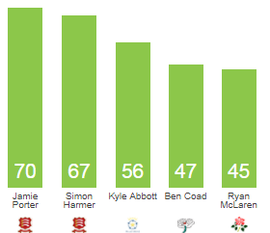
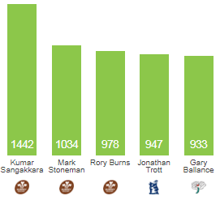

Most Fours Best Economy*

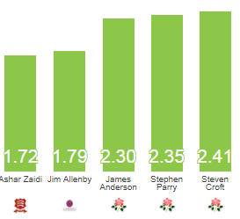
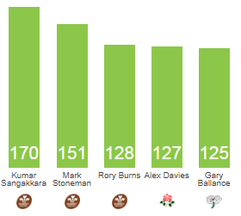

* 4+ Overs

Player Statistics 2017 – Division Two

Most Runs Most Wickets

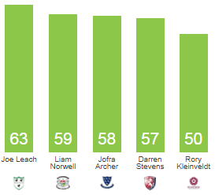
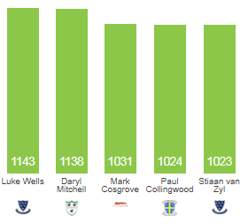

Most Fours Best Economy*

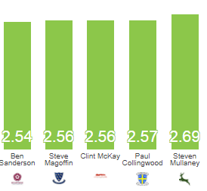
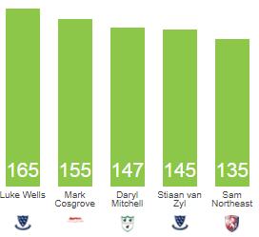

*4+ Overs

