Biovac Environmental Technology AS acquires BRA Miljöteknik Sverige AB (BMS)

BMS was founded in 2011 by Terje Skaarnes, and the company's foundation was and is the distributor agreement with Biovac for the Swedish market. Since then, a competence-driven organization with an extreme focus on technical sales has built up a strong and leading position in Sweden, including a significant service portfolio.
Biovac Environmental Technology AS entered as co-owner in November 2014 with a share of 33.5%, as a consequence of a joint desire for closer cooperation between the companies. This share has increased to 100% as of January 25th 2019.
- We have always had local presence as one of our mainstays, and with a desire for a firm foothold for the Biovac group throughout Scandinavia, this acquisition is a natural part of our further strategy. BMS is a well-run company with a good reputation. With our experience and ability to execute, we will move the company on to a new level, says CEO of Biovac Group, Petter Mellquist.
Biovac Environmental Technology AS and BRA Miljöteknik Sverige AB will after the acquisition have a total turnover of just over NOK 200 million and approximately 60 permanent employees. In addition, there are more than a hundred service engineers and several hundred dealers of the Group's products and solutions.
- I am very proud of what I have achieved with my colleagues in Uddevalla and the rest of Sweden since 2011, with the Biovac products as the starting point for it all. But everything has its time, and now it was right to hand over the further development of the company to Biovac. It has been a fantastic journey, and I will keep an eye on the company in the continuation as well, says founder and former shareholder Terje Skaarnes.
- With this acquisition, Biovac is further positioning as Scandinavia's leading supplier of small and medium-sized wastewater treatment plants. What we are doing at Biovac, we do with regards to the future, concludes Petter Mellquist.

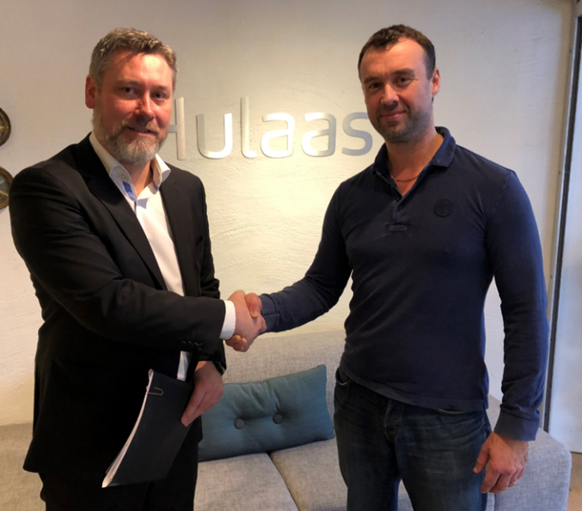
Petter Mellquist, CEO in Biovac Environmental Technology and Terje Skaarnes, former owner of BRA Miljöteknik Sverige AB

