Double podiums for Jessica Bäckman at the Nürburgring
Last weekend 5–7 August, Jessica Bäckman claimed two podiums in the fourth round of the ADAC TCR Germany at the legendary Nürburgring track in Germany. Jessica is still 2nd in the championship standings with 3 race weekends remaining.
- The weekend has been a bit tricky for us, we haven't really got the car exactly as we wanted this weekend, it's small margins in motorsport that are decisive. Despite this, I am very satisfied that we managed to leave Nürburgring with two more podium places this weekend. Looking forward to the next race weekend at the Lausitzring in two weeks, Jessica Bäckman says.
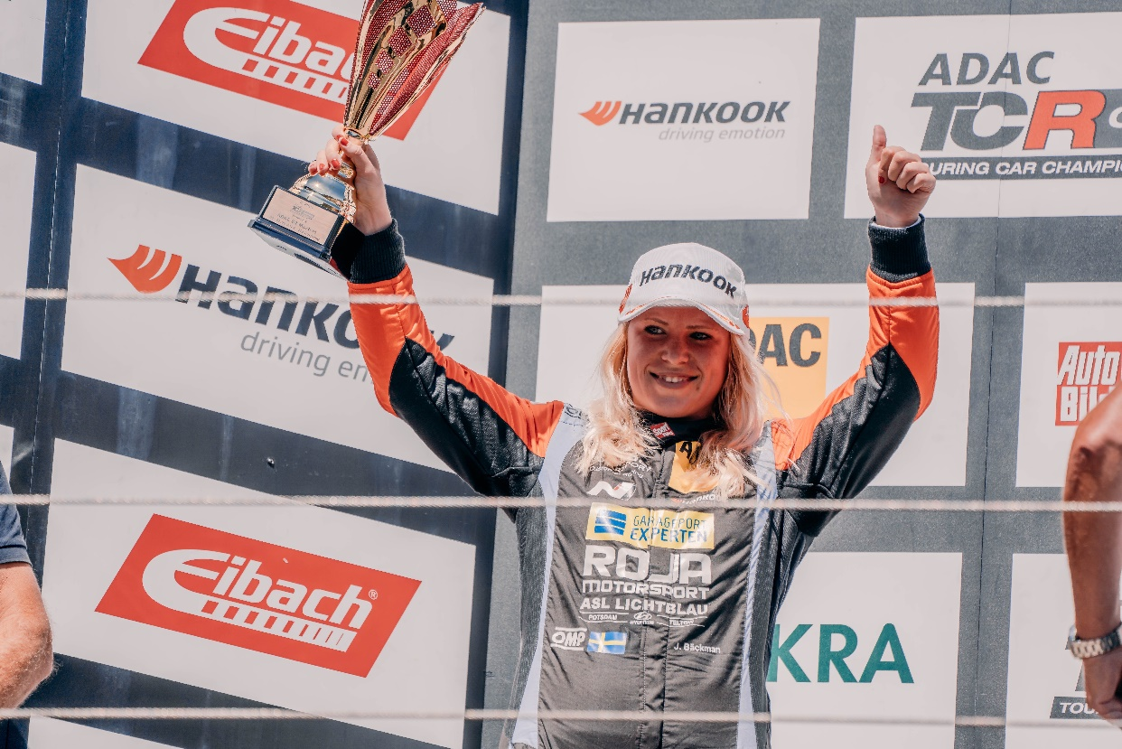
TCR Germany is one of the toughest TCR series in the world and has a high status for the drivers who come from several different countries around Europe. Each race weekend consists of two free practice sessions on Friday, one qualifying session on Saturday which determines the starting position in Race 1 on Saturday, and one qualifying session on Sunday which determines the starting position in Race 2 on Sunday. Points are awarded to the top 10 in the time qualifying and the top 15 in each race. The driver with the most points after the final race at the Hockenheimring at the end of October will take home the driver's title "ADAC TCR Germany Drivers Title" in the ADAC TCR Germany series. Last weekend, August 5-7, the fourth round of ADAC TCR Germany was run at the Nürburgring track in Germany, where Jessica finished on a third place and got fastest lap in Saturday's Race 1 and then took second place in Race 2 on Sunday.
- The weekend has been a bit tricky for us, we haven't really got the car exactly as we wanted this weekend, it's small margins in motorsport that are decisive. Despite this, I am very satisfied that we managed to leave Nürburgring with two more podium places this weekend. Looking forward to the next competition at the Lausitzring in two weeks, Jessica Bäckman says.
Difficult Saturday for Jessica Bäckman
The first qualifying on Saturday was a bit more difficult than usual for Jessica. The car didn't feel perfect, then she also ended up in a lot of traffic, which made it harder to set a good lap. The time was enough for a fourth place, which also became her starting position in Race 1. In Race 1, Jessica got a good start and was 4th in the first lap and was then aiming to catch up the 3rd place driver in front of her. After many overtaking attempts Jessica finally overtook the next driver and was now in third place, it was then 7 seconds up to the lead. Jessica gained 5 seconds in a total time of 8 minutes and also set the fastest lap of the race, but the race was a little too short to fully catch up and had to settle for a nice third place and fastest lap of the race.
- On Saturday, we didn't have the flow in qualifying, which made the race tougher. In the end I was happy with the day, I managed to get a podium and show good speed during the race, it was motivating to see the leaders in front of me and to be able to catch them more and more every lap, in such a situation I would have hoped the race was a few minutes longer, Jessica Bäckman says.
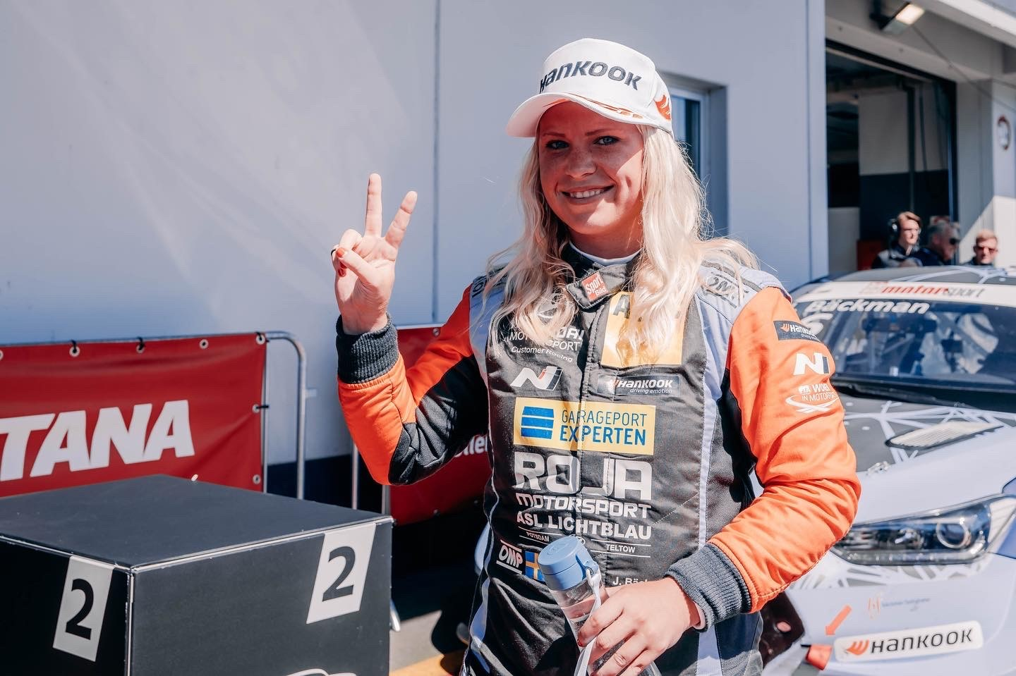
6 out of 8 podiums for Jessica in ADAC TCR Germany
On Sunday the team had made some changes to the car for qualifying in the morning and Jessica felt happy with the car. She set a good lap good enough for second place and then looked to improve on lap 2 but was again held up by traffic. This meant that Jessica had to start from box 2 in Race 2. In the race, Jessica got a super start and was in the lead on the first lap. But was heavily pressured from behind already after a few corners when the car did not catch up as she had hoped. She was overtaken by one car which then also gained a 2 second gap. When Jessica's car started to feel better, the leader and Jessica drove at similar lap times every lap so the gap neither decreased nor increased. Jessica finished the race in 2nd place and collected important points for the championship. This means that Jessica has now taken 6 podiums in 8 races this season, and 4 of these are wins. Jessica is still 2nd in the championship with 3 race weekends remaining.
- On Sunday, the car felt much better in qualifying, which was also enough for a second place, then I focused on making a good start and think this was my best start ever in my career. It's a shame that I didn't manage to keep the lead to the finish, but a second place is also very good. Overall, a good weekend for the team, now we recharge for the Lausitzring in two weeks, Jessica Bäckman says.
Jessica’s results:
Free Practice 1: 3rd place
Free Practice 2: 1st place
Qualifying 1: 4th place
Race 1: 3rd place
Qualifying 2: 2nd place
Race 2: 2nd place
Championship standings:
ADAC TCR Germany – Total (Top three)
ADAC TCR Germany 2022 (after 4 out of 7 rounds)
1: Martin Andersen (DKK), 234 p.
2: Jessica Bäckman (SWE), 205 p.
3: Szymon Ladniak (POL), 162 p.
Click to see full championship standings
TV links in case you missed the races:
Race 1: Click to watch Race 1
Race 2: Click to watch Race 2
Free rights to use images.

