Epson Launches First 12,000 lumen Native 4K 3LCD Laser Projector and New 20,000 lumen Projector

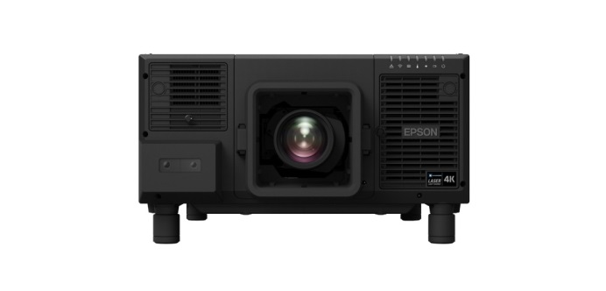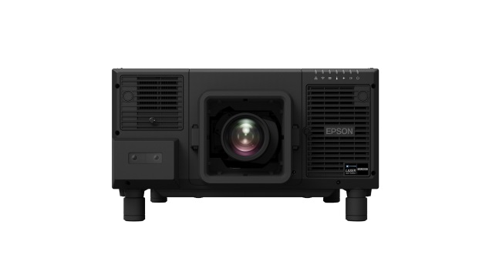
Epson EB-L12000Q (left) and EB-L20000U projectors (right)

Bangkok, 8 January 2019 – Epson, the number-one selling projector brand, announced the launch of two new 3LCD laser projectors – The EB-L12000Q, which is the industry’s first 12,000 lumen native 4K 3LCD laser projector and is one of the lightest in class, and the EB-L20000U, Epson’s first model in the 20,000 lumen WUXGA installation projection sector.

The new EB-L12000Q projector comes with the Epson-developed native 4K panel, delivering stunning 4K resolution at 3840 x 2160 pixels for more than ultra-high definition quality projections.

Driven by Epson’s proprietary laser light source, these powerful projectors are designed to expand Epson’s line-up in the high-end AV rental sector, and are suitable for use in demanding environments including rental and staging events, large auditoriums and digital signage installations.

The EB-L12000Q and EB-L20000U comes in a light and compact design, making them easy to integrate into existing infrastructure, and is a breakthrough in terms of size at this level of brightness. With Epson’s original laser light source structure and advanced electrostatic filter, the projectors deliver up to 20,000 hours of maintenance-free use.

The projectors come with a triple layer dust-proof structure housing a sealed optical engine for excellent durability and resistance, reducing airflow by 86% compared to the previous models, greatly reducing the risk of dust and smoke intrusion. A newly developed liquid cooling system maintains optimal temperatures of key optical elements within the sealed optical engine. Additionally, the projectors come with a mechanical shutter that protects the lens from laser light damage.

The projectors are designed to ensure maximum installation flexibility, and are able to rotate 360 degrees in any direction without loss in image brightness. A built-in camera enables remote diagnostics and setup. Epson’s new Professional Projector Tool software simplifies set-up of multi-projector installations and offers intuitive geometry correction such as automated edge-blending, curve correction and colour matching. Additionally, interchangeable interface boards mean greater flexibility and futureproofing, allowing for new interfaces and interface updates in future.

Both models are also compatible with the same 4K-compatible lenses used by Epson’s EB-L1000 series projectors for interchangeable use. Both projector models are compatible with the new zero lens offset ultra-short throw lens ELPLX02 with wider lens shift, useful for environments with extremely limited lens-to-screen distances. The new projectors also feature support for Hybrid Log Gamma and HDR10.

“We have achieved a new milestone with the EB-L12000Q with 4K native projection, bringing amazing quality resolution to our range of projectors. Both the projectors are able to offer a wide range of functions and ease of integration to existing infrastructure to the rental and staging sector with their compatibility of lenses and interchangeable interfaces, and are indeed an important addition to our high brightness line up,” said Ng Ngee Khiang, Regional Director, Visual Products & Robotics Solution Division, Epson Singapore.

The EB-L12000Q projector has been awarded the Good Design Awards 2018 for its design. The awards are presented annually for designs that benefit and enrich people’s lifestyles and society in general.

The EB-L12000Q and EB-L20000U projectors will be available for sale in the region in the second half of 2019.

***

About Epson
Epson is a global technology leader dedicated to connecting people, things and information with its original efficient, compact and precision technologies. With a lineup that ranges from inkjet printers and digital printing systems to 3LCD projectors, watches and industrial robots, the company is focused on driving innovations and exceeding customer expectations in inkjet, visual communications, wearables and robotics.
Led by the Japan-based Seiko Epson Corporation, the Epson Group comprises more than 81,000 employees in 85 companies around the world, and is proud of its contributions to the communities in which it operates and its ongoing efforts to reduce environmental impacts.
http://global.epson.com/

About Epson Malaysia
Epson began operations in Malaysia in 1991 as Epson Trading (M) Sdn Bhd before being incorporated as Epson Malaysia Sdn Bhd. The company has the exclusive rights to market, distribute and support a complete range of leading-edge Epson consumer and business digital imaging products in Malaysia and Brunei. Today, Epson Malaysia has 84 employees and an extensive network of 61 authorised service outlets throughout the country. For more details, please visit www.epson.com.my or connect with us at www.facebook.com.my/EpsonMalaysia.

For media enquiries, please contact:

Chua Li Tinn,
Marketing Communications Manager
Epson Malaysia Sdn Bhd
Tel: (03) 5628 8288 Ext 274
Email: ltchua@emsb.epson.com.my

LEWIS
Anoushka Bhar / Natasha Aida / Priyanka Raj
Tel: +603 2716 5818
Email: EpsonMY@teamlewis.com

Refers to the laser light source. Approximate time until brightness decreases 50% from first usage. Measured by acceleration test assuming use of 0.04 - 0.20 mg/m³ of particulate matter. Time varies depending on usage conditions and environments.
Compared with EB-L25000U. Measured by acceleration test assuming use of 0.04 - 0.20 mg/m3 of particulate matter. Results may vary depending on usage conditions.
Measured by acceleration test assuming use of smoke made of white oil. Depending on the usage condition and types of smoke used, there may be a case to clean up or replace components of the projector.

