FOR IMMEDIATE RELEASE

NIKE VISION RELEASES NEW
ESSENTIAL LIFESTYLE SUNGLASSES COLLECTION
New Collection Features Performance and Style Evolved

New for Fall 2016 and Spring 2017, premium sports eyewear brand Nike Vision introduces its Essential Lifestyle Collection of sunglasses. Informed by sports technology and inspired by the streets, skateparks and runways of the world, Nike Vision’s new five-style Lifestyle Collection takes you effortlessly through every part of your active day. The assortment includes the Nike Essential Spree, Nike Essential Jaunt, Nike Essential Chaser, Nike Essential Venture and the Nike Essential Navigator.

Nike Vision’s Essential Collection traces its lineage to athletic eyewear while offering the next generation of style. The sunglasses feature a variety of on-trend shapes and colorways, premium branding and technical benefits – combining personal style with performance. Each pair features a lightweight frame built for durability and everyday wear. Along with all of Nike Vision’s performance products, the lifestyle collection includes Max Optics lenses, which provides 100% UVA and UVB protection, and precise clarity from all angles. Inspired by sports and cultural moments, the new collection delivers an expression of contemporary style and uncompromised comfort.

“The new lifestyle sunglasses are a part of a collection our athletes are going to appreciate as the line has evolved from sports, and consists of stylish frames that are designed for everyday life,” said Jackie Bronfeld, Retail Channel Marketing Manager at Marchon, Nike’s global eyewear licensee. “As our athletes navigate through their busy lives, it’s great to offer a collection of sunglasses that can accompany them with all-around style and performance benefits that meet their needs.”

THE ESSENTIAL LIFESTYLE COLLECTION INCLUDES:

Nike Essential Spree
Casual and lightweight, with a notched nose bridge and a timeless square frame. Available in six colorways.
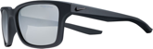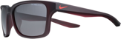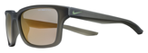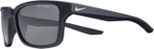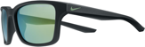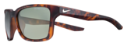

Nike Essential Jaunt
Aviator inspired, with a curved-lens profile that is strong and nuanced at the same time. Available in five colorways.
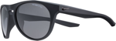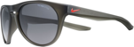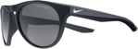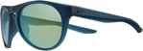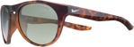

Nike Essential Chaser
Wide, square lenses with softened edges lend these sunglasses a sturdy, retro look. Available in eight colorways.
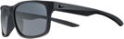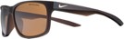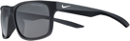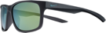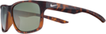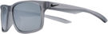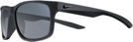

Nike Essential Venture
A linear, dipped top frame and strong square shape add modish appeal. Available in six colorways.
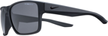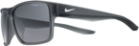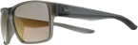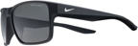

Nike Essential Navigator (Releasing in January 2017)
Curves and sharp angles combine in an unexpected frame shape with rubber inlays for all-day comfort.
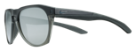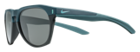

OVERALL FEATURES AND BENEFITS OF THE COLLECTION INCLUDE:

- MAX Optics provide precise clarity from all angles
- Lightweight, durable nylon frame
- 6-base frames offer everyday coverage
- Durable, high tension hinges
- 100% UVA and UVB protection

The Lifestyle Collection is now available for purchase at Nike.com. For more information, visit www.nikevision.com, and follow along on social media at @NikeVision.

ABOUT NIKE, INC.
NIKE, Inc., based near Beaverton, Oregon, is the world's leading designer, marketer and distributor of authentic athletic footwear, apparel, equipment and accessories for a wide variety of sports and fitness activities. Wholly owned NIKE subsidiaries include Converse Inc., which designs, markets and distributes athletic footwear, apparel and accessories and Hurley International LLC, which designs, markets and distributes action sports and youth lifestyle footwear, apparel and accessories. For more information, visit www.nikeinc.com and follow @Nike.

ABOUT MARCHON EYEWEAR, INC.
Marchon Eyewear, Inc. is one of the world's largest manufacturers and distributors of quality eyewear and sunwear. The company markets its products under prestigious brand names including: Airlock, Calvin Klein Collection, Calvin Klein platinum, Calvin Klein Jeans, Chloé, Columbia Sportswear, Diane von Furstenberg, Dragon, Etro, Flexon®, G-Star RAW, Karl Lagerfeld, Lacoste, Liu Jo, Marchon NYC, Marni, MCM, Nautica, Nike, Nine West, Salvatore Ferragamo, Sean John, Skaga. Marchon distributes its products through numerous local sales offices serving over 80,000 accounts in more than 100 countries.

