University invests in major KONGSBERG
simulation upgrade

Aaland University of Applied Sciences signs up for extensive upgrade to all Kongsberg Digital simulators on its premises to optimize integrated team training programs

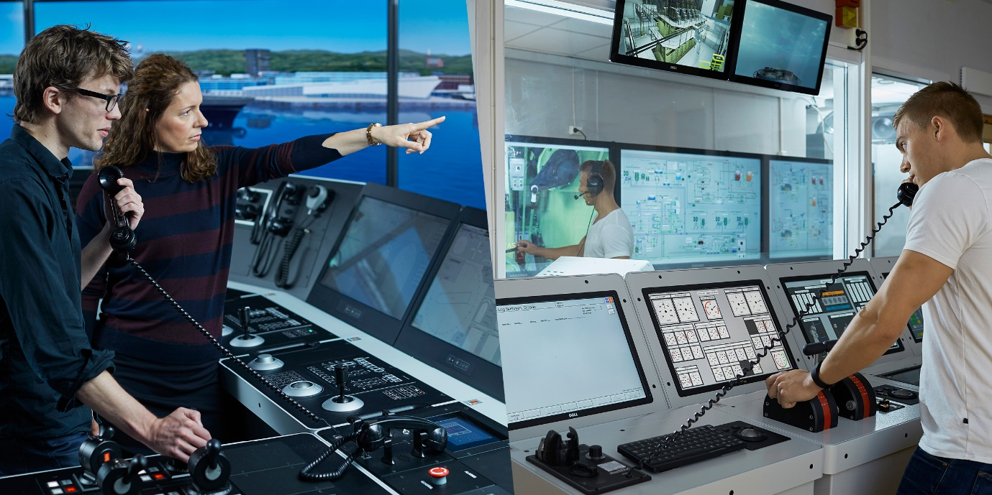

Kongsberg, Norway, May 19th, 2020 – Kongsberg Digital has been contracted by the Aaland University of Applied Sciences in Aaland, Finland to deliver a comprehensive upgrade of the institution’s simulator training capabilities. This large-scale overhaul will update the university’s existing K-Sim Engine simulators to the newest technology and models, while the faculty’s ship’s bridge simulators will in turn be upgraded with new hardware panels and ported over to the latest K-Sim Navigation technology platform.
Additionally, to enable advanced training in LNG handling and bunkering procedures, a new vessel model based on a pioneering Dual Fuel passenger ship will be developed as an integrated Bridge/Engine simulator solution for the K-Sim Engine DEDF 42 model. The entire delivery, scheduled for the autumn 2020, is reinforced with a five-year LTSSP (Long-Term Service Support Program) agreement.
Included in the delivery will be several K-Sim Navigation Full Mission Bridge simulators meeting DNV GL Class A and B certification requirements. One of the simulators will be integrated with KONGSBERG’S Dynamic Positioning system for DP training. Further, the contract also includes K-Sim Navigation DNV GL Class C Desktop Bridge simulators incorporating NAV and GMDSS notations; instructor and debriefing systems; and a K-Sim Engine Full Mission and Desktop simulator upgrade with four additional student stations, instructor training modules, touch-based main and emergency switchboards, and model software simulating operational equipment on a variety of vessels.
The end result will be a state-of-the-art simulator facility with largely unparalleled functionality in an educational establishment, capable of mounting integrated team training exercises for marine engineers and bridge crew on a total of five different simulated vessel models. The integration of K-Sim solutions will instruct students on such crucial disciplines as decision-making and leadership, situational awareness, team interaction and crew/ship-to-shore communications.
“We chose Kongsberg Digital to deliver this contract because the company offered the best solution at the best price,” says Bengt Englund, Vice-Rector, Aaland University of Applied Sciences, “and that combination is unequalled, so it was a logical and beneficial choice. This huge upgrade emphasizes our commitment to educate students by using the best and most modern simulation equipment available. It’s a substantial investment which means that the university will now have a complete range of simulators for study and research purposes. Our focus is on team training to strengthen both individual and collective competence, and the five simulated vessel models, with their integration flexibility, will address all of our training requirements.”
“This highly significant contract continues the long and mutually fruitful relationship we have enjoyed with the University of Applied Sciences in Aaland,” adds Tone-Merete Hansen, Senior Vice President, Kongsberg Digital. “We’re extremely proud to be providing such high-quality training tools for the university, knowing that by doing so we’re helping to produce the best-qualified and skilled crews for the maritime industry in Finland.”
Ends

For further information, please contact:

Anne Voith
Marketing Manager, Maritime Simulation
Kongsberg Digital
Tel: +47 4567 8255
anne.voith@kdi.kongsberg.com

David Pugh
Saltwater Stone
Tel: +44 (0)1202 669244
d.pugh@saltwater-stone.com

About Kongsberg Digital
Kongsberg Digital is a provider of next-generation software and digital solutions to customers within maritime, oil and gas, and renewables and utilities. The company consists of more than 500 software experts with leading competence within the internet of things, smart data, artificial intelligence, maritime simulation, automation and autonomous operations.
Kongsberg Digital is subsidiary of KONGSBERG (OSE-ticker: KOG), an international, knowledge-based group delivering high-technology systems and solutions to clients within the oil and gas industry, subsea, merchant marine, defence and aerospace. KONGSBERG has 11.000 employees located in more than 40 countries.
Web: Kongsberg Gruppen | Kongsberg Digital
Social media: LinkedIn | Twitter | Facebook

