APPROVED PRESS RELEASE (1.264) 27th August 2020
Shutdown Battery option added to IQ range to provide continued operations in a power outage and fail-to-position functionality
Rotork has launched the IQT Shutdown Battery to provide further operational flexibility to the IQT3 range of part-turn 1-phase, 3-phase and DC electric actuators with the addition of a new integral battery option that provides fail-to-position functionality in explosionproof applications.
This pre-programmed movement of the valve on loss of power or communications means our customers retain important control over their operations during a power outage or Emergency Shut-Down (ESD). This is the first time that the IQT3 has been offered with a shutdown battery option in an explosionproof design. A lithium-ion battery supplies the potentially vital backup power from within the actuator enclosure. The integral battery pack provides a compact, explosionproof shutdown solution.
In the event of mains power loss, the Shutdown Battery can continue to function automatically to a site configurable end of travel safe position, providing fail-to-position functionality on critical valves. The failure mode can change depending on customer requirements. This fail-to-position can be fail-closed, open, stayput or go-to-a-per-cent position, depending on what fail-to-position action is needed to ensure the process fails to a safe operating state. This means the process finishes in a safe operating state, preventing any safety issues and avoiding monetary consequences due to loss of control. With the Shutdown Battery there is no need for additional back-up systems, such as compressors, to provide this functionality.
The IQT Shutdown Battery also features an Uninterruptible Power Supply (UPS) mode. This ensures that there is continued control and operation of the actuator on loss of mains power until the battery charge has run out. Operations can continue as normal while the battery charge lasts, mitigating the risk of deferred or lost revenue due to power outages.
Solar-powered installations are increasingly required for remote installations, such as pipeline pump stations. Here, the IQT Shutdown Battery mitigates fluctuating solar power and eliminates the need for expensive external batteries.
The IQT Shutdown Battery is ideally suited to unmanned applications which require further fail-safe functionality when power is lost; it is appropriate for applications on PSD/ESD valves such as well heads, line breaks and high/low pressure scenarios. Programmable logic allows for a delay before the fail operation occurs. Local battery power at the actuator offers further operational flexibility unavailable with ‘hair-trigger’ spring-based ESD systems. If power or communications systems temporarily drop out through unreliable power supplies, operation can continue; this maintains crucial operation time and prevents costly restarts.
The IQT Shutdown Battery is ideal for control valves, blow down valves and control process applications which must be shut down in a phased or staged sequence. It is also perfectly suited for the transfer of crude oil and valves at often unmanned natural gas custody transfer stations, where valves should ‘fail-to-divert’ process fluid back to the storage tanks on loss of power. The Shutdown Battery can also be used as a compact alternative to spring-return fail-safe actuators.
The new models are able to provide the same functionality as the existing IQT3 range. Applications with many valve functions, such as tank farms, will benefit from the commonality of the IQT3 Shutdown Battery with other IQ and Rotork actuators, as an integrated change control network with common user-interfaces and diagnostics. This interchangeability also reduces training and commissioning time. Ingress protection and hazardous area classification to ATEX, ICEx, CSA and CSAus from IQT actuators is maintained, providing increased flexibility and reliability. Partial stroking, site configurable speed setting, a non-intrusive IP68 double sealed enclosure and Bluetooth® Communications remain. They are capable of up to 1,200 starts per hour and are fully compatible with all networks.
END
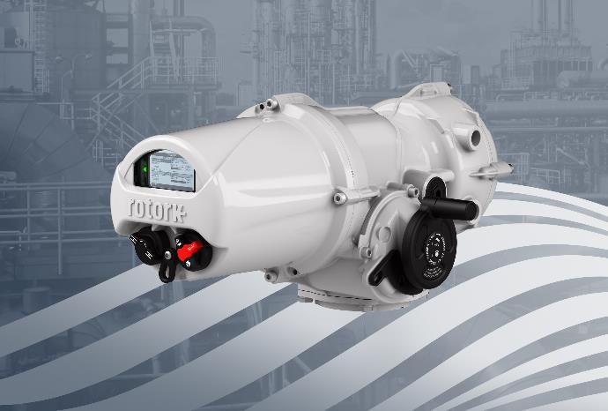
Photo caption
A new integral battery option provides fail-to-position functionality in explosionproof applications.

For further information please contact Rotork PLC
Sarah Kellett Brassmill Lane
Group Marketing Communications Manager Bath
Telephone: +44 (0) 1225 733492 BA1 3JQ
Email: Sarah.Kellett@rotork.com UK

About Rotork
Rotork is a market-leading global provider of mission-critical flow control and instrumentation solutions for oil and gas, water and wastewater, power, chemical process and industrial applications. We help customers around the world to improve efficiency, reduce emissions, minimise their environmental impact and assure safety.

