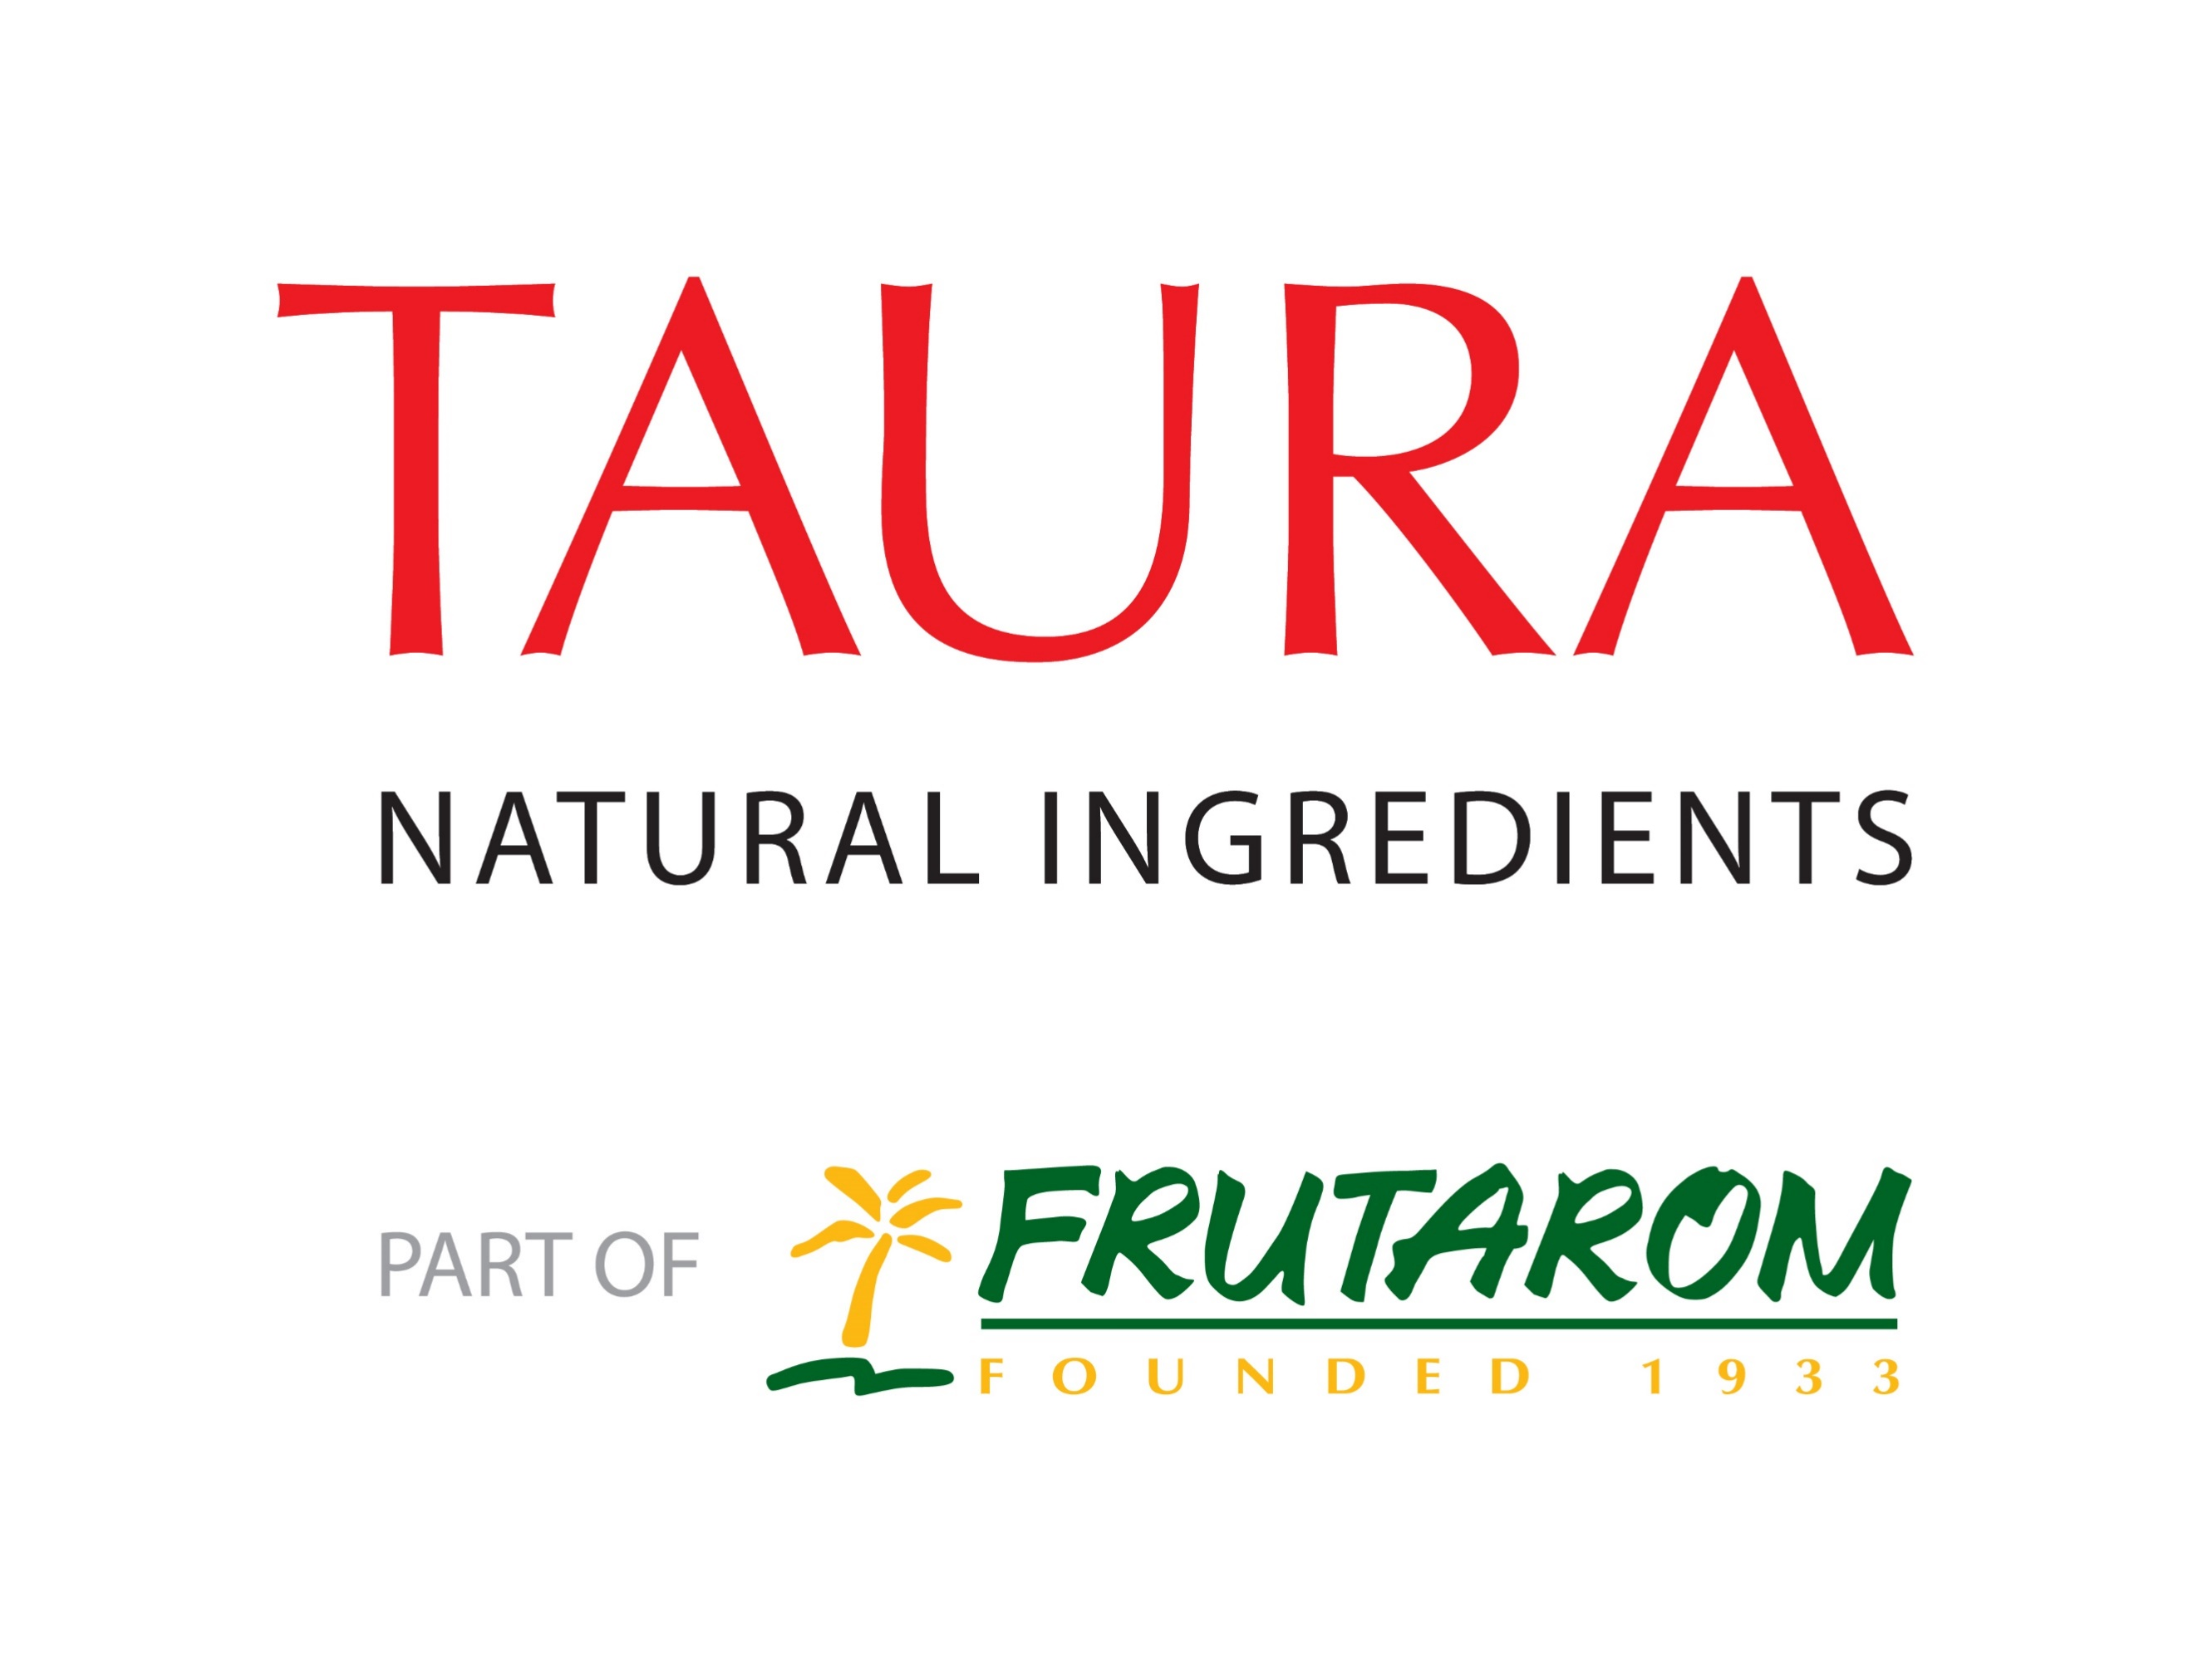
Consumers prefer taste and sweetness of reduced-sugar cookies with Taura’s JusFruitTM pieces

Reduced-sugar cookies containing Taura’s JusFruitTM pieces are perceived to be just as sweet as full-sugar alternatives, research has found.

In a consumer sensory panel, reduced-sugar cookies containing the concentrated fruit pieces were not perceived to be less sweet than a full sugar alternative, even though they contained 30% less sugar. Furthermore, they outscored both full-sugar and standard reduced-sugar options on overall taste, and came closest to optimum sweetness.

Taura’s JusFruitTM pieces are made with the company’s unique Ultra-Rapid Concentration (URC®) technology, which concentrates the natural sweetness of fruit. Including them in sugar-reduced recipes creates “sweet spots” which increase the overall perception of sweetness.

Researchers set out to test the ability of the pieces to overcome the challenge of decreased sweetness and flavour in sugar-reduced biscuits. Twenty-six untrained panellists blind-tasted a full-sugar cookie, a cookie with 30% reduced added sugar, and a cookie with 49% reduced added sugar with JusFruitTM pieces.

The two reduced sugar recipes had similar sugar content due to the sugars that occur naturally in the fruit. An added benefit of the addition of JusFruitTM pieces was that it increased the fibre content of the cookies by 60%.

The tasters were first asked to evaluate how sweet they thought each recipe was. The results revealed no significant difference between the full sugar reference cookies and the sugar-reduced cookies with JusFruitTM pieces. However, the sweetness of the standard sugar-reduced cookies was perceived to be significantly lower.

Sweetness was also evaluated on a seven-point hedonic scale, with a score of four corresponding to “just sweet enough.” The standard sugar-reduced cookies scored 3.71, while the full-sugar cookies scored 4.57, suggesting that they were considered too sweet. The cookies with JusFruitTM pieces came closest to optimum sweetness with a score of 4.25. Furthermore, they outscored the other two recipes on overall taste.

Commenting on the findings, Dr Els Vandenberghe, Product Development Technologist at Taura Natural Ingredients said: “The big challenge for manufacturers of sweet bakery products is to develop recipes that offer lower free sugar intake without compromising on taste. Our JusFruitTM pieces offer the ideal solution. This research demonstrates that the sweet spots they provide can compensate for loss of flavour and sweetness in sugar-reduced cookies. Not only were the cookies with our pieces perceived as just as sweet as the full-sugar version, they were also liked more.”

Notes to Editors

View full findings at:
http://www.tauraurc.com/sweet-spots-reduced-sugar-whitepaper

About Taura Natural Ingredients

Taura Natural Ingredients, part of Frutarom, has over 30 years of international experience and URC® production facilities in Belgium and New Zealand. Its URC® fruit pieces, flakes and pastes are designed to deliver the taste, texture and goodness of real fruit to a range of commercially manufactured food products.

