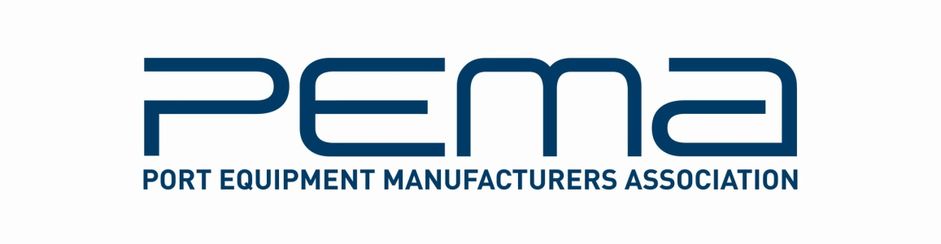
Media Release
PEMA to host innovative container terminal technology forum
at TOC Europe 2011
Leading global port equipment and technology suppliers gather to discuss emerging trends and advances in terminal automation at TOC Europe, June 7-9, in Antwerp.
May 25, 2011 - The Port Equipment Manufacturers Association (PEMA) will host a State of the Industry forum at the upcoming TOC Europe 2011 show in Antwerp to discuss advances in technology and equipment for container terminal automation.
Representatives from leading PEMA member companies, their clients and the press will join together in a new Q&A format, to be facilitated by Paul Avery, Associate Editor at World Cargo News. The session will be held in the Innovation Zone on the TOC exhibition floor and is free to attend for all attendees.
Running for a full afternoon on Tuesday June 7, the forum will feature five panels discussing the shape of the industry today and what to expect in the near future for terminal automation, including:
- Automated Cranes – Adoption of automated stacking cranes in container yards continues to gather speed, with a significant number of new projects now in planning worldwide. This session will look at what’s driving the growth, where the technology is headed and the prospects for quayside crane automation
- Real Time Data Capture and Telemetrics - The panel will talk about what new technologies are coming and how data capture technologies like OCR and RFID are changing the face of traditional and automated terminals
- Automated Horizontal Transport – To complement the automated crane discussion, three experts will discuss the use of AGVs and other horizontal transport technologies for quay-yard transfer
- Application Software - Software brings it all together. This session will address new applications, including asset management, emulation and simulation systems, and how terminals can benefit from them
- Complex IT Project Integration - In this key closing session, suppliers and their clients will discuss what it takes to integrate multiple systems. Joining this panel will be Oscar Pernia Fernandez, Processes, Systems and Innovation Team Leader at Total Terminal International Algeciras, the first automated terminal in southern Europe, and David Serral, IT Director for Grup TCB. Mr. Serral is responsible for Grup TCB’s new greenfield terminal in Buenaventura Colombia.

In a new format for the long-established TOC conference, there will be no prepared speeches. An interactive open interview style with three to four suppliers and users should lead to active debate and some interesting discussion.
“From its inception, the mandate of PEMA has been to advance knowledge and best practice in equipment and technology, which play such a crucial role in helping ports and terminals meet today’s demands for productivity, efficiency, safety and sustainability; the member companies participating in the forum represent major industry suppliers and are all at the forefront of these issues,” says PEMA President Ottonel Popesco.
PEMA members will also be contributing to other debates taking place during TOC Europe on Safety, Energy & Environmental Conservancy and Container Weights.
Paul Holloway, TOC Events Director, adds: “We are delighted to extend our partnership with PEMA and co-produce this joint forum. PEMA and TOC have made a commitment to the industry and we believe these types of activities drive real value to the market. We are excited about this inaugural forum and hope the format and content will make this a must-attend event.”
Founded in 2004, PEMA’s mission is to provide a forum and public voice for the global port equipment and technology sectors. The Association has see strong growth in recent years, and now has over 45 member companies, including crane, equipment and component manufacturers, systems and software providers, consultants and other experts. www.pema.org
TOC Europe 2011 will take place at the Antwerp Expo, between June 7 and 9. www.tocevents-europe.com
For more information on this media release, please contact Rachael White, PEMA Secretary General at: Tel +44 20 8279 9403 | rachael.white@pema.org

