The Marine Technology Experience
Proven by Progress –Williams Jet Tenders-

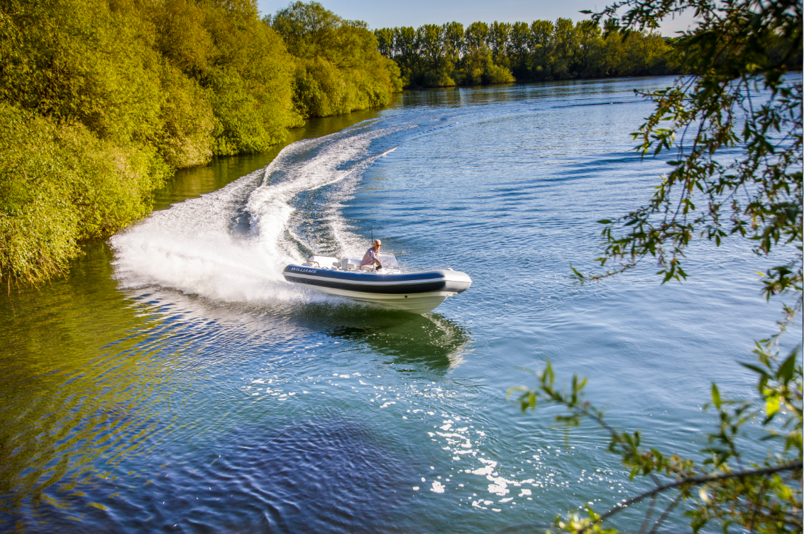

The remarkable story of Williams Jet Tenders (Williams) began when two young brothers turned a passion for the water into a thriving tender business with quality engineering and craftsmanship at its core. From its first vessel built in a garden shed, Williams has become the UK’s most prolific boat builder, outputting around 1,000 units a year.

Starting early
From a young age, Mathew and John Hornsby were always encouraged to play on the river by their parents. In doing so, the brothers developed a love for the water that continues to this day. As young boys – and best friends – little did they know this early encouragement would sow the seeds for a business idea that would become their true vocation.

Driven by ambition and a desire to work together, they built their first boat in their mother’s garden shed and displayed it at the Henley-on-Thames boat show. They called the fledgling company ‘Williams’ (their mother’s maiden name) and the beautiful 20-foot mahogany boat called ‘Jade’ was sold for use on the Italian lakes. Their next boat, ‘Izana’, also was quickly sold and ended up on the French Riviera. Both craft are still in operation today.

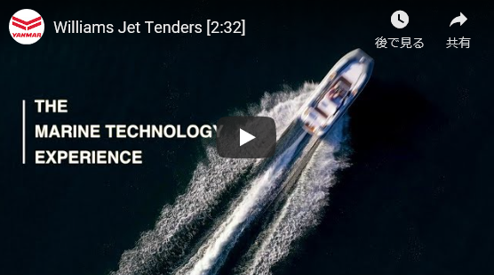

Change of direction
The entire business focus shifted when Mathew and John identified an important gap in the market – a lack of quality-engineered tenders that fitted inside yachts. These vital ship-to-shore vessels offer freedom and fun to the passengers, allowing them to explore coastlines, scuba dive, tow a water-ski or wakeboard behind – as well as stow away easily within a yacht.

The two brothers worked tirelessly to build a successful business supplying tender boats for all types of yachts. They constantly expanded their product range and workforce, while moving into bigger premises to meet the increased demand from many of the best-known OEMs.

Yacht sales and the sheer size of yachts have been steadily rising since the end of the financial crisis. The ultimate status symbol just keeps on growing in size and for some, having a mere ‘yacht’ is no longer enough – it has to be bigger, better and faster, and so do the tenders that fit inside it.

As the trend towards larger yachts continued, this presented the brothers with a perfect business opportunity – to design larger Williams tenders that would bring the same levels of excitement and fun to customers enjoying the benefits of these watercraft.

With larger tenders, especially those carrying lots of passengers, a diesel engine is best because of the extra torque it produces. The search for an engine supplier started and this was how the relationship between Williams and Yanmar began, when the ‘Dieseljet’ range of tenders was conceived.
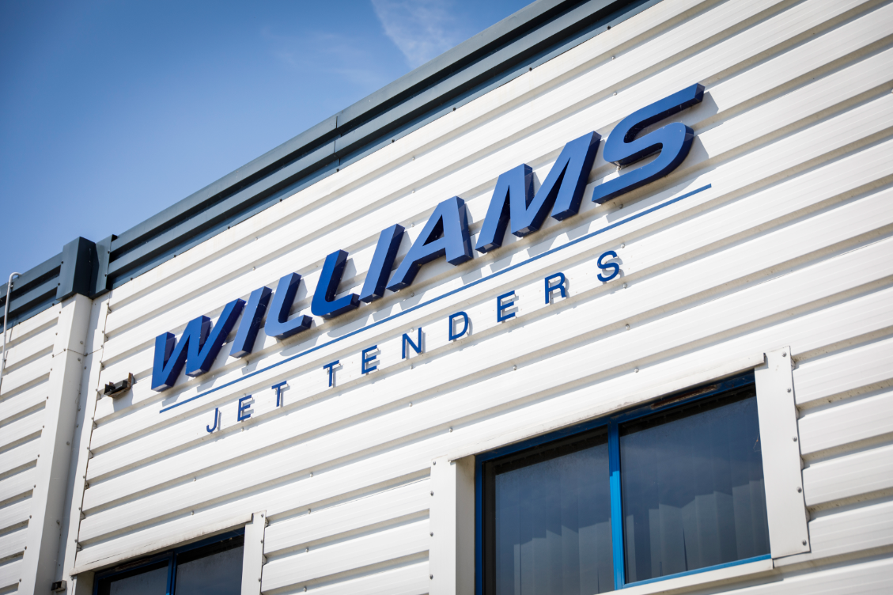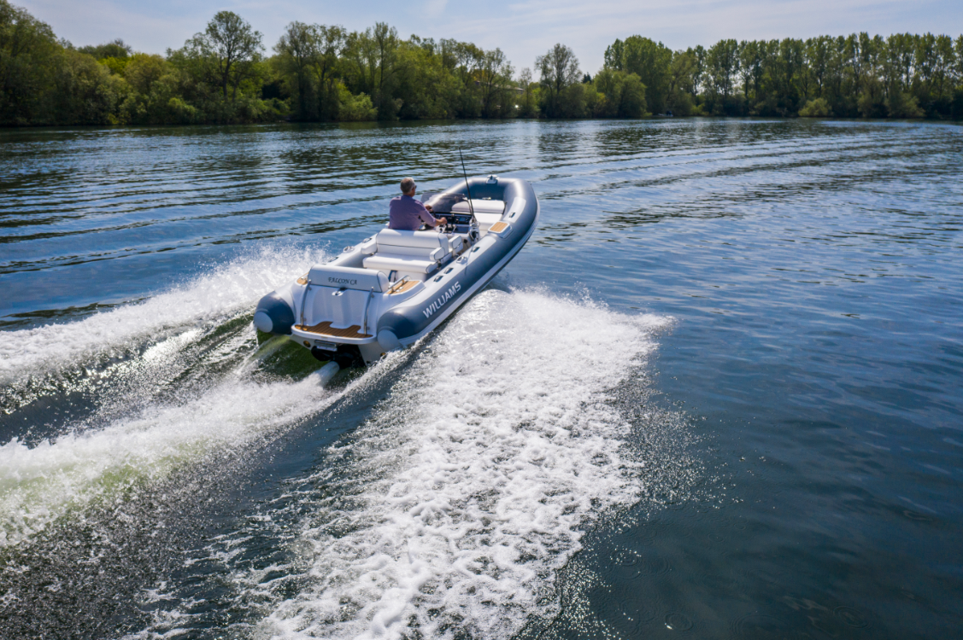

The ‘Y’ connection
“As yachts have become larger, we’ve followed as a tender manufacturer,” says John Hornsby, who heads up Williams’ in-house technical department.

“During our initial research, we looked at several engine manufacturers. It quickly became apparent that the Yanmar range was well engineered, with an excellent power-to-weight ratio. Since we began our working relationship with Yanmar, we’ve designed multiple boats using Yanmar power packages. Our relationship gets stronger every year.”

This is a view shared by John’s brother Mathew, who is keen to stress the special partnership existing between the two companies. “By definition, the engine is at the heart of our tenders. So, new product development and the installation of that engine is a collaborative process with Yanmar.”

Indeed, Williams and Yanmar’s strong working relationship has allowed them to overcome various technology challenges together, such as the re-engineering of the 4LV engine to allow it to fit two of the Dieseljet models.

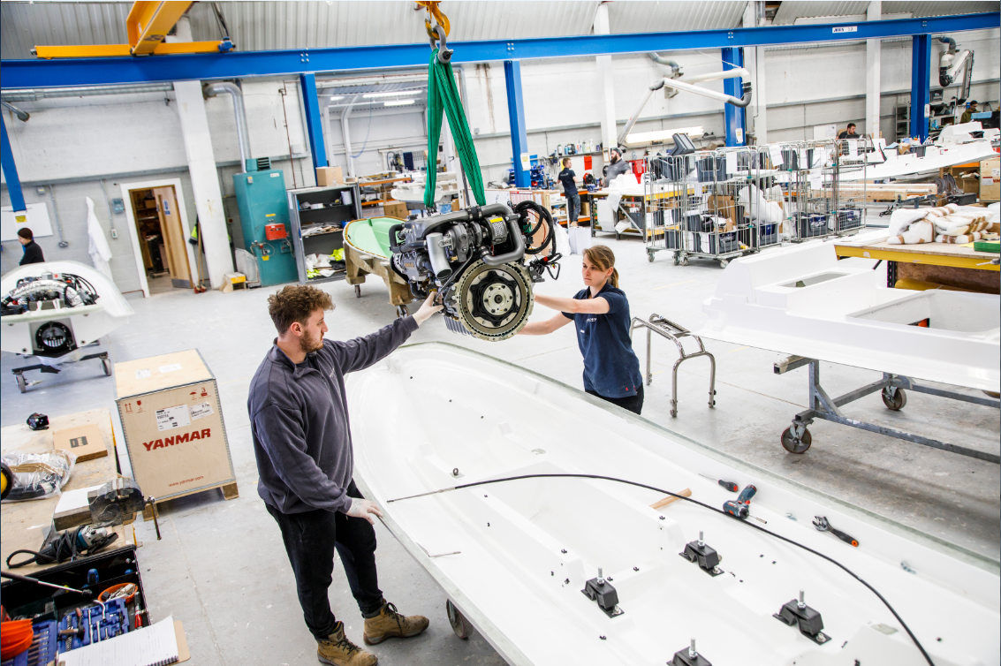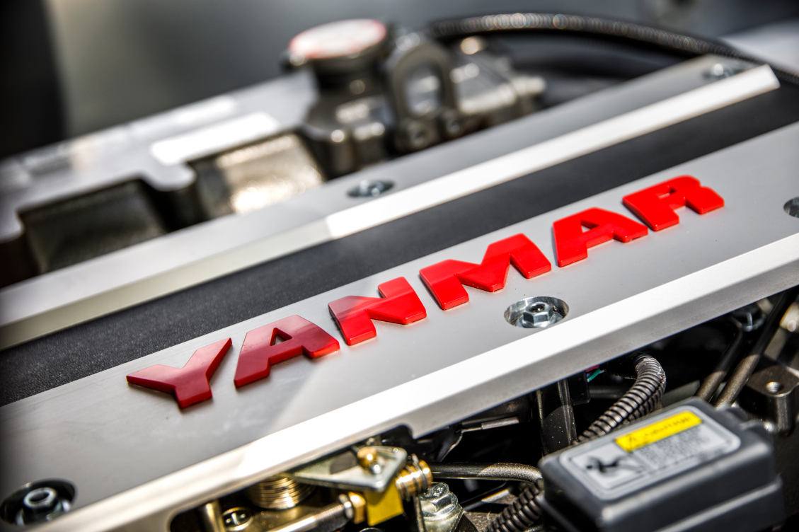
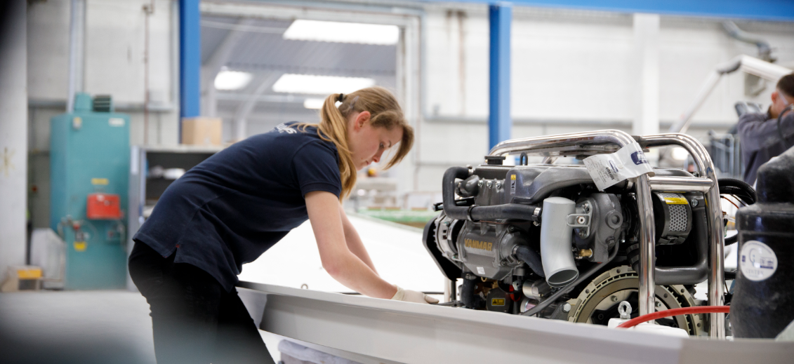

Powered by growth
The established four-model ‘DieselJet’ line-up is available for yachts over 25 metres in length, and designed with a choice of sizes, Yanmar engine configurations and seating for between 7 and 11 people. However, an exciting new addition to the fleet has just been unveiled to reflect the latest ‘super-sizing’ market trend. The 7-metre EVOJET is Williams’ most advanced and luxurious tender to date – designed for superyachts of over 40 metres, capable of seating 13 passengers in comfort and powered by Yanmar’s 230/250hp 4LV diesel engine.

Superyacht migration trends show that many owners are increasingly seeking privacy away from the crowds that frequent the traditional blue-water havens. As such, they have commissioned more extravagant yachts that are capable of seeking out adventurous new destinations in style and comfort. The owners of these opulent vessels naturally require the largest tenders that can be accommodated, and this is where Williams is literally riding the crest of a wave with its Yanmar-powered range.

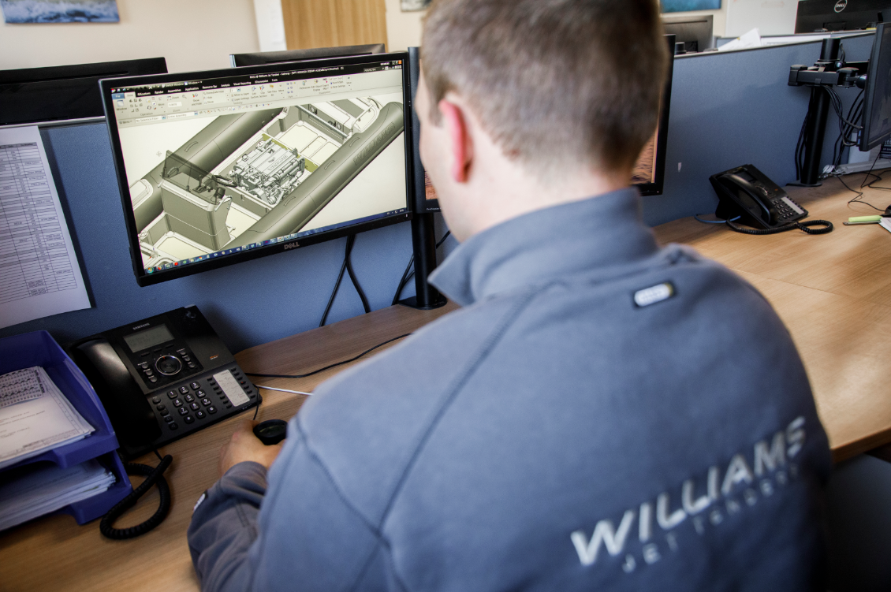

The future’s better together
“Our next generation of boats is going to be larger, with a range of superyacht tenders,” enthuses Mathew. “We are obviously choosing Yanmar to power these products, so that’s a whole new collaborative process that we’re entering into.

“The whole boating experience is about passion and fun, and this partnership with Yanmar has to share the same feeling that our customers have. When both parties understand that element of our product, it really helps to drive both businesses forward.”

As people are increasingly enjoying the comfort and space a bigger yacht offers, Williams’ partnership with Yanmar is helping deliver the associated fun and thrills that a powerful diesel tender offers. Superyacht builders, which are the main customer of Williams’ vessels, report full order books for ever larger vessels. This is a trend that is not going away anytime soon.

