FOR IMMEDIATE RELEASE

Fischer Panda UK Supplies End-to-End Electric Drive System for
Mayflower Autonomous Ship Project

Autonomous transatlantic research vessel will depend on Fischer Panda equipment during 2020 voyage

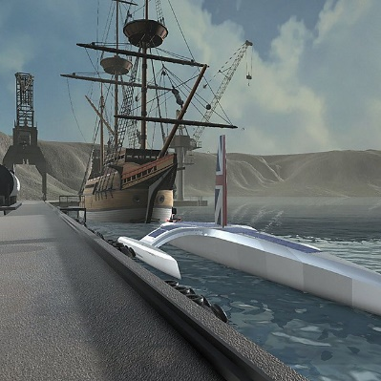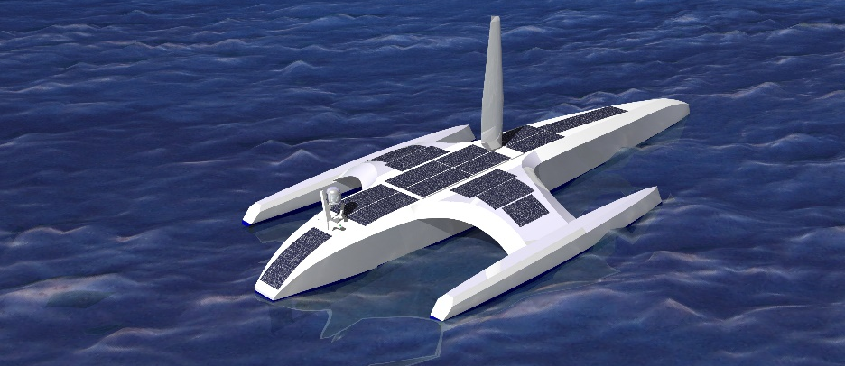

Reliable drive systems will be essential for the unmanned Atlantic crossing in September 2020.
Images courtesy of the University of Birmingham Human Interface Technologies team.

Fischer Panda UK has announced a contract to supply, install and commission a complete electric propulsion system for the innovative Mayflower Autonomous Ship (MAS) project. The installation –which will include motors, batteries, diesel generators and associated power and control electronics – will be crucial to ensuring the success of the unmanned Atlantic crossing, which is scheduled for September 2020.
The voyage, from Plymouth, UK to Plymouth, Massachusetts, is proposed for next year in celebration of the 400th anniversary of the voyage of the pilgrim fathers in their eponymous ship. Equipped with advanced research sensors and IBM’s latest AI, Power servers and edge technologies, the 15m trimaran is expected to make the crossing in approximately 12 days at speeds up to 20 knots – a huge leap from the original Mayflower’s 60 days at 2.5 knots. To achieve this, she will be powered by a 21st century fully-electric propulsion system from Fischer Panda, primarily charged by wind and solar energy which, the builders anticipate, will give unlimited range in equatorial sunshine and breeze – although Fischer Panda diesel generators will offer backup should conditions be less ideal.
MAS is a collaborative venture between several academic and commercial institutions. Leading the initiative is ProMare, a non-profit charity established to promote marine research and exploration throughout the world, and the vessel is being designed by Whiskerstay and MSubs, both companies with extensive experience developing manned and unmanned marine vehicles. The Universities of Plymouth and Birmingham are also significantly involved, respectively developing the research pods and virtual/augmented reality systems.

Asked why Fischer Panda was chosen to supply the drive system, Brett Phaneuf, Managing Director of MSubs, said: “We wanted to buy an end-to-end hybrid drive that was fully integrated and tested by the manufacturer and we knew would work. We’ve used Fischer Panda in the past for our military work and found them to be very reliable.”
The equipment, which will be installed and commissioned by Fischer Panda UK’s engineering team,
will comprise:
- Two 48V DC generators – a 22kW Fischer Panda AGT 22000 and a 4kW Fischer Panda AGT 4000. Both generators are in ‘PVM’ format, with a dry exhaust. This removes the need for a raw water intake, a potential source of leakage or corrosion.
- Two 48V Fischer Panda 20kW 600rpm Easybox shaft motors.
- A Mastervolt Mass Combi 48/3500-50 Inverter and Charger, supported by a battery management system for control and monitoring.
- A 38.4kWh battery bank consisting of eight of the new Mastervolt MLi Ultra 5500 Lithium Ion batteries, providing 800Ah at 48V.
Barry Fower, Managing Director at Fischer Panda UK, said: “We’re delighted to be involved in this innovative venture, and for our products to be chosen to play such a vital role. We look forward to supporting the MAS team throughout the project.”
MAS is designed so that sensor and control modules can be easily exchanged, allowing units developed on shore to be swapped and tested with minimal installation. On passage, the vessel is hoped to collect significant data to assist research into ocean conditions, marine pollution, meteorology and conservation, and to refine autonomous navigation and machine learning techniques. As such, Phaneuf says, “it’s a research ship that is in itself a research project.”
With hybrid drives, autonomous control and environmental awareness all at the leading edge of marine research at present, MAS is likely to prove a blueprint for future developments. “This is the first of many vessels to come,” said Fredrik Soreide, ProMare Project Director. “This is a seagoing vessel which can go a long distance. Most previous unmanned vessels have only been able to go short distances, so this is a big change.”
For more information about Fischer Panda UK’s range of products, visit www.fischerpanda.co.uk.
For more information about the MAS project, visit www.promare.org/mayflower.
Ends

Media Contacts
Chris Fower David Pugh
Fischer Panda Saltwater Stone
+44 (0)1202 820840 +44 (0) 1202 669244
chris.fower@fischerpanda.co.uk d.pugh@saltwater-stone.com
www.fischerpanda.co.uk www.saltwater-stone.com

About Fischer Panda UK
Celebrating its 25th anniversary year, Fischer Panda UK Ltd offers full-system design capability, servicing and aftercare as a leading distributor of diesel generators and a major supplier of the latest technology in air-conditioning systems, hybrid electric propulsion systems, integrated mobile power solutions and watermakers for a variety of commercial and leisure vessels.
Renowned worldwide as innovative, reliable and extremely quiet, the extensive Fischer Panda range of compact diesel generators includes its next generation highly efficient and powerful variable speed iSeries-Generators. Fischer Panda generators from the Panda 4000s Neo up to the next generation iSeries Panda 45i genset have passed type approval by members of the IACS (International Association of Classification Societies) board.
Other world-class products from Fischer Panda UK include desalination systems from Sea Recovery, HRO, and Village Marine, with models suitable for day-boats to warships and offshore platforms, plus air-conditioning systems from leading marine HVAC supplier Dometic, CZone digital switching and Mastervolt power solutions.
Fischer Panda UK is ISO UKAS 9000/1 accredited and operates from a purpose built 9,000 sq. ft facility in Verwood, Dorset. Its experienced engineers, sales and operational staff work with OEMs to develop integrated systems for custom vessels and offer specialist technical support and on-going aftercare to its customers.
Also active in the military and automotive sectors, the company works with UK MOD and other armies around the world providing solutions for specialist vehicle and land-based applications. Two thirds of Formula 1 mobile truck units install Fischer Panda generators, as do the BBC, Sky and many other mobile broadcasting vehicles.
Operating since 1977, Fischer Panda GmbH is headquartered in Paderborn, Germany. The Fischer Panda team covers more than 500 technicians and partners in over 90 countries worldwide.

