NFC Technology will be available in the Patient Status Engine in the future
With the support of a funding project of the ILB Brandenburg

Due to funding by ILB Brandenburg (Big FuE), the implementation of the integration of NFC/RFID-Technologies for the identification of medical devices in use on patients for telemedical applications was successful. The prototype is complete and the test phase can start. The plan is to integrate the new technologies into the medical device.

The simplification of the workflow by implementing RFID-Technology was the key goal of the project. The NFC-Technology, which is based on the RFID-Technology, is used at the gateway for the registration of persons (patients and medical staff) and for the registration of the respective sensors (patches Lifetouch, Lifetemp, Blood pressure and oxygen saturation). While connected the required persons and sensors are in close proximity. Each login and each logoff is currently controlled by a barcode solution. Various discussions with users have made clear that this procedure, developed for hospitals, is not effective outside clearly defined institutions. The goal was to create a considerably simplified and optimized workflow, which enables the connection of patient and device in “3 simple clicks”.

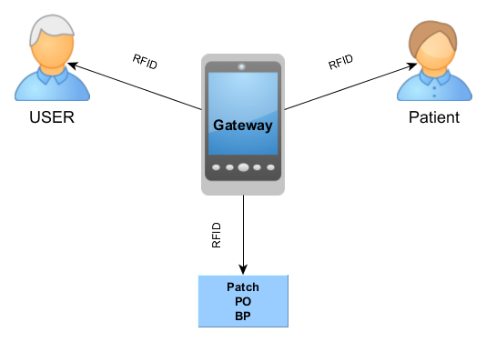

The use of the technology is making an essential contribution to preparing the Patient Status Engine (PSE) for new applications for telemedicine (“Hospital at Home”) in the future. In the field of telemedicine a simple and quick workflow is needed. To be able to manage the workflow for the staff (for example emergency services) by just three “touches” is a great relief and increases the transparency and security for the medical staff and the patients at the same time.

