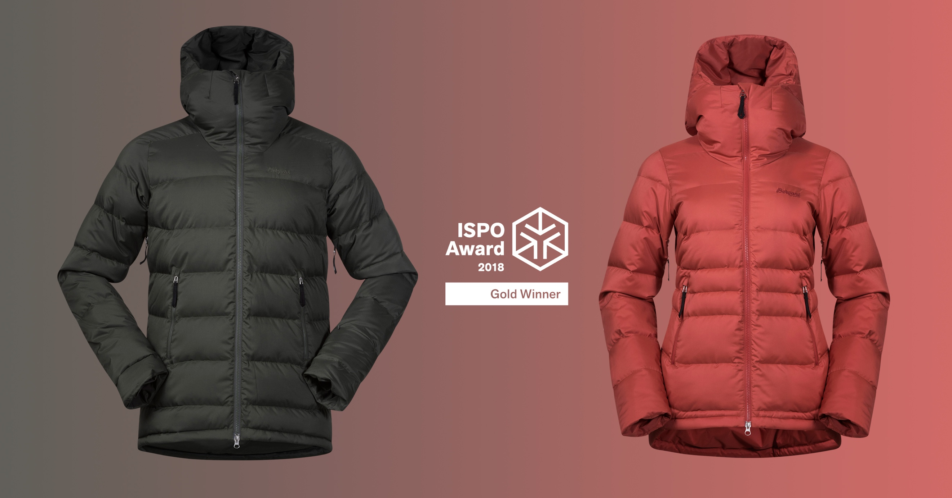
Bergans Stranda Down Hybrid Jacket is proclaimed: Gold Winner in ISPO Awards 2018
Stranda Down Hybrid Jacket is announced as gold winner in the category Snowsport – Outer Layer Hybrid. The jacket is rewarded for its durable and sustainable materials and versatile usability.
The jury, which has evaluated the snow sport category, consists of ten independent members. In addition, a separate Eco Jury has honored extraordinarily sustainable innovations and services. The jury's reasoning of proclaiming Stranda Down Hybrid Jacket as gold winner, is as following:
“The Stranda Down Hybrid Jacket is sustainably designed to provide you with lovely warmth and the highest level of comfort from the mountain to the city. The jacket is made of 100 % recycled polyester from SpinDye®, using solution dyeing for less water consumption and chemical usage, and filled with recycled down from Re:Down® and PrimaLoft® Gold Insulation Active+. It’s a fully featured ski jacket with Recco® reflector, yet versatile.”

– In Bergans we strive to produce more environmentally friendly and long lasting products, every day. We put strict demands on ourselves when it comes to sustainability and durability. At the same it’s crucial for us to obtain our high level of technical quality of our product. The Stranda Collection is a great example in this case. SpinDye® has been a fantastic partner in the development process, and has a significant part of the credit for this award. We are grateful and proud to be announced as a gold winner in ISPO Awards, says Sven Mostögl, Product & Design Director in Bergans.

