For Immediate Release
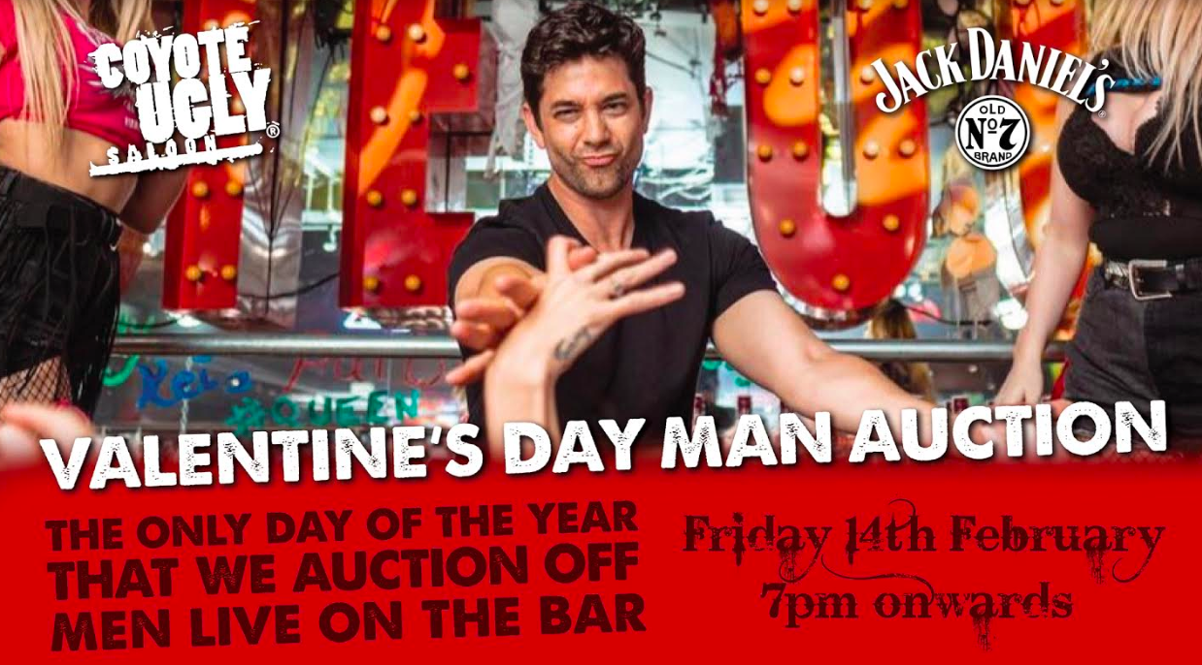
Inaugural Valentine’s Day Man Auction at Coyote Ugly Saloon

Press Release 3rd February 2020, Singapore - In the movie 'Coyote Ugly,' lead character Violet needs to raise money and auctions off her guy friend. We are bringing that scene back to life at Coyote Ugly Saloon Singapore – the most famous bar on the planet – which will be organising its very first Valentine’s Day Man Auction on the on Friday, 14th of February, from 7pm onwards.

This special event follows a tradition carried out at Coyote Ugly Saloons around the world every year, when a man auction is conducted on this special day. It’s also the only time of the year that men are allowed on the bar top.

Ten eligible bachelors are in the line-up and the auction starts at SGD$10. The winning bidders will then go on an immediate date with their hunk of choice. Whatever the bid, the money will then go straight into paying for food and drinks for the date.

The ten bachelors whose ages range from 25-40 years were nominated by their friends and selected based on their looks and personalities. Resident Coyotes will be hosting the auction, ensuring a sizzling show throughout the night.

A popular event celebrated in Coyote Ugly, especially in the US and UK outlets where lots of single women and their friends buy tickets to attend the party, the first instalment of the Singapore edition will be free admission. Doors open at 5pm.Customers are encouraged to make their reservations early by emailing rsvpsg@coyoteuglysaloon.com

######

Media Contact: Empower Marketing Asia Yvonne Phua | yvonne.phua@empowerasia.biz | +65 9236 5356
High resolution images are available at this link: http://bit.ly/coyoteuglysaloonsg

VALENTINE'S DAY MAN AUCTION
Date: 14 February, Friday
Time: 7pm onwards
Address: 3B River Valley Rd, Blk B Clarke Quay, #01-08, Singapore 179021
Media RSVP: yvonne.phua@empowerasia.biz
Facebook: https://www.facebook.com/events/496865954304407/

INFORMATION:
Address: 3B River Valley Rd, Clarke Quay Blk B, #01-08, Singapore 179021
Tel: 62616564
Opening Hours: 5pm to 3am, daily
Capacity: 700
Reservations: rsvpsg@coyoteuglysaloon.com
Website: https://www.coyoteuglysingapore.com/
Facebook: https://www.facebook.com/CoyoteUglySaloonSingapore/
Instagram: https://www.instagram.com/coyoteuglysaloonsingapore/ , #coyoteuglysg

Design My Party:
Bachelorette Party: $388++ for 6 pax (1 house pour bottle or 3 bottles of wine/cava/prosecco + 1 platter appetisers + 1 hour dance training)

Bachelor Party: $388++ for 6 pax (1 house pour bottle + 1 beer tower + 1 Coyote Ugly Game Over T-shirt)

Birthday Parties: $328 for 6 pax (1 house pour bottle + 1 Beer tower + 1 bottle of wine/cava/prosecco) + 1 platter appetisers)

