

070 SHAKE RETURNS TO LIVE TOURING WITH 3-MONTH, 36-CITY TOUR OF U.S. AND EUROPE, OPENING SEPT. 18TH IN ATLANTA.

CAPS EXTRAORDINARY YEAR OF SUCCESS WITH CRITICALLY ACCLAIMED DEBUT ALBUM MODUS VIVENDI VIA G.O.O.D. MUSIC/DEF JAM RECORDINGS

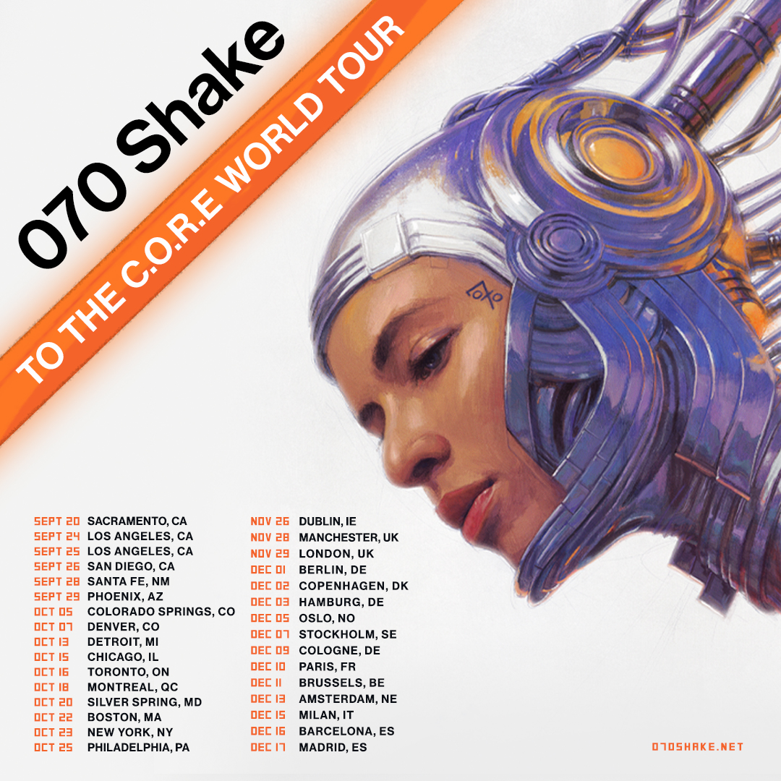

“A vital new singer makes her debut…an emo-rap Dark Side Of The Moon …Modus Vivendi suggests Enya and Pink Floyd as much as Frank Ocean…the sound of a realist and fantasist sparring, it reflects an artist still coming into focus on her own thrilling terms.”


"On 'Modus Vivendi', she manages to craft a sound that’s anthemic, and built for festivals and clubs; but within the grooves, she’s precise... This is project sculpted away from current trends."


“There’s no use trying to box in 070 Shake: her music effortlessly slips in and out of genres, annexing influences as varied as contemporary hip-hop, eighties glam rock, and hazy synth pop.”

“She is constantly playing with contrasts—raw and smooth, light and dark, harsh and tender—and the songs on Modus Vivendi seem to shift with her mood.”


(June 8, 2021 – New York, NY) 070 Shake – the innovative, genre-defying artist whose critically acclaimed debut album MODUS VIVENDI via G.O.O.D. Music/Def Jam Recordings made Top 20 “Albums Of The Year” and “Best New Artist” lists around the world – will return to the road this fall for a long overdue tour of North America and Europe.

The three-month, 36-city tour will open September 18th at Music Midtown Festival in Atlanta and will conclude at Sala But in Madrid on December 17th. A limited number of VIP packages will be available starting, Wednesday, June 9th at 10am local and include a meet & greets, exclusive merchandise & more. Details at http://www.070shake.net.

Shake’s last 25-city tour of Europe and North America was an unforgettable sold-out trip that began in Dublin on Jan. 19, 2020, the weekend after MODUS VIVENDI’s release. The tour ended dramatically back in Washington, DC, on Saturday, March 7th, the weekend that the Covid-19 lockdown began. The album spun off a non-stop run of massive single + video drops over the course of the year: “Guilty Conscience (Tame Impala Remix),” “Under the Moon,” “Nice To Have,” and “Terminal B” have collectively netted hundreds of millions of global streams.

Shake maintained an active, high-visibility profile during 2020, starting with the SXSW Film Festival Awards in March, where she took top honors for the “Nice To Have” video directed by Noah Lee. Shake closed the month with a performance on TheFader.com’s Digital Fort series.

April brought the “Shake The World Live” concert event on YouTube, comprising live performances of "Guilty Conscience," "Rocketship," and "Glitter" from her sold-out show at New York’s Webster Hall just weeks before. In May, also from Webster Hall, "Don't Break The Silence" and "Come Around" were posted; view them HERE. Over the course of that month, Webster Hall clips were posted of “Morrow,” “Stranger,” “Nice To Have,” “Microdosing,” “Honey,” and “Under the Moon.”

In August, Shake opened fans’ eyes and ears to something new and daring, as she lent her vocals to “Trumpets,” the ‘jazz-adjacent’ single by Alex da Kid aka Alexander Grant, under his new moniker _by.ALEXANDER. On October 7th, Shake made her solo tv debut on The Tonight Show with Jimmy Fallon, sharing a new, unreleased song, “History,” along with her hit “Guilty Conscience.”

ABOUT 070 SHAKE:
070 Shake slips between hip-hop, pop, alternative, indie, and R&B like a ghost, leaving her mark on each before she vanishes again. Born of Dominican descent and raised in New Jersey, she embraced her position as an outlier in high school with predispositions for both poetry and basketball. (Her nickname “Shake” references a particularly mean crossover dribble) She found a place to fit in among the G.O.O.D. Music crew after they heard her independent single “Proud.” Following the 2018 Glitter EP, she materialized at the forefront of popular culture with tastemaker-approved guest spots on chart-topping releases, including “Santeria” from Pusha T’s magnum opus Daytona and the outro of “Ghost Town” from Kanye West’s eighth studio album Ye. At the top of 2020, her full-length debut Modus Vivendi bowed in the Top 10 of the Billboard Top Current Albums Chart and notched 4-star reviews from Rolling Stone and NME in addition to praise from The New Yorker, The Wall Street Journal, and Pitchfork. It also emerged on mid-year lists from Complex, i-D, and Esquire, while The Ringer hailed the single “Guilty Conscience” among “The Best Songs of 2020 (So Far).” Psychedelic arena band Tame Impala even remixed the latter. Plus, she brought this captivating vision on the road and sold out her entire world tour. Not to mention, she has collaborated with everyone from Nas and DJ Khaled to Jessie Reyez and _By.Alexander. With hundreds and millions of streams to date, 070 Shake continues to reimagine and redefine popular music with every move.

070 SHAKE 2021 Tour of North America & Europe

Date City Venue
Sept. 18 Atlanta, GA Music Midtown Festival
20 Sacramento, CA Ace of Spades
24 Los Angeles, CA El Rey Theatre
25 Los Angeles, CA El Rey Theatre
26 San Diego, CA House of Blues
28 Santa Fe, NM Meow Wolf
29 Phoenix, AZ Crescent Ballroom Lounge
Oct. 3 Austin, TX Austin City Limits Music Festival
5 Colorado Springs, CO The Black Sheep
7 Denver, CO Ogden Theatre
9 Austin, TX Austin City Limits Music Festival
13 Detroit, MI Majestic Theatre
15 Chicago, IL House of Blues
16 Toronto, ON History
18 Montreal, QC Corona Theatre
20 Silver Spring, MD The Fillmore Silver Spring
22 Boston, MA Paradise Rock Club
23 New York, NY Terminal 5
25 Philadelphia, PA TLA (Theatre of the Living Arts)
29 San Francisco, CA Outside Lands Music & Arts Festival
Nov. 26 Dublin, Ireland Academy
28 Manchester, England Academy 2
29 London, England O2 Forum Kentish Town
Dec. 1 Berlin, Germany Berghain
2 Copenhagen, Denmark Vega
3 Hamburg, Germany Uebel & Gefährlich
5 Oslo, Norway Vulkan Arena
7 Stockholm, Sweden Fållan
9 Cologne, Germany Kantine
10 Paris, France La Cigale
11 Brussels, Belgium Botanique - Orangerie
13 Amsterdam, Netherlands Melkweg
15 Milan, Italy Magazzini Generali
16 Barcelona, Spain Sala Apolo
17 Madrid, Spain Sala But

FOLLOW 070 SHAKE
INSTAGRAM | TWITTER | FACEBOOK | SPOTIFY | SOUNDCLOUD | YOUTUBE |
OFFICIAL WEBSITE
CONTACT:
GENESIS GARCIA
Genesis.Garcia@umusic.com
GABE TESORIERO
G.T@umusic.com

