Epson’s WorkForce DS-320 Portable Scanner recognised for Outstanding Mobile Scanner for Business by Keypoint Intelligence - Buyers Laboratory

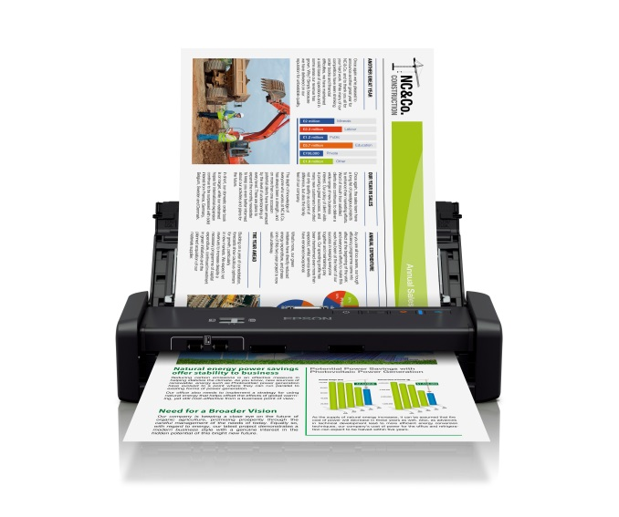
Epson’s WorkForce DS-310 scanner

Kuala Lumpur, Malaysia, 9 August 2018, –
Epson, a leading provider of innovative business solutions, announced that the WorkForce DS-320 Portable Duplex Document Scanner, known as the WorkForce DS-310 scanner in Southeast Asia, has been awarded the BLI’s Winter 2018 Pick Award for Outstanding Mobile Scanner for Business. Keypoint Intelligence - Buyers Lab (BLI) is a leading independent evaluator of document imaging software, hardware, and services.
Delivering the fastest scan speeds in its class, the compact DS-310 duplex document scanner offers speeds of up to 25 ppm or 50 ipm and features a maximum scanning resolution of up to 1200 dpi. The scanner features a 20-page Auto Document Feeder (ADF), with the ability to scan paper thickness between 51.8 to 230 g/m², which includes namecards and paper documents.
This portable scanner also includes TWAIN and ISIS drivers for seamless integration with existing document management systems. Users can scan to online storage accounts like Dropbox and SharePoint, or to searchable PDFs and editable Word and Excel files using the included software.
“The portable WorkForce DS-310 scanner is power packed with features in a compact and lightweight body, and is designed to meet the needs of the busy professional on the move. BLI’s recognition of Epson products underscores our commitment to meeting our customers’ evolving business needs in SE Asia,” said Jocelyn Tan, Regional Manager, Printer (Home, SOHO & Biz) & Wearable Division, Epson Singapore.

The BLI “Pick” awards gives special recognition to the hardware and software products that are reviewed by BLI’s team of expert technicians and analysts at the BLI lab. All laboratory test data is then compiled to select the top products that have been evaluated within the past six months. The products and solutions that stand out from the competition and provide the most outstanding performance with the highest evaluation scores, are then awarded a Pick award within their respective industry category.
***

About Keypoint Intelligence - Buyers Lab
Keypoint Intelligence is a one-stop shop for the digital imaging industry. With our unparalleled tools and unmatched depth of knowledge, we cut through the noise of data to offer clients the unbiased insights and responsive tools they need in those mission-critical moments that define their products and empower their sales.

For over 50 years, Buyers Lab has been the global document imaging industry’s resource for unbiased and reliable information, test data, and competitive selling tools. What started out as a consumer-based publication about office equipment has become an all-encompassing industry resource. Buyers Lab evolves in tandem with the ever-changing landscape of document imaging solutions, constantly updating our methods, expanding our offerings, and tracking cutting-edge developments.

About BLI Pick Awards
Buyers Lab Picks stand alone in the industry and are hard-earned awards, as they are based on rigorous testing, including an extensive durability assessment and evaluation of key attributes such as usability, image quality, and value. Each product that passes our lab test earns Buyers Lab’s Recommended or Highly Recommended seal and our Certificate of Reliability, with the best performers qualifying as Pick contenders.

About Epson
Epson is a global technology leader dedicated to connecting people, things, and information with its original efficient, compact, and precision technologies. With a line-up that ranges from inkjet printers and digital printing systems to 3LCD projectors, watches and industrial robots, the company is focused on driving innovations and exceeding customer expectations in inkjet, visual communications, wearables, and robotics.
Led by the Japan-based Seiko Epson Corporation, the Epson Group comprises more than 76,000 employees in 87 companies around the world and is proud of its contributions to the communities in which it operates and its ongoing efforts to reduce environmental impacts.
http://global.epson.com/

About Epson Singapore
Since 1982, Epson has developed a strong presence across major markets in Southeast Asia and South Asia. Led by the regional headquarters Epson Singapore, Epson’s business in Southeast Asia spans an extensive network of 11 countries with a comprehensive infrastructure of close to 500 service outlets, 7 Epson solution centres and 7 manufacturing facilities.
http://www.epson.com.sg

About Epson Malaysia
Epson Malaysia Sdn Bhd was established in Malaysia in 1991 as Epson Trading (M) Sdn Bhd, a sales company of the Seiko Epson Corporation, Japan. The company has exclusive rights to market, distribute and support a complete range of leading-edge Epson consumer and business digital imaging products in Malaysia and Brunei. Today, Epson Malaysia has 84 employees and an extensive network of 59 authorised service outlets nationwide. For more info, please visit www.epson.com.my or connect with us at www.facebook.com.my/EpsonMalaysia

Media Enquiries:
Epson Malaysia Sdn Bhd  Chua Li Tinn  Manager – Marketing Communications  Tel: (03) 5628 8288 Ext 274  Email: ltchua@emsb.epson.com.my | SWOT Communications Sdn Bhd  Vino Nair  Tel: 016 365 6268  Email: vino@swotcommunications.com

Based on letter-sized scans at 300 dpi in Black-and-White, Grayscale or Color Mode, using the AC adapter and power cable.

