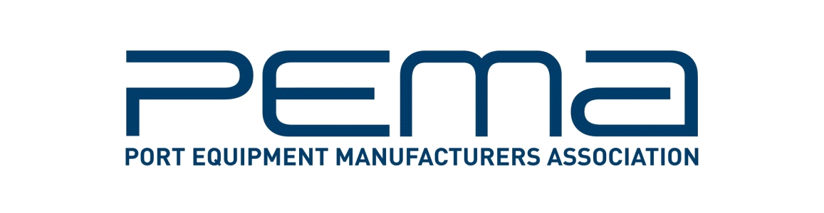
Media Release

Port Equipment Manufacturers Association updates recently published shore power information paper

September 06, 2016 – The Port Equipment Manufacturers Association, (PEMA) has published an updated version of its recently released information paper on shore power connection to reflect feedback from industry figures, and to more accurately define the scope of the paper.

The information paper, entitled Shore Connection – Regulatory Developments and Best Practice and first published on June 15 2016, provides an overview of current regulatory developments, including the ISO/IEC/IEEE80005-1 (Utility connections in port - Part 1: High Voltage Shore Connection (HVSC) Systems -- General requirements) standard that defines shore side electrical connection for larger vessels, and which entered into effect in 2012.

The following two changes have been made to the paper. In the ‘Document Purpose’ section on page five, the redefined text reads as follows:

- This paper focuses on the ISO/IEC/IEEE80005-1standard that defines shore side electrical connection for larger vessels, and which entered into effect in 2012. While being covered by the above standard, this paper does not review shore connection for tanker vessels. The paper excludes bulk and inland vessels, and vessels with a power requirement of less than 1 Mega Volt Amp (MVA). Retrofitting of vessels for shore power also fall outside the scope of this paper.

In the first version of the paper, this paragraph was drafted accordingly:
This paper focuses on the ISO/IEC/IEEE80005-1 standard that defines, but does not regulate, shore side electrical connection for larger vessels, and which entered into effect in 2012. This paper does not include tanker, bulk or inland vessels, nor vessels with a power requirement of less than 1 Mega Volt Amp (MVA). Retrofitting of vessels for shore power also fall outside the scope of this paper.

- And on page 9, the caption to figure 2 is now:
Figure 2: IEC/IEEE80005-1 standard main requirements for container and passenger vessels.

The original caption read as follows:
Figure 2: IEC/IEEE80005-1 standard main requirements.

These changes are considered significant because the original text in the Document Purpose section of PEMA’s information paper was open to the interpretation that the IEC/ISO/IEEE 80005-1 is not applicable to tankers when, in fact, it is. The aim of the recent update is to clarify that PEMA’s information paper, although focusing on IEC/ISO/IEEE 80005-1, does not review shore connection for tankers.

The report was written by Loréne Grandidier, Cavotec and former vice chair of the PEMA Safety & Environment Committee; Diederik Lenssens, WCS Group; Jana Blechschmidt, Prysmian Group; Luciano Corbetta, Cavotec; M. Tiling, Igus; S. Caballero, Schneider Electric; G. Fischer, Siemens; and Knut Marquart, Siemens.

The paper is part of a series of information papers developed by the Safety & Environment Committee to inform readers about the design and use of equipment and technology to improve the safety of people, equipment and cargo, as well as enhance the environmental performance of port and terminal operations.

PEMA regularly publishes information papers, independent research reports, and technology briefings intended to inform decision makers in the ports and terminals sector about the design, manufacture and operation of port equipment and technologies worldwide.

While the association does not – and may not – advocate specific technologies, it does seek to contribute to industry awareness of issues and options that ports and terminals may wish to consider. Topics recently covered include container weighing, crane fatigue, container yard automation, and laser technologies. All publications are available for free download at pema.org/publications/.

ENDS

About PEMA
Founded in 2004, PEMA provides a forum and public voice for the global port equipment and technology sectors. The Association has seen strong growth in recent years, and now has more than 100 member companies representing all facets of the industry, including crane, equipment and component manufacturers; automation, software and technology providers; consultants and other experts. Find out more at: pema.org.

For more information on this media release, please contact Cassandra Kelly, PEMA Head of Administration at cassandra.kelly@pema.org.

