UNIDENTIFIED: INSIDE AMERICA’S UFO INVESTIGATION
WITH TOM DELONGE
Series 2

NEW AND EXCLUSIVE SERIES RETURNS ON HISTORY®

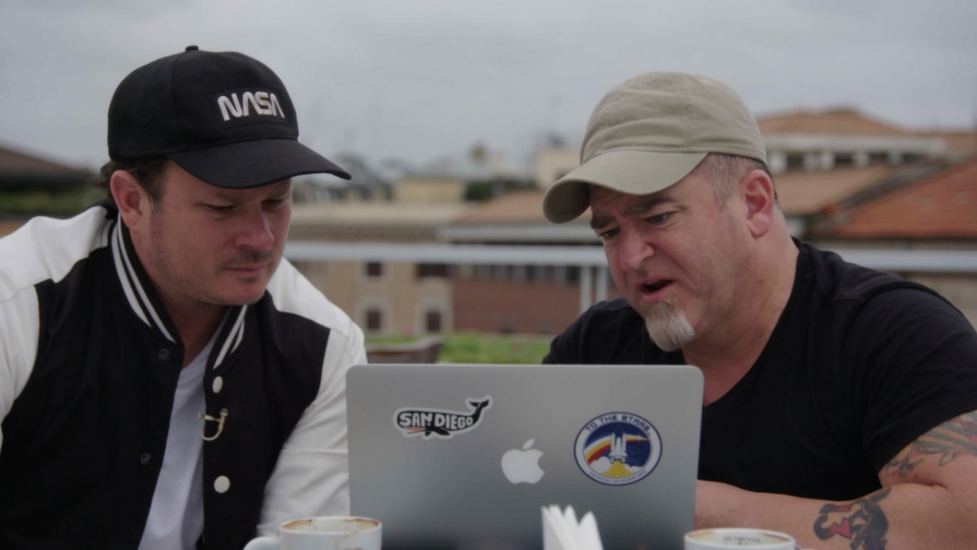

MÅNDAGAR FRÅN 26 OKTOBER KL 21.00 (8x1)

INTERVIEWS AVAILABLE ON REQUEST
(Canal Digital | Com Hem | Boxer | Viasat | Telia | Telenor | Sappa | IP Sweden | Sydantenn)

Website: http://www.historytv.se
Facebook: facebook.com/HISTORYSverige
Instagram: instagram.com/HISTORYSve
Download preview clip HERE
Comic Con interview

“It's not often a new television series gets the U.S. government to cough up its long-held secrets. That's exactly what happened after Unidentified: Inside America’s UFO Investigation aired…” SYFY

Following the recently released Pentagon UFO videos, former Blink 182 star, Tom DeLonge (pictured left) returns to HISTORY for a brand-new series of Unidentified: Inside America’s UFO investigation.

In season two each episode follows a specific case of the Pentagon’s U.F.O. Task Force, the Unidentified Aerial Phenomenon (UAP) which according to The New York Times will standardise collection and reporting on sightings of unexplained aerial vehicles, and report findings to the public every six months, following a recent Senate Committee Report.

Investigators followed in the series include former military intelligence official and Special Agent In-Charge, Luis Elizondo (pictured right), and former Deputy Assistant Secretary of Defence and Intelligence, Chris Mellon.

The team continue to divulge what the US government know about these bizarre craft, hear additional first-hand eyewitness accounts of UAP sightings from military and civilian personnel, and share insight and information about these craft to produce tangible evidence and build the most indisputable case for the existence and threat of UAP ever assembled. In episode 1 ‘UFOs Combat’, we hear direct from an eyewitness account of an Army specialist stationed in Afghanistan who saw a UFO while on duty.

Starting with a 2017 frontpage New York Times exposé, which revealed the existence of a hidden Pentagon UFO investigation unit, this new series continues to uncover shocking revelations from sources close to the pentagon, the FBI and the US government – led by former Blink-182 frontman Tom DeLonge.

Headed up from 2007-2012 by Luis Elizondo, a $22 million project - officially dubbed the Advanced Aerospace Threat Identification Program (AATIP) - was tasked with investigating the threat of UFOs and around the globe.

Elizondo is now part of a team of UFO investigators led by Tom DeLonge, which includes renowned CIA researcher and quantum physicist, Hal Puthoff, and former Assistant Secretary of Defence for Intelligence, Chris Mellon.

Luis Elizondo teases that Season 2 will continue to impress following the revelations in the first season. Elizondo said: "When the audience gets a taste of what we were able to do in South America, that’s going to open the aperture and the floodgates… I was literally in their office with their Secretary of the Air Force and four-star generals having this conversation directly with me on camera, for the first time ever, saying, 'Yes, my government thinks this is a serious issue. We actively investigate UFOs and we know they are real, and we want to share information with your government.' That’s a drop-the-mic moment."

In the eight-part series DeLonge, Elizondo, Mellon, Puthoff and others reveal for the first time the AATIP’s copy of the United States Blue Book on UFO sightings and analyse its explosive contents.

The second series of Unidentified: Inside America’s UFO Investigation premieres on HISTORY on Monday 26 October at 21.00.

SHOW PAGE: https://www.historytv.se/program/unidentified-inside-americas-ufo-investigation

HISTORY is available on Canal Digital | Com Hem | Boxer | Viasat | Telia | Telenor | Sappa | IP Sweden | Sydantenn.

Viewing material and interview access available on request.

Episode Synopses

Episode 1: UFOs in Combat Måndag 26 oktober kl 21.00
Everything we know about UFOS has changed. Now, the all-star team that led the U.S Navy to admit UFOs are real launches a new season of investigations aided by a fresh wave of exclusive, military eyewitnesses. These veterans testify to an extraordinary series of encounters between US Military and UFOs dating to the Vietnam War. The team attempts to connect the dots. Are these the same unidentified craft shown in declassified US Navy videos and have they been shadowing American forces for decades? Download preview clip here.

Episode 2: Planetary Threat Måndag 2 november kl 21.00
In an international UFO hotspot, Lue Elizondo uncovers exclusive video of a glowing orb recorded recently by an airline pilot at 35,000 feet and investigates possible connections to secret technology related to the USSR, plus a shocking aerial battle between a jet fighter pilot and an UFO. Local people reveal an ancient connection, as high-ranking officials drop a Project Blue Book bombshell. The planetary threat of UFO is explored.

Episode 3: UFOs vs. Nukes Måndag 9 november kl 21.00
The team investigates an alarming pattern of UFOs allegedly appearing near US Air Force bases that house nuclear weapons, and nuclear-powered US warships. A new eyewitness account suggests these craft have an incredible ability. Connections to a historic sighting where a UFO allegedly interfered with a US nuclear weapon are explored. Elizondo briefs former US Senator Harry Reid who offers a stunning theory about UFOs.

Episode 4: The Triangle Mystery Måndag 16 november kl 21.00
Former intelligence officer Chris Mellon spearheads an investigation into one of the UFO phenomenon's great mysteries. Giant triangles allegedly capable of incredible acceleration and speeds have been seen all over the world, and even near major American cities. The lingering mystery: what are these objects, and what is their purpose? A new eyewitness may provide the answer: the triangles are mapping the surface of the earth, but for what purpose? Mellon and the team come to a headline-making conclusion.

Episode 5: The UFO Cover-Up Måndag 23 november kl 21.00
In 2017, Tom DeLonge and Luis Elizondo helped engineer the release of 3 videos captured by US Navy fighter pilots of "Tic Tac UFOs." The strange objects had no wings and were capable of seemingly impossible manoeuvres. These videos impelled the US Navy to acknowledge these unidentified objects exist. Now, new eyewitnesses radically expand what's known about “Tic Tacs” and could provide clues to the mysterious craft's origin. Evidence of a possible US government cover-up is examined.

Episode 6: Sightings Surge Måndag 30 november kl 21.00
Luis Elizondo calls on a new technology to analyse a series of UFO videos all recorded in 2019--a year that featured a huge increase in UFO sightings. While previously focusing on US Military eyewitnesses, the team broadens its focus to civilian accounts. Among the cases are a series of strange formations of craft reported by civilians in Colorado. Connections to UFO sightings by the US Military are explored.

Episode 7: Airline Encounters Måndag 7 december kl 21.00
US airline pilots are reporting near mid-air collisions with UFOs. Elizondo hears a never-told-before account from a major legacy airline pilot whose report of a glowing orange sphere while in the cockpit over Arizona is backed up by photo evidence. Elizondo speaks with another veteran commercial pilot, also former military, with a harrowing story of an unidentified object apparently tracking his jetliner. In both cases, the pilots feared a mid-air collision that would have killed hundreds of passengers.

Episode 8: Extra-terrestrial Encounters Måndag 14 december kl 21.00
When Luis Elizondo was part of the Pentagon's Advanced Aerospace Threat Identification Program (AATIP) he identified five observable characteristics of UFOs, dubbed the "five observables." But there is a so-called sixth observable Elizondo began to investigate--an invisible threat these craft may pose. On the trail of this phenomenon, he uncovers never-before-told accounts by U.S. Air Force personnel stationed at the USA's most sensitive sites.

Contributor biographies:
Tom DeLonge
Co-founder of US rock bands Blink-182 and Angels & Airwaves, and having sold over 25 million records worldwide, DeLonge has since dedicated much of his life to exposing the truth about extra-terrestrial lifeforms on earth. After being involved with various other business ventures, DeLonge also co-founded To The Stars Academy of Arts & Science in 2017, and is President of the organisation.

Luis Elizondo
Luis Elizondo is a former employee of the Office of the Under Secretary of Defence for Intelligence (OUSDI). He currently serves as Director of Global Security and Special Programs at To The Stars Academy of Arts and Science. Elizondo formerly headed the Advanced Aerospace Threat Identification Program (AATIP) until the program was defunded. AATIP was a secretive $22 million program initiated by the Defence Intelligence Agency in order to study Unidentified Aerial Phenomena (UAP), also known as UFOs. According to the Pentagon, it was cancelled in 2012

Chris Mellon
Christopher Mellon is the former United States Deputy Assistant Secretary of Defence for Intelligence (the third highest intelligence position at the Pentagon), having served in the Bill Clinton and George W. Bush administrations. He also formerly served as the Staff Director of the United States Senate Select Committee on Intelligence. Mr. Mellon is currently a private equity investor and National Security Affairs Advisor and shareholder in To the Stars Academy of Arts and Sciences.

Hal Puthoff
Harold E. Puthoff, Ph.D. is an American physicist who has co-authored several books on gravitational and paranormal research. Puthoff is well known within gravitational physics circles for his papers on alternative approaches to general relativity and quantum mechanics. In the 70s and 80s he directed a CIA/DIA-funded program at SRI International to investigate paranormal abilities. Puthoff was once a United States Navy officer who was assigned to the National Security Agency (NSA), later becoming a civilian employee.

ENDS

For more information please contact:
Jo Fellows på A+E Networks UK / Joanna.Fellows@aenetworks.co.uk / +44 7583 022 665
Adel Brandlin på A+E Networks UK / Adel.Brandlin@aenetworks.co.uk

Editor’s Notes

- Facebook: @HISTORYSverige
- Instagram: @HISTORYSve
- HISTORY is available on Canal Digital | Com Hem | Boxer | Viasat | Telia | Telenor | Sappa | IP Sweden | Sydantenn.
- Show PAGE
- Clips, viewing materials and images to be provided on request
- New key art and assets coming
- Interview access available depending on availability
- All information correct at time of writing

Om HISTORY®
HISTORY is the flagship brand of the A+E Networks UK portfolio which is made up of true crime channel Crime+Investigation®, entertainment channel Lifetime®, HISTORY2 and free to air channel BLAZE. HISTORY is available in Sweden on Canal Digital | Com Hem | Viasat | Telia | Telenor | Sappa | IP Sweden | Sydantenn

Om A+E Networks UK®
A + E Networks UK är ett joint venture mellan Hearst och Sky. Företagets portfölj består av banbrytande fakta- och underhållningskanaler av hög kvalitet, som inkluderar HISTORY®, Lifetime®, Crime + Investigation®, HISTORY2™ och den nya free-to-air-kanalen BLAZE®. A+E Networks UK lanserades i november 1995, och företagets 20 kanaler når 60 miljoner hushåll i nästan 100 länder i Storbritannien, Skandinavien, Benelux, Central- och Östeuropa, Afrika och Mellanöstern. Företaget har kontor i London, Warszawa och Johannesburg. https://www.aenetworks.tv / @AENetworksUK

