Press release
Kongsberg Digital to deliver Vessel Insight to Güngen fleet

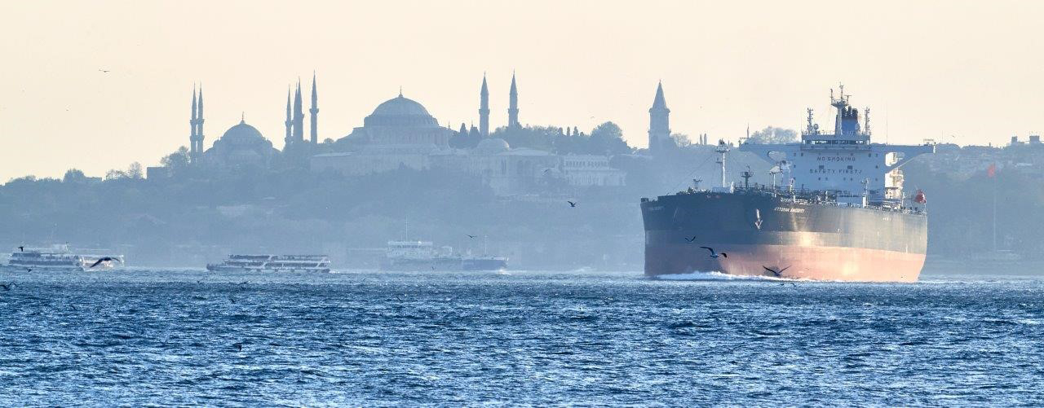
Güngen is to deploy Kongsberg Digital’s Vessel Insight infrastructure across its entire Suezmax tanker fleet

Asker, Norway, July 7th, 2021 – Kongsberg Digital announced today that it has signed a contract to deliver its Vessel Insight infrastructure to Güngen Denizcilik ve Ticaret A.Ş. (Güngen), a Turkish-owned and registered shipping company which operates a fleet of six high-specification Suezmax crude oil-tankers. Güngen will install Vessel Insight on all its vessels as an important step in the company’s digitalization strategy, helping to reduce fleet emissions and optimize performance.
“We are very pleased to have signed a contract to deliver our Vessel Insight infrastructure to Güngen,” says Andreas Jagtøyen, Executive Vice President, KDI. “Güngen is a well-reputed shipping company with ambitions to digitalize its fleet to the highest level, and is a forerunner in standardizing the digitalization process on vessels. We are looking forward to working with Güngen to unlock the full potential that lies in digitalization and the software available on the market.”
Güngen’s immediate goal for installing Vessel Insight is to benchmark the vessels within its fleet, providing the foundation for increased fuel savings and reduced emissions. The strategic purpose is to standardize the digitalization process and collect all data from the ships’ assets. Inputs can then be analyzed, and the system easily connected to software applications in the Kognifai Marketplace.
“The multitude of sensors onboard our ships produce a massive amount of valuable data,” says Selim Güngen, C.O.O. of Güngen. “So far, despite enjoying the best satellite communication contracts which the market has to offer, we have only really been able to access this data by logging into our ships. This relatively slow and inefficient process has obstructed our predictive maintenance and data analysis endeavors. We therefore reached out to KONGSBERG, who also made our ships’ automation systems, to find a solution which will deliver an effortless data stream, accessible from anywhere and at any time from a user-friendly interface. We very much look forward to working with Kongsberg Digital to set yet another milestone in our digitalization process.”
Vessel Insight infrastructure
Kongsberg Digital’s Vessel Insight is a cost-efficient data infrastructure solution that enables shipowners and operators to begin their digitalization process. Vessel Insight collects and contextualizes data from vessels, allowing top-level applications to use the necessary data to solve a predefined set of Key Performance Indicators.
By subscribing to Vessel Insight, Güngen will gain access to the Kognifai Marketplace, a network of market leading third-party software applications that can be utilized by shipowners and operators to help make their businesses more sustainable and gain a competitive edge in the industry. The Kongsberg Digital Customer Success Team will assist Güngen in meeting their identified targets through the Vessel Insight infrastructure and the applications available on the Kognifai Marketplace.
The contract between Kongsberg Digital and Güngen was signed on May 5th, 2021. Installation of Vessel Insight is expected to commence in July 2021.

KONGSBERG DIGITAL
Kongsberg Digital is a provider of next-generation software and digital solutions to customers within maritime, oil and gas, and renewables and utilities. The company consists of more than 500 software experts with leading competence within the internet of things, smart data, artificial intelligence, maritime simulation, automation and autonomous operations. www.kongsbergdigital.com
KONGSBERG
KONGSBERG (OSE-ticker: KOG) is an international, leading global technology corporation delivering mission-critical systems and solutions with extreme performance for customers that operate under extremely challenging conditions. We work with nations, businesses and research environments to push the boundaries of technology development in industries such as space, offshore and energy, merchant marine, defense and aerospace, and more. KONGSBERG has about 11,000 employees located in more than 40 countries, creating a total revenue of NOK 25.6bn in 2020. Follow us on kongsberg.com, Facebook, Twitter and LinkedIn.
GÜNGEN
Güngen Denizcilik ve Ticaret A.Ş. is a spinoff of the former dedicated marine operations department of Güngen Foreign Trade Co. Ltd., which was founded in 1976 as a family-owned company. Today the company owns and operates high-spec SUEZMAX type crude-oil tankers. All aspects from Design to Crewing, Technical and Commercial issues are managed in-house. Besides the latter, the company still charters a varying number of vessels in service of its trading arm.

CONTACT:  Mathilde Magnussen  VP Communication and Marketing  Kongsberg Digital  (+47) 456 78 255  mathilde.magnussen@kdi.kongsberg.com | Burak Güler  ETS Department  Güngen Denizcilik ve Ticaret A.Ş.  (+90) 216 556 56 56  ets@gungen.com

