Groundbreaking ‘sweet’ culture reduces added sugar in fermented dairy products
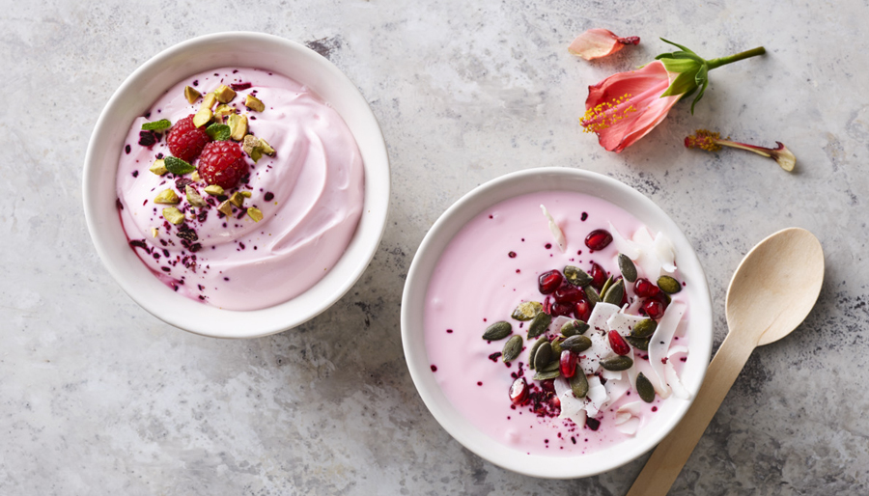
Chr. Hansen launches Sweety® Y-1: The first culture in the world allowing dairy manufacturers to create naturally sweeter products while reducing added sugar
Health organizations, governments and retailers are setting objectives to reduce sugar in foods while consumers are increasingly focusing on sugar content, looking for healthy and natural products that taste great. This means dairy manufacturers are experiencing pressure to reduce added sugar in their products, especially in yogurt.
“Dairy manufacturers often add sugar to their products to compensate for the taste of post acidification, finding the right balance between sweet and sour. With our new patented culture, post acidification is very low, which reduces the need for added sugar,” says Jessica Bentley, commercial development manager, Fresh Dairy at Chr. Hansen.
Exploit the natural sweetness in milk
Sweety® Y-1 is an innovative culture solution allowing the natural creation of sweetness by unlocking milk’s own resource – lactose.
“Using what is naturally available in milk and applying our expertise in culture application, we have developed a culture that will enable a sweeter taste than other cultures can,” explains Kim Soerensen, senior principal scientist in strains, Bacterial Physiology at Chr. Hansen.
Sweety® Y-1 is a culture solution using Streptococcus thermophilus and Lactobacillus bulgaricus cultures. It can convert the existing sugars in milk, using more of the lactose and yielding glucose – which provides a
greater sweetness intensity. This means you can add less sugar and still get the same sweet-tasting product, resulting in a healthier product offering.
Let your yogurt stay sweet throughout shelf life with a clean label
With Sweety® Y-1, Chr. Hansen brings a groundbreaking innovation to the dairy market. The culture enables manufacturers to meet modern market trends and consumer demands for healthy food by reducing added sugar without compromising the good taste of the product.
“Sweety® Y-1 is a mild culture with superior pH stability. This enables dairy manufacturers to create products that maintain sweetness throughout shelf life. As the first and only company to launch such a solution, we expect a lot of interest and are excited to engage with our customers,” Bentley elaborates.
Using Sweety® Y-1 cultures in the production of fermented dairy foods enables dairy producers to:
- Enhance sweetness by converting the existing sugar in milk
- Maintain the sweet taste during shelf life with very low post acidification
- Create natural and clean label products without the use of artificial sweeteners
“At Chr. Hansen, we are dedicated to improving food and health – not only for this generation but for the generations to come. To do this, we are actively contributing to the UN Global Goals, including goal number three: Good health and well-being. Sweety® Y-1 fits this agenda perfectly by using nature’s own resources to provide good tasting fermented dairy products with less sugar added, enhancing a healthy lifestyle,” Bentley concludes.

