Digital Yacht’s AISView app for Android
phones and tablets now available on the Play Store

For immediate release: June 2014

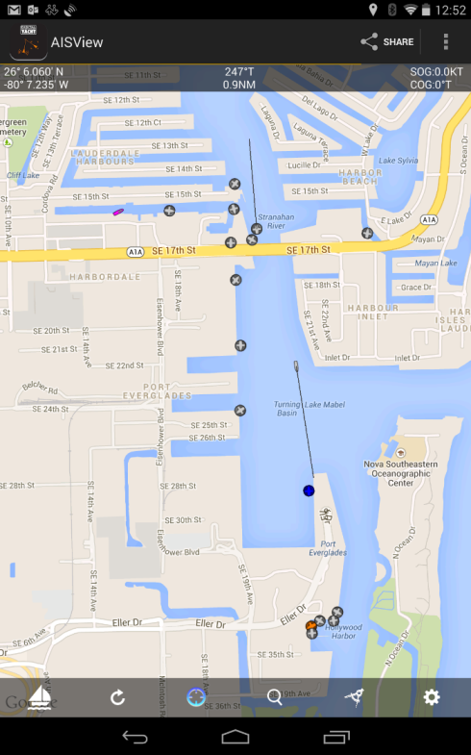
With over 1m Android devices activated daily, it’s the world’s leading mobile platform but, up until now, supported remarkably few marine navigation apps. Digital Yacht have just changed that with the introduction of AISView – an AIS viewing application for Android tablets and phones.

AISView is designed to wirelessly connect into your boat’s AIS system via any of Digital Yacht’s NMEA to Wifi devices like the WLN10 or iAIS. Alternatively, you can also connect using Digital Yacht’s USB-NMEA adaptor which can link to a tablet’s USB port via a suitable adaptor but you’ll have a cable attached to the tablet. Once installed, you’ll see an overlay of AIS target information onto a background Google map. Tap on a target and you’ll get a drop down list with identity, heading and closest point of approach (CPA) information. A heading vector makes it easy to see potential collision course targets. Google maps can now be cached if you don’t have an internet connection but even if this feature isn’t used, AISView will present an attractive radar like visualisation with range rings overlaying the targets around your vessel.

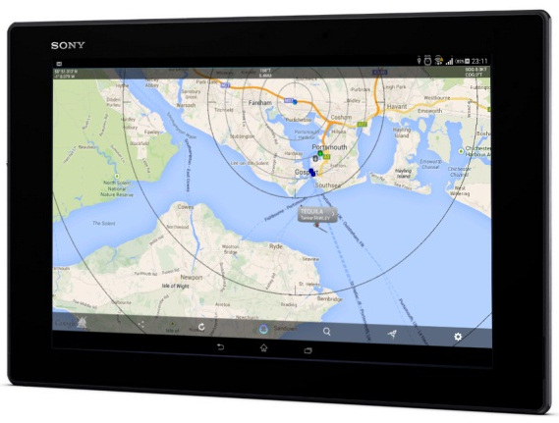
AISView also supports a simple bearing and distance ruler, compass heading display and current position and track history from the device’s built in GPS. Alarms can be configured for closest point of approach and AIS SARTs – useful for MOB applications. If you have a live internet connection, you can also supplement the real time overlay with AIS information obtained from the popular BoatBeacon internet AIS app (if this is installed) allowing you to view AIS targets in remote ports or locations.

AISView is available now and is priced at $10/£5.75. Further details from Digital Yacht TEL 01179 55474 or visit the Google Play store

-Ends-
Digital Yacht – Note’s For Editors
Digital Yacht is a UK based manufacturer of specialist marine electronics with offices in the US and China and a global network of resellers in over 100 cuntries. We produce a range of innovative products including AIS receivers and transponders, WiFi servers for on board NMEA data, long range WiFi internet devices and a range of sensors including GPS and electronic compasses. Digital Yacht won the prestigious METS DAME Electronic Product Award for iAIS as well as the NMEA Technology Award for BOATraNet in 2011. The GPS150 was nominated for a DAME award at this year’s 2013 exhibition in November. Our blog at www.digitalyacht.net has a range of interesting White Papers on many aspects of marine technology.

For further information, please contact:

Nick Heyes Direct Line + 44 207 100 9116 or US 978 277 1234

Digital Yacht Ltd. The Technology Centre, Green Lane, Failand, Bristol. BS8 3TR. UK.
Telephone: +44 (0)1179 554474 Email: sales@digitalyacht.co.uk www.digitalyacht.co.uk

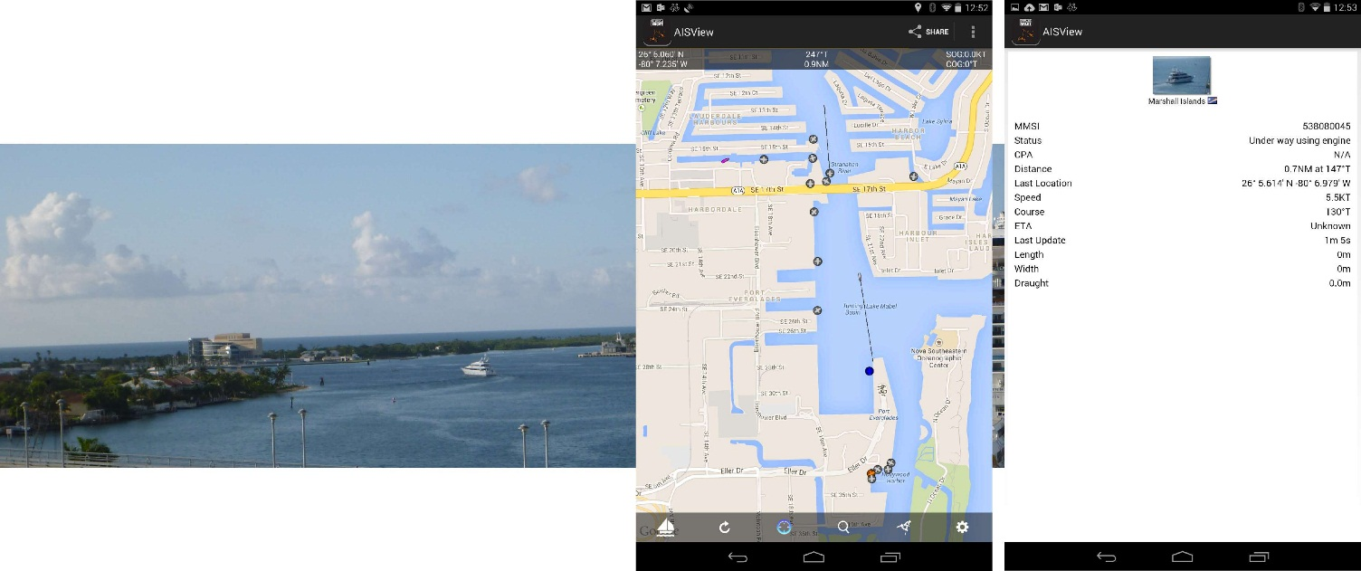
Additional Images
Here we can see a visual target, presentation in AISView (target in the middle of the screen) and drop down target information

